**Binary Tree**

## Introduction

A tree is a frequently-used data structure to simulate a hierarchical tree structure.

Each node of the tree will have a root value and a list of references to other nodes which are called child nodes. From graph view, a tree can also be defined as a directed acyclic graph which has N nodes and N-1 edges.

A Binary Tree is one of the most typical tree structure. As the name suggests, a binary tree is a tree data structure in which each node has at most two children, which are referred to as the left child and the right child.

By completing this card, you will be able to:

1. Understand the concept of a tree and a binary tree;
2. Be familiar with different traversal methods;
3. Use recursion to solve binary-tree-related problems;

Traverse A Tree

 Traverse a Tree - Introduction

 Binary Tree Preorder Traversal

 Binary Tree Inorder Traversal

 Binary Tree Postorder Traversal

 Binary Tree Traversal - Solution

 Level-order Traversal - Introduction

 Binary Tree Level Order Traversal

 Binary Tree Level Traversal - Solution

Solve Problems Recursively

 Solve Tree Problems Recursively

 Maximum Depth of Binary Tree

 Symmetric Tree

 Path Sum

 Count Univalue Subtrees

Conclusion

 Construct Binary Tree from Inorder and Postorder Traversal

 Construct Binary Tree from Preorder and Inorder Traversal

 Populating Next Right Pointers in Each Node

 Populating Next Right Pointers in Each Node II

 Lowest Common Ancestor of a Binary Tree

 Serialize and Deserialize Binary Tree

## Traverse A Tree

In the introduction, we have gone through the concept of a tree and a binary tree.

In this chapter, we will focus on the traversal methods used in a binary tree. Understanding these traversal methods will definitely help you have a better understanding of the tree structure and have a solid foundation for the further study.

The goal of this chapter is to:

1. Understand the difference between different tree traversal methods;
2. Be able to solve preorder, inorder and postorder traversal recursively;
3. Be able to solve preorder, inorder and postorder traversal iteratively;
4. Be able to do level traversal using BFS.

**Traverse a Tree - Introduction**

### **Pre-order Traversal**

Pre-order traversal is to visit the root first. Then traverse the left subtree. Finally, traverse the right subtree. Here is an example:

**Note:** in the following animation, the **highlighting** in red indicates that we return from the visit of the node. The order of the visit is indicated on the array right below the binary tree.

### **In-order Traversal**

In-order traversal is to traverse the left subtree first. Then visit the root. Finally, traverse the right subtree.

Let's do in-order traversal together:

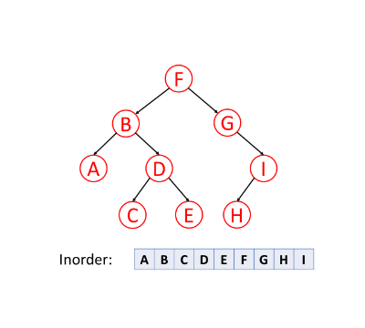

Typically, for binary search tree, we can retrieve all the data in sorted order using in-order traversal. We will mention that again in another card([Introduction to Data Structure - Binary Search Tree](https://leetcode.com/explore/learn/card/introduction-to-data-structure-binary-search-tree/)).

### **Post-order Traversal**

Post-order traversal is to traverse the left subtree first. Then traverse the right subtree. Finally, visit the root.

Here is an animation to help you understand post-order traversal:

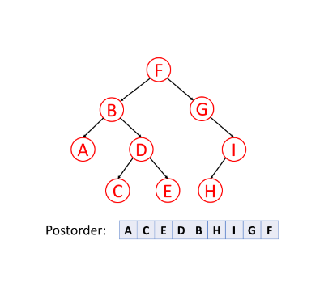

It is worth noting that when you delete nodes in a tree, deletion process will be in post-order. That is to say, when you delete a node, you will delete its left child and its right child before you delete the node itself.

Also, post-order is widely use in mathematical expression. It is easier to write a program to parse a post-order expression. Here is an example:

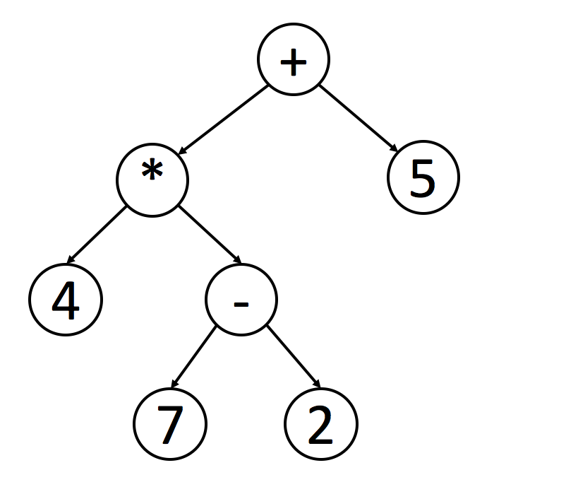

You can easily figure out the original expression using the inorder traversal. However, it is not easy for a program to handle this expression since you have to check the priorities of operations.

If you handle this tree in postorder, you can easily handle the expression using a stack. Each time when you meet a operator, you can just pop 2 elements from the stack, calculate the result and push the result back into the stack.

### **Recursive or Iterative**

Try to practice the three different traversal methods in our after-article exercise. You might want to implement the methods recursively or iteratively. Implement both recursion and iteration solutions and compare the differences between them.

**Binary Tree Preorder Traversal**

Given the root of a binary tree, return *the preorder traversal of its nodes' values*.

**Example 1:**

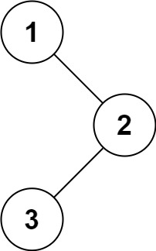

**Input:** root = [1,null,2,3]

**Output:** [1,2,3]

**Example 2:**

**Input:** root = []

**Output:** []

**Example 3:**

**Input:** root = [1]

**Output:** [1]

**Example 4:**

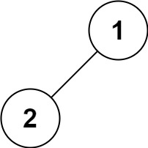

**Input:** root = [1,2]

**Output:** [1,2]

**Example 5:**

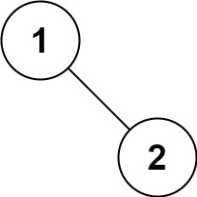

**Input:** root = [1,null,2]

**Output:** [1,2]

**Constraints:**

* The number of nodes in the tree is in the range [0, 100].
* -100 <= Node.val <= 100

**Follow up:** Recursive solution is trivial, could you do it iteratively?

## Solution

#### **How to traverse the tree**

There are two general strategies to traverse a tree:

* Breadth First Search (BFS)

We scan through the tree level by level, following the order of height, from top to bottom. The nodes on higher level would be visited before the ones with lower levels.

* Depth First Search (DFS)

In this strategy, we adopt the depth as the priority, so that one would start from a root and reach all the way down to certain leaf, and then back to root to reach another branch.

The DFS strategy can further be distinguished as preorder, inorder, and postorder depending on the relative order among the root node, left node and right node.

On the following figure the nodes are numerated in the order you visit them, please follow 1-2-3-4-5 to compare different strategies.

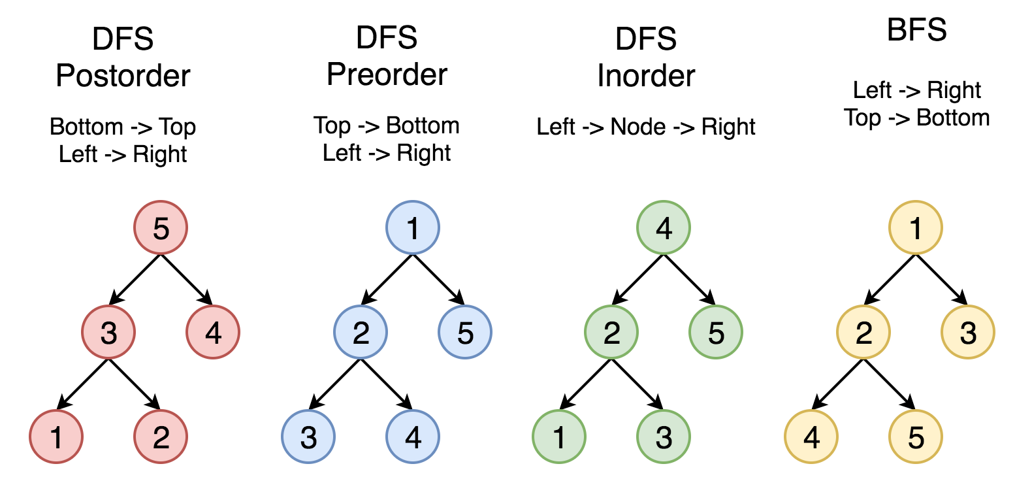

Here the problem is to implement preorder traversal using iterations.

#### **Approach 1: Iterations**

**Algorithm**

First of all, here is the definition of the TreeNode which we would use in the following implementation.

|  |
| --- |
| /* Definition for a binary tree node. */  public class TreeNode {  int val;  TreeNode left;  TreeNode right;  TreeNode(int x) {  val = x;  }  } |

Let's start from the root and then at each iteration pop the current node out of the stack and push its child nodes. In the implemented strategy we push nodes into output list following the order Top->Bottom and Left->Right, that naturally reproduces preorder traversal.

|  |
| --- |
| class Solution {  public List<Integer> preorderTraversal(TreeNode root) {  LinkedList<TreeNode> stack = new LinkedList<>();  LinkedList<Integer> output = new LinkedList<>();  if (root == null) {  return output;  }  stack.add(root);  while (!stack.isEmpty()) {  TreeNode node = stack.pollLast();  output.add(node.val);  if (node.right != null) {  stack.add(node.right);  }  if (node.left != null) {  stack.add(node.left);  }  }  return output;  }  } |

**Complexity Analysis**

* Time complexity : we visit each node exactly once, thus the time complexity is O(*N*), where *N* is the number of nodes, i.e. the size of tree.
* Space complexity : depending on the tree structure, we could keep up to the entire tree, therefore, the space complexity is O(*N*).

#### **Approach 2: Morris traversal**

This approach is based on [Morris's article](https://www.sciencedirect.com/science/article/pii/0020019079900681) which is intended to optimize the space complexity. The algorithm does not use additional space for the computation, and the memory is only used to keep the output. If one prints the output directly along the computation, the space complexity would be O(1).

**Algorithm**

Here the idea is to go down from the node to its predecessor, and each predecessor will be visited twice. For this go one step left if possible and then always right till the end. When we visit a leaf (node's predecessor) first time, it has a zero right child, so we update output and establish the pseudo link predecessor.right = root to mark the fact the predecessor is visited. When we visit the same predecessor the second time, it already points to the current node, thus we remove pseudo link and move right to the next node.

If the first one step left is impossible, update output and move right to next node.

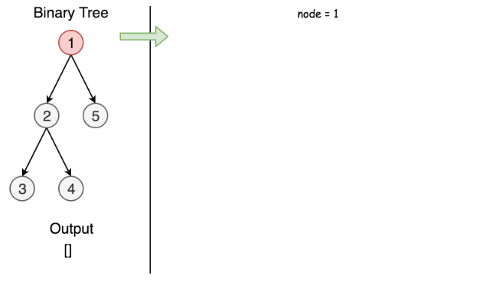

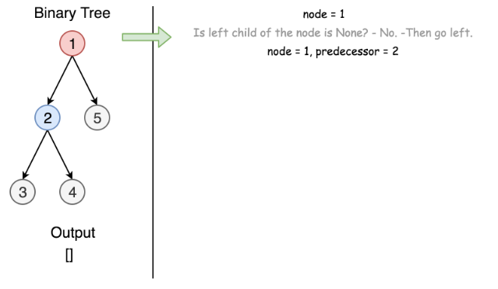

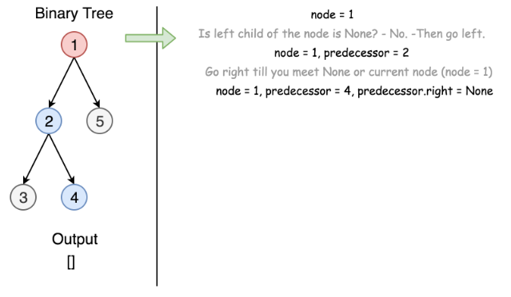

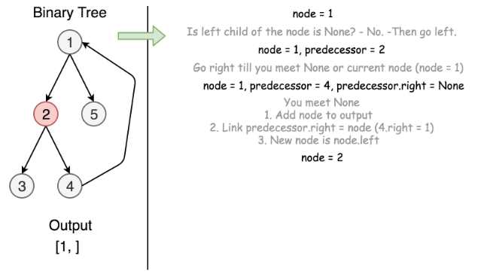

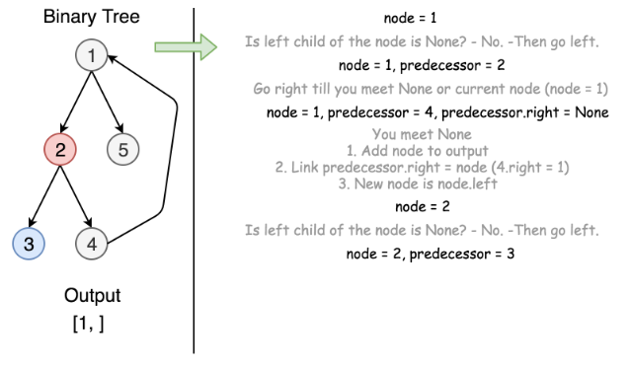

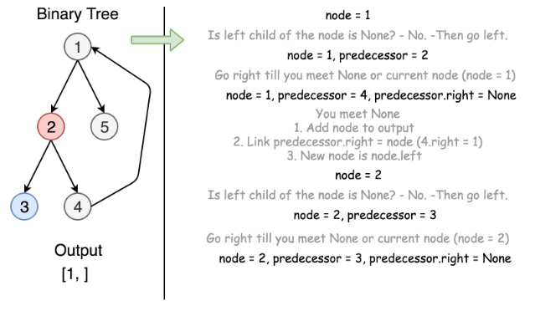

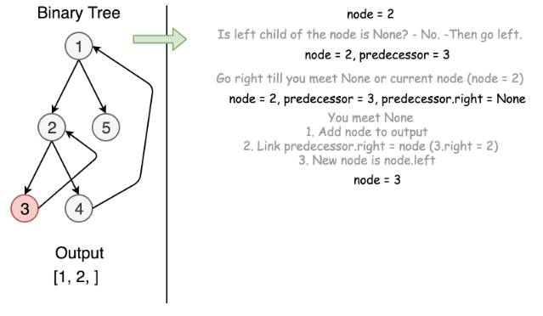

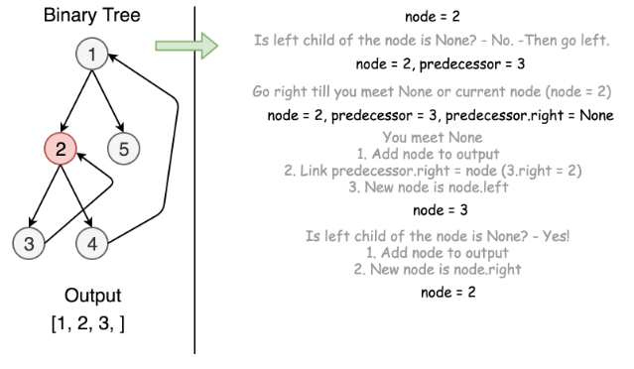

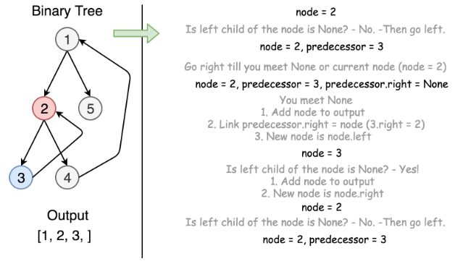

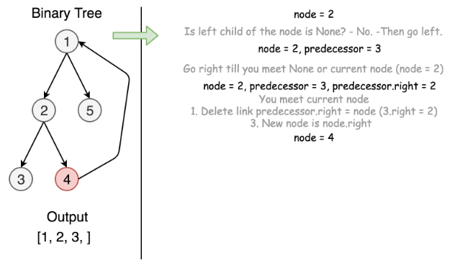

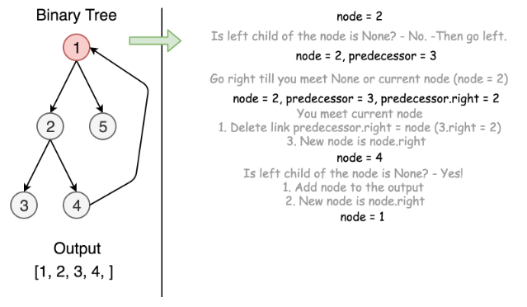

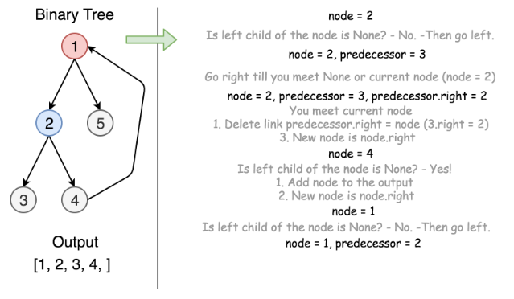

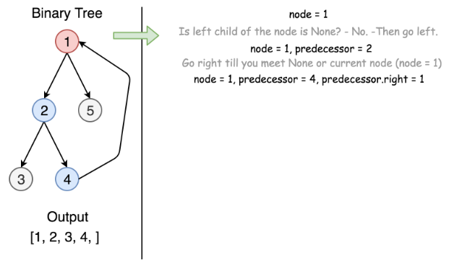

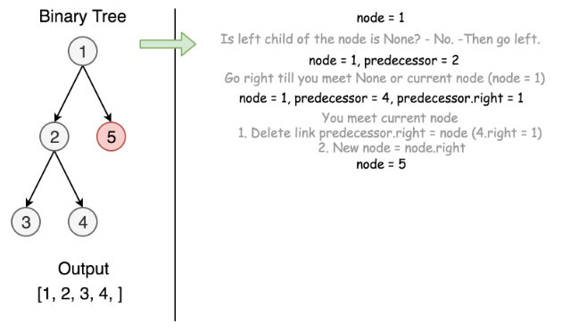

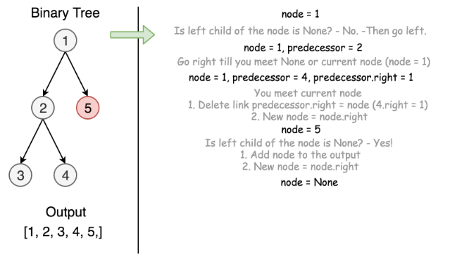

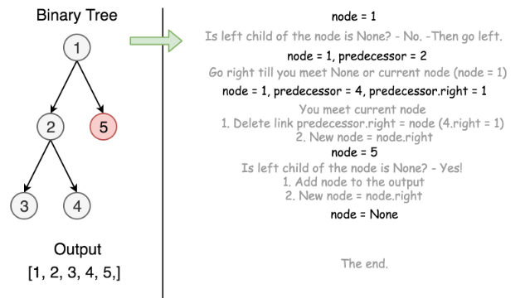

|  |
| --- |
| class Solution {  public List<Integer> preorderTraversal(TreeNode root) {  LinkedList<Integer> output = new LinkedList<>();  TreeNode node = root;  while (node != null) {  if (node.left == null) {  output.add(node.val);  node = node.right;  }  else {  TreeNode predecessor = node.left;  while ((predecessor.right != null) && (predecessor.right != node)) {  predecessor = predecessor.right;  }  if (predecessor.right == null) {  output.add(node.val);  predecessor.right = node;  node = node.left;  }  else{  predecessor.right = null;  node = node.right;  }  }  }  return output;  }  } |

**Complexity Analysis**

* Time complexity : we visit each predecessor exactly twice descending down from the node, thus the time complexity is O(*N*), where *N* is the number of nodes, i.e. the size of tree.
* Space complexity : we use no additional memory for the computation itself, but output list contains *N* elements, and thus space complexity is O(*N*).

**Binary Tree Inorder Traversal**

Given the root of a binary tree, return *the inorder traversal of its nodes' values*.

**Example 1:**



**Input:** root = [1,null,2,3]

**Output:** [1,3,2]

**Example 2:**

**Input:** root = []

**Output:** []

**Example 3:**

**Input:** root = [1]

**Output:** [1]

**Example 4:**



**Input:** root = [1,2]

**Output:** [2,1]

**Example 5:**



**Input:** root = [1,null,2]

**Output:** [1,2]

**Constraints:**

* The number of nodes in the tree is in the range [0, 100].
* -100 <= Node.val <= 100

**Follow up:**

Recursive solution is trivial, could you do it iteratively?

## Solution

#### **Approach 1: Recursive Approach**

The first method to solve this problem is using recursion. This is the classical method and is straightforward. We can define a helper function to implement recursion.

|  |
| --- |
| class Solution {  public List < Integer > inorderTraversal(TreeNode root) {  List < Integer > res = new ArrayList < > ();  helper(root, res);  return res;  }  public void helper(TreeNode root, List < Integer > res) {  if (root != null) {  if (root.left != null) {  helper(root.left, res);  }  res.add(root.val);  if (root.right != null) {  helper(root.right, res);  }  }  }  } |

**Complexity Analysis**

* Time complexity : *O*(*n*). The time complexity is *O*(*n*) because the recursive function is *T*(*n*)=2⋅*T*(*n*/2)+1.
* Space complexity : The worst case space required is *O*(*n*), and in the average case it's *O*(log*n*) where *n* is number of nodes.

#### **Approach 2: Iterating method using Stack**

The strategy is very similiar to the first method, the different is using stack.

Here is an illustration:

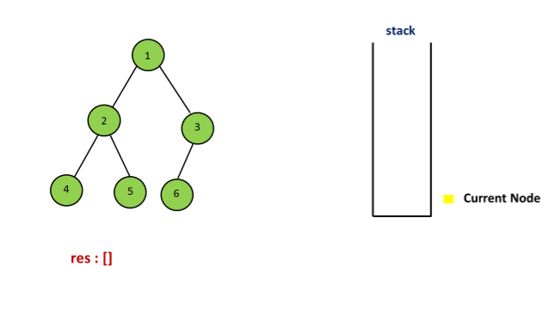

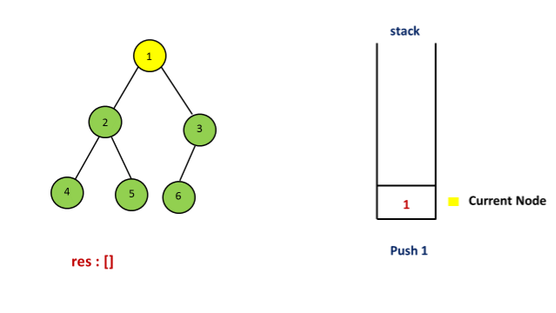

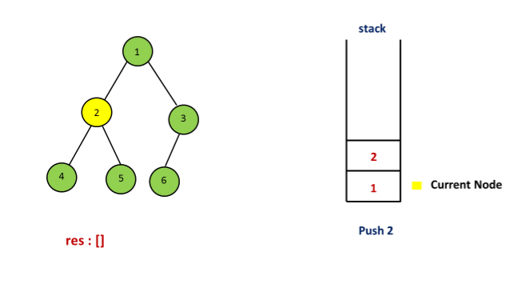

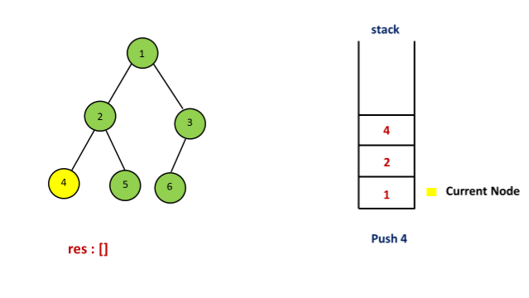

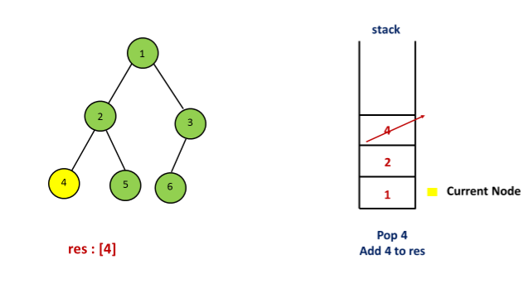

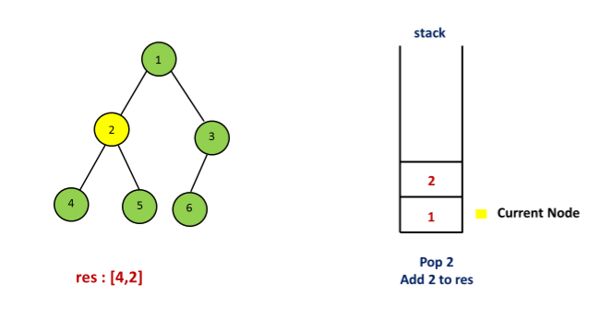

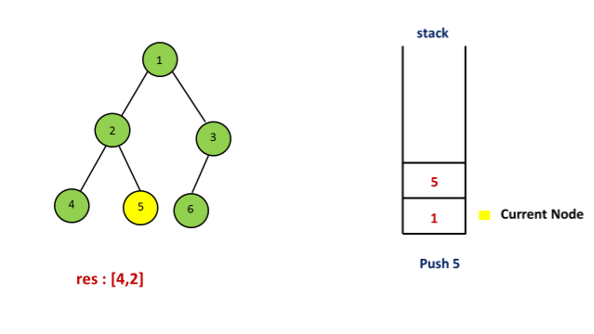

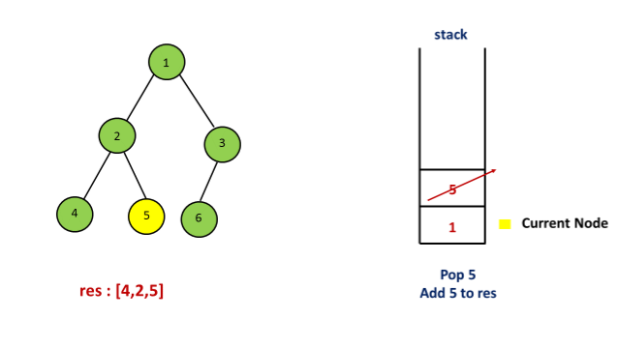

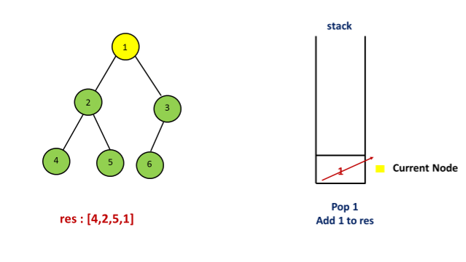

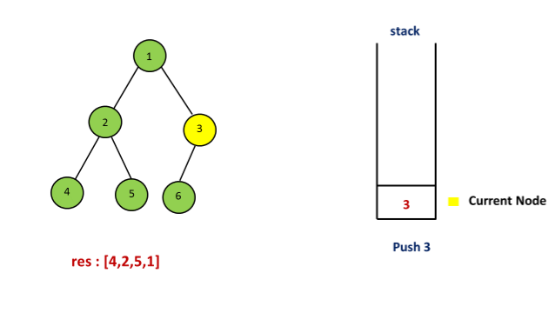

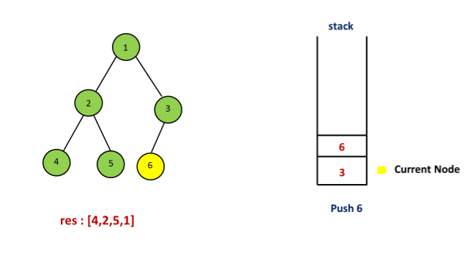

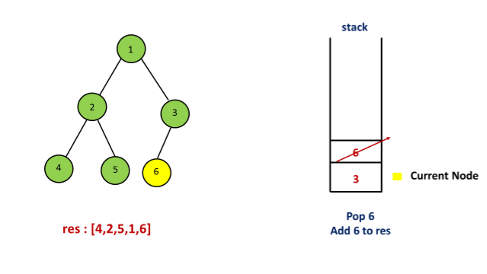

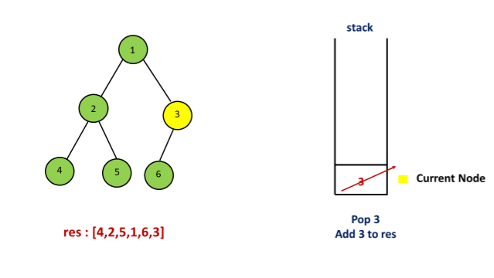

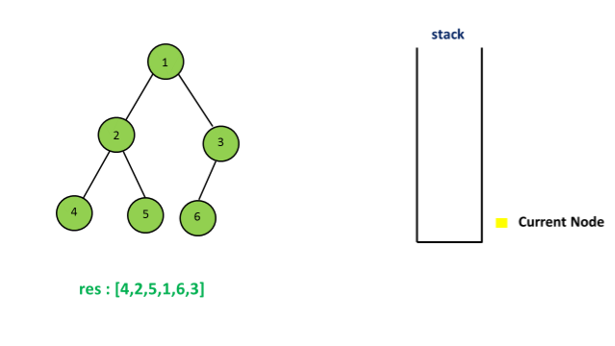

|  |
| --- |
| public class Solution {  public List < Integer > inorderTraversal(TreeNode root) {  List < Integer > res = new ArrayList < > ();  Stack < TreeNode > stack = new Stack < > ();  TreeNode curr = root;  while (curr != null || !stack.isEmpty()) {  while (curr != null) {  stack.push(curr);  curr = curr.left;  }  curr = stack.pop();  res.add(curr.val);  curr = curr.right;  }  return res;  }  } |

**Complexity Analysis**

* Time complexity : *O*(*n*).
* Space complexity : *O*(*n*).

#### **Approach 3: Morris Traversal**

In this method, we have to use a new data structure-Threaded Binary Tree, and the strategy is as follows:

Step 1: Initialize current as root

Step 2: While current is not NULL,

If current does not have left child

a. Add current’s value

b. Go to the right, i.e., current = current.right

Else

a. In current's left subtree, make current the right child of the rightmost node

b. Go to this left child, i.e., current = current.left

For example:

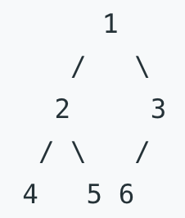

First, 1 is the root, so initialize 1 as current, 1 has left child which is 2, the current's left subtree is

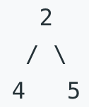  
  
So in this subtree, the rightmost node is 5, then make the current(1) as the right child of 5. Set current = cuurent.left (current = 2). The tree now looks like:

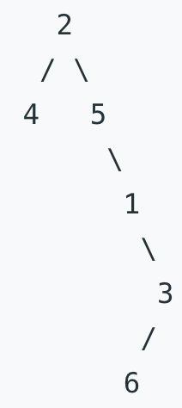  
For current 2, which has left child 4, we can continue with thesame process as we did above

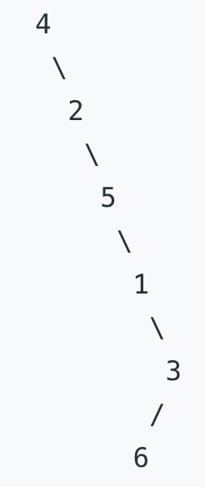

then add 4 because it has no left child, then add 2, 5, 1, 3 one by one, for node 3 which has left child 6, do the same as above. Finally, the inorder taversal is [4,2,5,1,6,3].

For more details, please check [Threaded binary tree](https://en.wikipedia.org/wiki/Threaded_binary_tree) and [Explaination of Morris Method](https://stackoverflow.com/questions/5502916/explain-morris-inorder-tree-traversal-without-using-stacks-or-recursion)

|  |
| --- |
| class Solution {  public List < Integer > inorderTraversal(TreeNode root) {  List < Integer > res = new ArrayList < > ();  TreeNode curr = root;  TreeNode pre;  while (curr != null) {  if (curr.left == null) {  res.add(curr.val);  curr = curr.right; // move to next right node  } else { // has a left subtree  pre = curr.left;  while (pre.right != null) { // find rightmost  pre = pre.right;  }  pre.right = curr; // put cur after the pre node  TreeNode temp = curr; // store cur node  curr = curr.left; // move cur to the top of the new tree  temp.left = null; // original cur left be null, avoid infinite loops  }  }  return res;  }  } |

**Complexity Analysis**

* Time complexity : *O*(*n*). To prove that the time complexity is *O*(*n*), the biggest problem lies in finding the time complexity of finding the predecessor nodes of all the nodes in the binary tree. Intuitively, the complexity is *O*(*n*log*n*), because to find the predecessor node for a single node related to the height of the tree. But in fact, finding the predecessor nodes for all nodes only needs *O*(*n*) time. Because a binary Tree with *n* nodes has *n*−1 edges, the whole processing for each edges up to 2 times, one is to locate a node, and the other is to find the predecessor node. So the complexity is *O*(*n*).
* Space complexity : *O*(*n*). Arraylist of size *n* is used.

**Binary Tree Postorder Traversal**

Given the root of a binary tree, return *the postorder traversal of its nodes' values*.

**Example 1:**

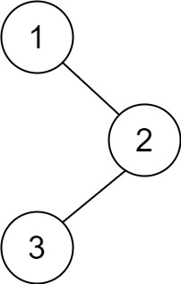

**Input:** root = [1,null,2,3]

**Output:** [3,2,1]

**Example 2:**

**Input:** root = []

**Output:** []

**Example 3:**

**Input:** root = [1]

**Output:** [1]

**Example 4:**

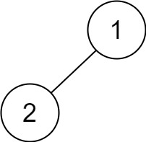

**Input:** root = [1,2]

**Output:** [2,1]

**Example 5:**

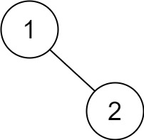

**Input:** root = [1,null,2]

**Output:** [2,1]

**Constraints:**

* The number of the nodes in the tree is in the range [0, 100].
* -100 <= Node.val <= 100

**Follow up:**

Recursive solution is trivial, could you do it iteratively?

## Solution

#### **How to traverse the tree**

There are two general strategies to traverse a tree:

* Breadth First Search (BFS)

We scan through the tree level by level, following the order of height, from top to bottom. The nodes on a higher level would be visited before the ones on the lower levels.

* Depth First Search (DFS)

In this strategy, we adopt the depth as the priority, so that one would start from a root and reach down to a leaf, and then back to root to reach another branch.

The DFS strategy can further be distinguished as preorder, inorder, and postorder depending on the relative order among the root node, left node, and right node.

 Figure 1. The nodes are numerated in the order you visit them, please follow *1-2-3-4-5* to compare different strategies.

Here the problem is to implement postorder traversal using iterations.

#### **Approach 1: Recursive Postorder Traversal**

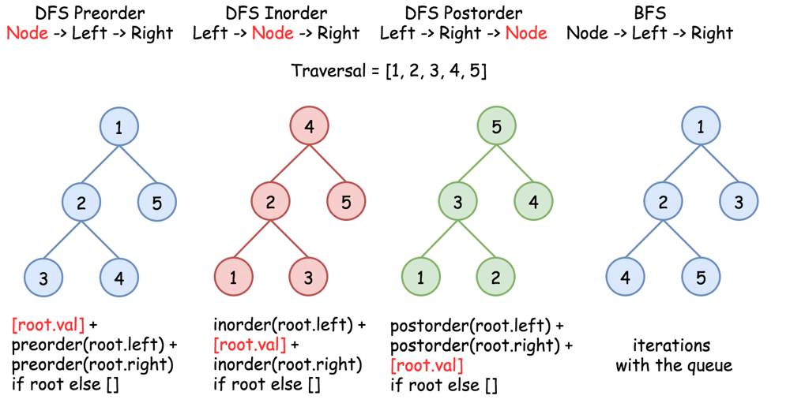 Figure 2. Recursive DFS traversals.

The most straightforward way is to implement recursion using Left -> Right -> Node traversal strategy.

|  |
| --- |
| class Solution {  public void postorder(TreeNode root, List<Integer> output) {  if (root == null) return;  postorder(root.left, output);  postorder(root.right, output);  output.add(root.val);  }    public List<Integer> postorderTraversal(TreeNode root) {  List<Integer> output = new ArrayList();  postorder(root, output);  return output;  }  } |

**Complexity Analysis**

* Time complexity: O(*N*), where *N* is the number of nodes. We visit each node exactly once, thus the time complexity is O(*N*).
* Space complexity: O(*N*). Up to O(*H*) to keep the recursion stack, where *H* is a tree height. In the worst case of the skewed tree *H*=*N*.

#### **Approach 2: Iterative Preorder Traversal: Tweak the Order of the Output**

Let's start from the root, and at each iteration, pop the current node out of the stack and push its child nodes. In the implemented strategy, we push nodes into stack following the order Top->Bottom and Left->Right. Since DFS postorder transversal is Bottom->Top and Left->Right the output list should be reverted after the end of the loop.

|  |
| --- |
| class Solution {  public List<Integer> postorderTraversal(TreeNode root) {  LinkedList<Integer> output = new LinkedList();  Deque<TreeNode> stack = new ArrayDeque();    if (root == null) return output;  stack.push(root);  while (!stack.isEmpty()) {  root = stack.pop();  output.addFirst(root.val);  if (root.left != null) stack.push(root.left);  if (root.right != null) stack.push(root.right);  }  return output;  }  } |

**Complexity Analysis**

* Time complexity: O(*N*), where *N* is the number of nodes. We visit each node exactly once, thus the time complexity is O(*N*).
* Space complexity: O(*N*). Up to O(*H*) to keep the stack, where *H* is a tree height. In the worst case of the skewed tree *H*=*N*.

#### **Approach 3: Iterative Postorder Traversal**

**Algorithm**

The idea is to fulfill the stack following right->node->left strategy. One could pop the last node out of the stack and check if it's the leftmost leaf. If yes, it's time to update the output. Otherwise, one should swap the last two nodes in the stack and repeat all these steps.

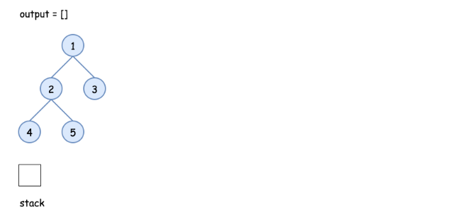

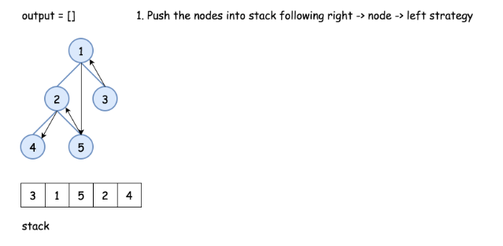

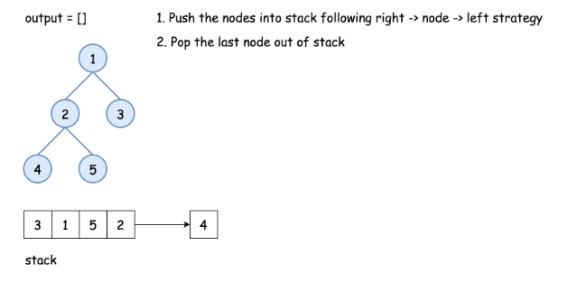

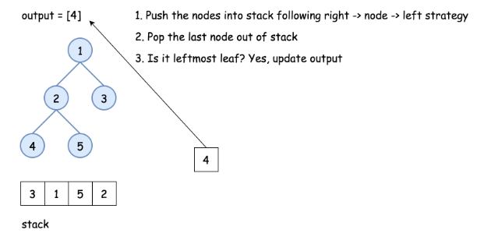

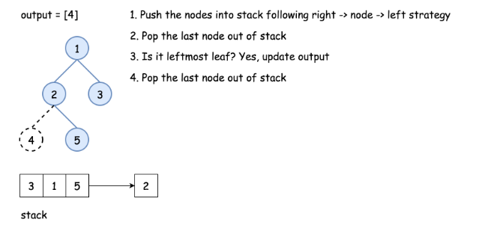

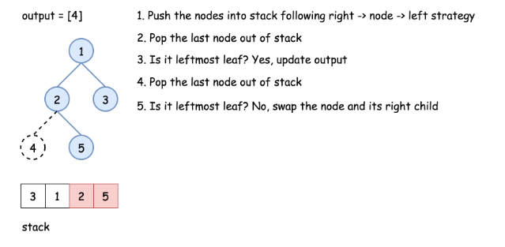

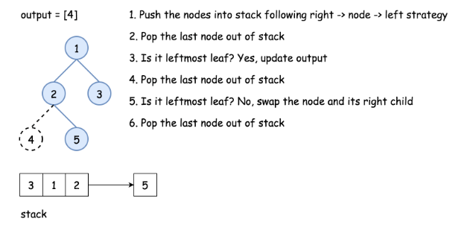

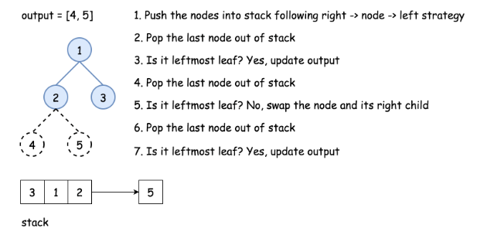

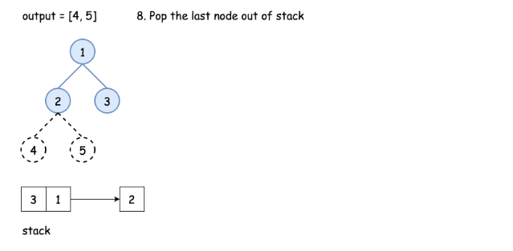

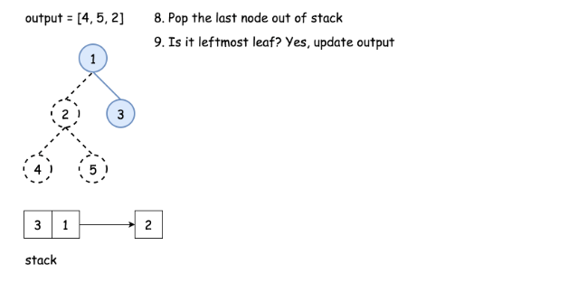

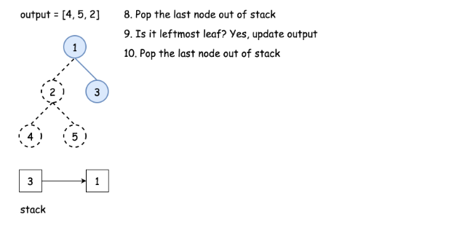

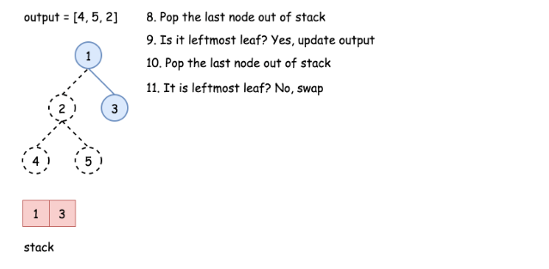

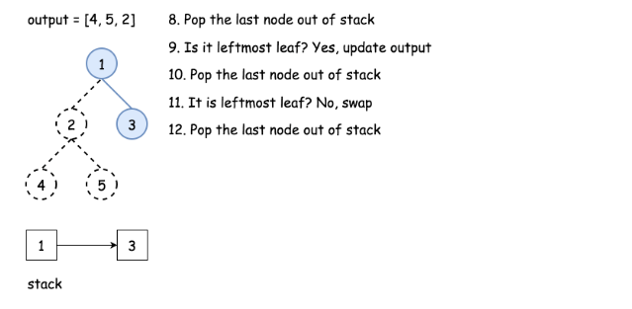

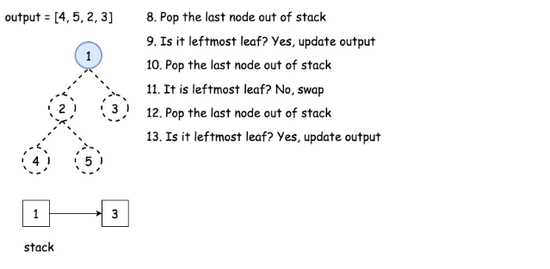

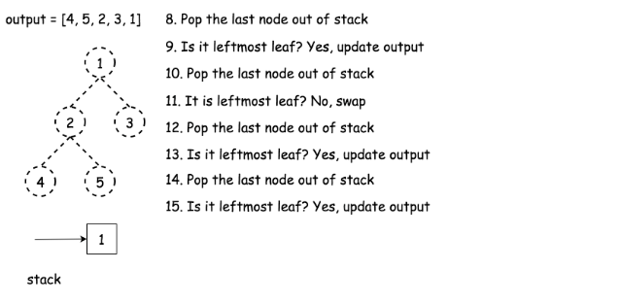

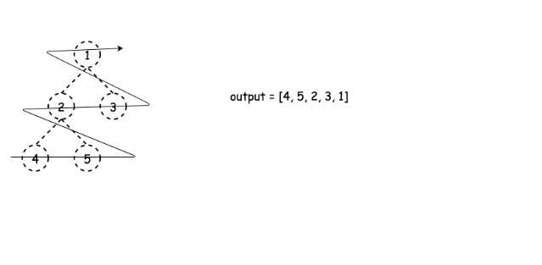

|  |
| --- |
| class Solution {  public List<Integer> postorderTraversal(TreeNode root) {  List<Integer> output = new ArrayList();  Deque<TreeNode> stack = new ArrayDeque();    while (root != null || !stack.isEmpty()) {  // push nodes: right -> node -> left  while (root != null) {  if (root.right != null) {  stack.push(root.right);  }  stack.push(root);  root = root.left;  }    root = stack.pop();    // if the right subtree is not yet processed  if (!stack.isEmpty() && root.right == stack.peek()) {  stack.pop();  stack.push(root);  root = root.right;  // if we're on the leftmost leaf  } else {  output.add(root.val);  root = null;  }  }  return output;  }  } |

**Complexity Analysis**

* Time complexity: O(*N*), where *N* is the number of nodes. We visit each node exactly once, thus the time complexity is O(*N*).
* Space complexity: O(*N*). Up to O(*H*) to keep the stack, where *H* is a tree height. In the worst case of the skewed tree *H*=*N*.

**Binary Tree Traversal - Solution**

In this article, we will provide the recursive solution for the three traversal methods we have mentioned. And talk about the implementation of the iterative solution. Finally, we will discuss the difference between them.

### ***Pre-order Traversal - Recursive Solution***

|  |
| --- |
| /**  * Definition for a binary tree node.  * public class TreeNode {  * int val;  * TreeNode left;  * TreeNode right;  * TreeNode(int x) { val = x; }  * }  */  class Solution {  private void preorderTraversal(TreeNode root, List<Integer> answer) {  if (root == null) {  return;  }  answer.add(root.val); // visit the root  preorderTraversal(root.left, answer); // traverse left subtree  preorderTraversal(root.right, answer); // traverse right subtree  }  public List<Integer> preorderTraversal(TreeNode root) {  List<Integer> answer = new ArrayList<>();  preorderTraversal(root, answer);  return answer;  }  } |

### ***In-order Traversal - Recursive Solution***

|  |
| --- |
| /**  * Definition for a binary tree node.  * public class TreeNode {  * int val;  * TreeNode left;  * TreeNode right;  * TreeNode(int x) { val = x; }  * }  */  class Solution {  private void inorderTraversal(TreeNode root, List<Integer> answer) {  if (root == null) {  return;  }  inorderTraversal(root.left, answer); // traverse left subtree  answer.add(root.val); // visit the root  inorderTraversal(root.right, answer); // traverse right subtree  }  public List<Integer> inorderTraversal(TreeNode root) {  List<Integer> answer = new ArrayList<>();  inorderTraversal(root, answer);  return answer;  }  } |

### ***Post-order Traversal - Recursive Solution***

|  |
| --- |
| /**  * Definition for a binary tree node.  * public class TreeNode {  * int val;  * TreeNode left;  * TreeNode right;  * TreeNode(int x) { val = x; }  * }  */  class Solution {  private void postorderTraversal(TreeNode root, List<Integer> answer) {  if (root == null) {  return;  }  postorderTraversal(root.left, answer); // traverse left subtree  postorderTraversal(root.right, answer); // traverse right subtree  answer.add(root.val); // visit the root  }  public List<Integer> postorderTraversal(TreeNode root) {  List<Integer> answer = new ArrayList<>();  postorderTraversal(root, answer);  return answer;  }  } |

### ***Iterative Solution***

There are several iterative solutions for tree traversal. One of the solutions is to use a stack to simulate the recursion process.

Taking pre-order traversal as an example, in each iteration, we pop one node from the stack and visit this node. Then if this node has a right child, push its right child into the stack. If this node has a left child, push its left child into the stack. It is noteworthy that we push the right child first so that we can visit the left child first since the nature of the stack is LIFO(last in first out). After that, we can continue to the next iteration until the stack is empty.

Here are java and c++ codes for your reference.

|  |
| --- |
| /**  * Definition for a binary tree node.  * public class TreeNode {  * int val;  * TreeNode left;  * TreeNode right;  * TreeNode(int x) { val = x; }  * }  */  class Solution {  public List<Integer> preorderTraversal(TreeNode root) {  List<Integer> answer = new ArrayList<>();  Stack<TreeNode> s = new Stack<TreeNode>();  if (root != null) {  s.push(root);  }  TreeNode cur;  while (!s.empty()) {  cur = s.pop();  answer.add(cur.val); // visit the root  if (cur.right != null) {  s.push(cur.right); // push right child to stack if it is not null  }  if (cur.left != null) {  s.push(cur.left); // push left child to stack if it is not null  }  }  return answer;  }  } |

### ***Complexity Analysis***

As we mentioned before, we can traverse a tree recursively to retrieve all the data in pre-order, in-order or post-order. The time complexity is O(N) because we visit each node exactly once. And the depth of the tree might be N in the worst case. That is to say, the level of recursion might be at most N in the worst case. Therefore, taking system stack into consideration, the space complexity is O(N) as well.

To be cautious, the complexity might be different due to a different implementation. It is comparatively easy to do traversal recursively but when the depth of the tree is too large, we might suffer from stack overflow problem. That's one of the main reasons why we want to solve this problem iteratively sometimes.

For the iterative solution, the time complexity is apparently the same with recursion solution which is O(N). The space complexity is also O(N) since in the worst case, we will have all the nodes in the stack. There are some other solutions for iterative traversal which can reduce the space complexity to O(1).

**Level-order Traversal - Introduction**

Level-order traversal is to traverse the tree level by level.

Breadth-First Search is an algorithm to traverse or search in data structures like a tree or a graph. The algorithm starts with a root node and visit the node itself first. Then traverse its neighbors, traverse its second level neighbors, traverse its third level neighbors, so on and so forth.

When we do breadth-first search in a tree, the order of the nodes we visited is in level order.

Here is an example of level-order traversal:

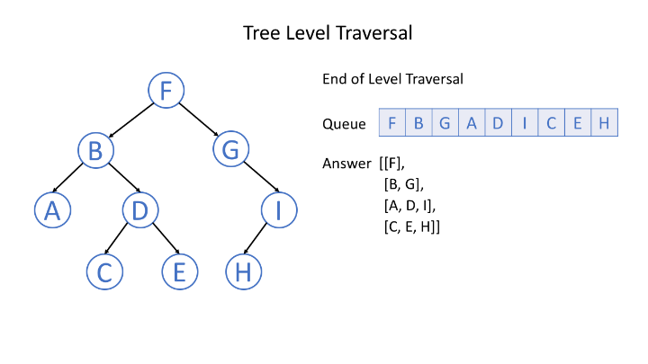

Typically, we use a queue to help us to do BFS. If you are not so familiar with the queue, you can find more information about that in another card coming soon.

**Binary Tree Level Order Traversal**

Given a binary tree, return the *level order* traversal of its nodes' values. (ie, from left to right, level by level).

For example:  
Given binary tree [3,9,20,null,null,15,7],

3

/ \

9 20

/ \

15 7

return its level order traversal as:

[

[3],

[9,20],

[15,7]

]

## Solution

#### **How to traverse the tree**

There are two general strategies to traverse a tree:

* Depth First Search (DFS)

In this strategy, we adopt the depth as the priority, so that one would start from a root and reach all the way down to certain leaf, and then back to root to reach another branch.

The DFS strategy can further be distinguished as preorder, inorder, and postorder depending on the relative order among the root node, left node and right node.

* Breadth First Search (BFS)

We scan through the tree level by level, following the order of height, from top to bottom. The nodes on higher level would be visited before the ones with lower levels.

On the following figure the nodes are numerated in the order you visit them, please follow 1-2-3-4-5 to compare different strategies.



Here the problem is to implement split-level BFS traversal : [[1], [2, 3], [4, 5]].

#### **Approach 1: Recursion**

**Algorithm**

The simplest way to solve the problem is to use a recursion. Let's first ensure that the tree is not empty, and then call recursively the function helper(node, level), which takes the current node and its level as the arguments.

This function does the following :

* The output list here is called levels, and hence the current level is just a length of this list len(levels). Compare the number of a current level len(levels) with a node level level. If you're still on the previous level - add the new one by adding a new list into levels.
* Append the node value to the last list in levels.
* Process recursively child nodes if they are not None : helper(node.left / node.right, level + 1).

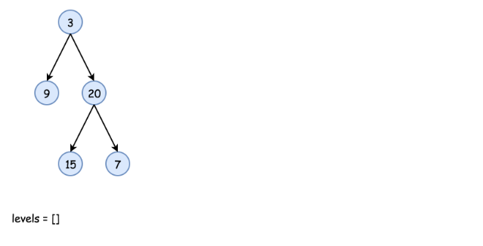

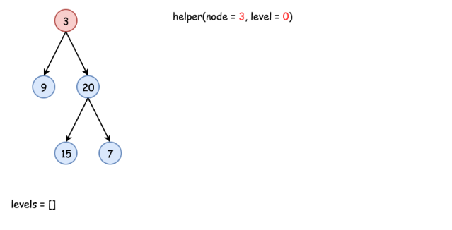

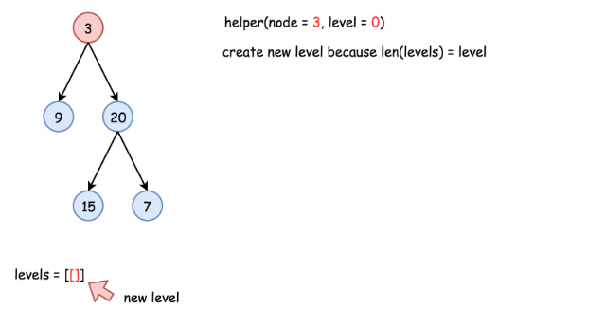

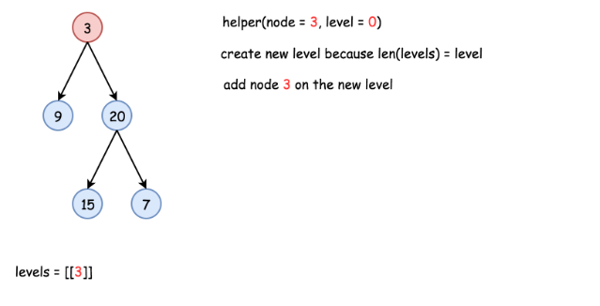

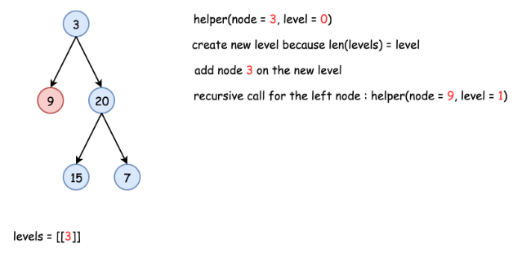

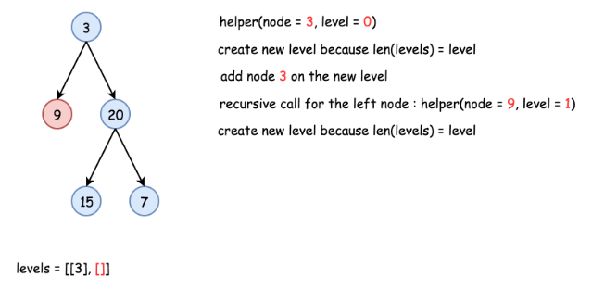

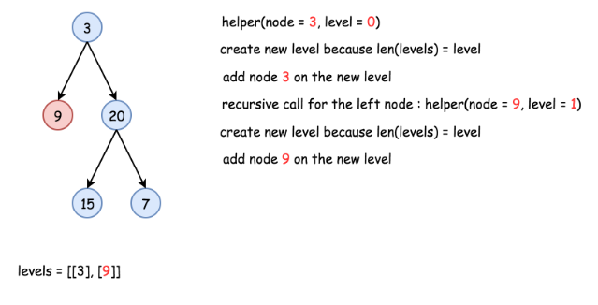

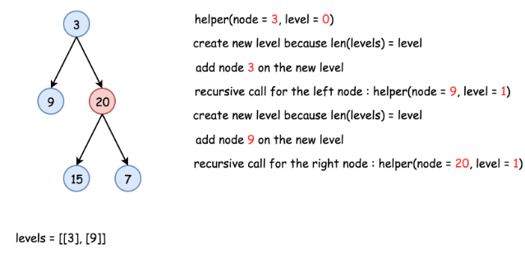

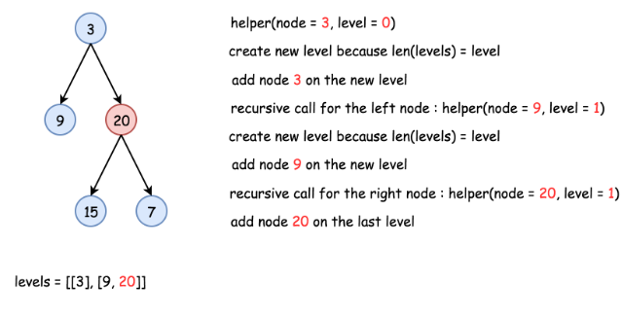

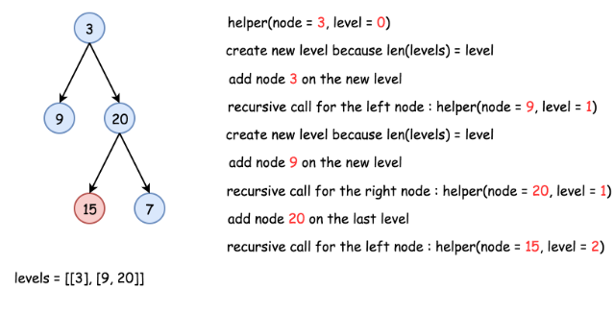

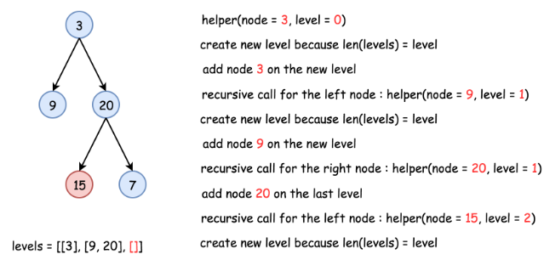

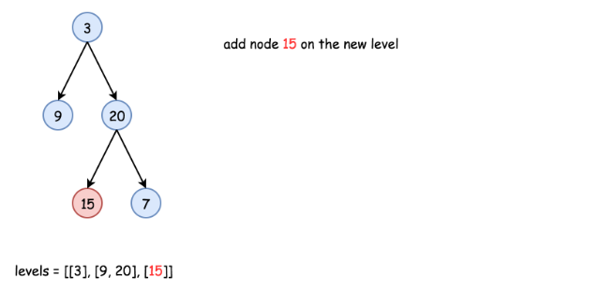

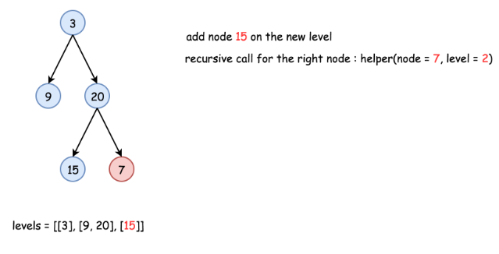

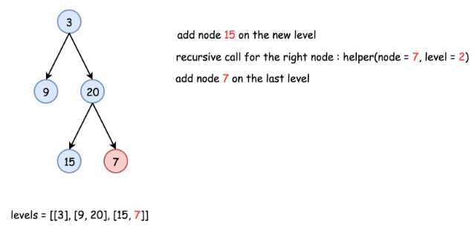

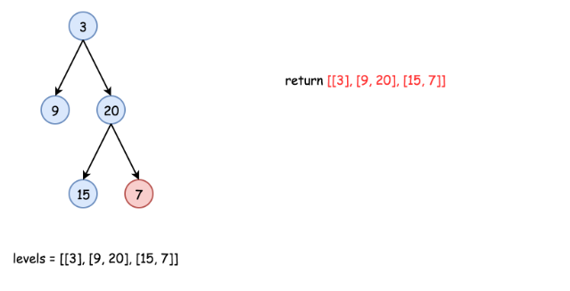

|  |
| --- |
| class Solution {  List<List<Integer>> levels = new ArrayList<List<Integer>>();  public void helper(TreeNode node, int level) {  // start the current level  if (levels.size() == level)  levels.add(new ArrayList<Integer>());  // fulfil the current level  levels.get(level).add(node.val);  // process child nodes for the next level  if (node.left != null)  helper(node.left, level + 1);  if (node.right != null)  helper(node.right, level + 1);  }    public List<List<Integer>> levelOrder(TreeNode root) {  if (root == null) return levels;  helper(root, 0);  return levels;  }  } |

**Complexity Analysis**

* Time complexity : O(*N*) since each node is processed exactly once.
* Space complexity : O(*N*) to keep the output structure which contains N node values.

#### **Approach 2: Iteration**

**Algorithm**

The recursion above could be rewritten in the iteration form.

Let's keep nodes of each tree level in the queue structure, which typically orders elements in a FIFO (first-in-first-out) manner. In Java one could use [LinkedList implementation of the Queue interface](https://docs.oracle.com/javase/7/docs/api/java/util/Queue.html). In Python using [Queue structure](https://docs.python.org/3/library/queue.html) would be an overkill since it's designed for a safe exchange between multiple threads and hence requires locking which leads to a performance loose. In Python the queue implementation with a fast atomic append() and popleft() is [deque](https://docs.python.org/3/library/collections.html#collections.deque).

The zero level contains only one node root. The algorithm is simple :

* Initiate queue with a root and start from the level number 0 : level = 0.
* While queue is not empty :
  + Start the current level by adding an empty list into output structure levels.
  + Compute how many elements should be on the current level : it's a queue length.
  + Pop out all these elements from the queue and add them into the current level.
  + Push their child nodes into the queue for the next level.
  + Go to the next level level++.

**Implementation**

|  |
| --- |
| class Solution {  public List<List<Integer>> levelOrder(TreeNode root) {  List<List<Integer>> levels = new ArrayList<List<Integer>>();  if (root == null) return levels;  Queue<TreeNode> queue = new LinkedList<TreeNode>();  queue.add(root);  int level = 0;  while ( !queue.isEmpty() ) {  // start the current level  levels.add(new ArrayList<Integer>());  // number of elements in the current level  int level_length = queue.size();  for(int i = 0; i < level_length; ++i) {  TreeNode node = queue.remove();  // fulfill the current level  levels.get(level).add(node.val);  // add child nodes of the current level  // in the queue for the next level  if (node.left != null) queue.add(node.left);  if (node.right != null) queue.add(node.right);  }  // go to next level  level++;  }  return levels;  }  } |

**Complexity Analysis**

* Time complexity : O(*N*) since each node is processed exactly once.
* Space complexity : O(*N*) to keep the output structure which contains N node values.

**Binary Tree Level Traversal - Solution**

We provide C++ and Java codes for your reference.

|  |
| --- |
| /**  * Definition for a binary tree node.  * public class TreeNode {  * int val;  * TreeNode left;  * TreeNode right;  * TreeNode(int x) { val = x; }  * }  */  class Solution {  public List<List<Integer>> levelOrder(TreeNode root) {  List<List<Integer>> ans = new ArrayList<>();  Queue<TreeNode> q = new LinkedList<>();  if (root != null) {  q.offer(root);  }  TreeNode cur;  while (!q.isEmpty()) {  int size = q.size();  List<Integer> subAns = new LinkedList<Integer>();  for (int i = 0; i < size; ++i) { // traverse nodes in the same level  cur = q.poll();  subAns.add(cur.val); // visit the root  if (cur.left != null) {  q.offer(cur.left); // push left child to queue if it is not null  }  if (cur.right != null) {  q.offer(cur.right); // push right child to queue if it is not null  }  }  ans.add(subAns);  }  return ans;  }  } |

Since each node in the tree will be pushed into the queue exactly once, the time complexity for level-order traversal is O(N), where N is the total number of nodes in the tree.

What about the space complexity? We have to maintain a queue to help us to do the traversal. And the size of the queue will be at most N because each node will be pushed into the queue exactly once. Therefore, the space complexity of level-order traversal is also O(N).

## Solve Problems Recursively

In previous sections, we have introduced how to solve tree traversal problem. And we tried to solve preorder, inorder and postorder traversal recursively.

Actually, recursion is one of the most powerful and frequently-used methods for solving tree related problems. We are going to introduce two typical recursive solutions for solving tree-related problems.

After completing this chapter, you should be able to solve basic recursion problems related to a binary tree by yourself.

**Solve Tree Problems Recursively**

In previous sections, we have introduced how to solve tree traversal problems recursively. Recursion is one of the most powerful and frequently used techniques for solving tree problems.

As we know, a tree can be defined recursively as a node(the root node) that includes a value and a list of references to children nodes. Recursion is one of the natural features of a tree. Therefore, many tree problems can be solved recursively. For each recursive function call, we only focus on the problem for the current node and call the function recursively to solve its children.

Typically, we can solve a tree problem recursively using a top-down approach or using a bottom-up approach.

### **"Top-down" Solution**

"Top-down" means that in each recursive call, we will visit the node first to come up with some values, and pass these values to its children when calling the function recursively. So the "top-down" solution can be considered as a kind of **preorder** traversal. To be specific, the recursive function top_down(root, params) works like this:

1. return specific value for null node

2. update the answer if needed // answer <-- params

3. left_ans = top_down(root.left, left_params) // left_params <-- root.val, params

4. right_ans = top_down(root.right, right_params) // right_params <-- root.val, params

5. return the answer if needed // answer <-- left_ans, right_ans

For instance, consider this problem: given a binary tree, find its maximum depth.

We know that the depth of the root node is 1. For each node, if we know its depth, we will know the depth of its children. Therefore, if we pass the depth of the node as a parameter when calling the function recursively, all the nodes will know their depth. And for leaf nodes, we can use the depth to update the final answer. Here is the pseudocode for the recursive function maximum_depth(root, depth):

1. return if root is null

2. if root is a leaf node:

3. answer = max(answer, depth) // update the answer if needed

4. maximum_depth(root.left, depth + 1) // call the function recursively for left child

5. maximum_depth(root.right, depth + 1) // call the function recursively for right child

Here is an example to help you understand how it works:

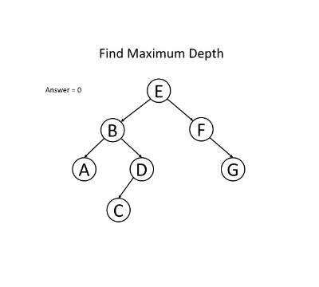 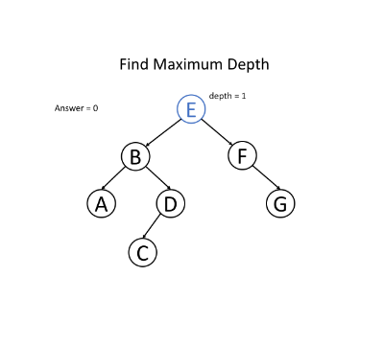

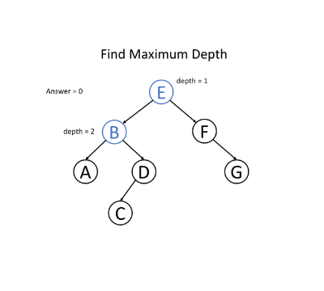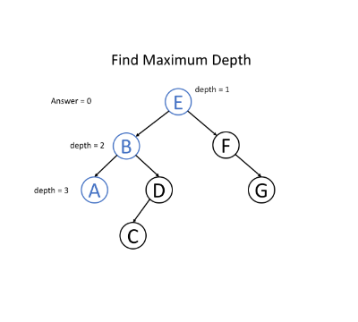

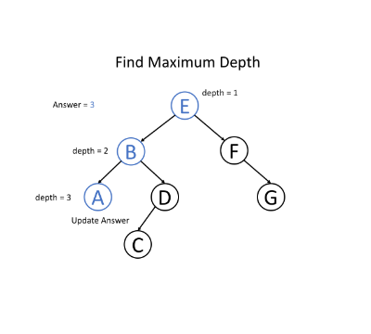 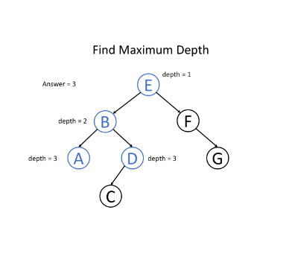 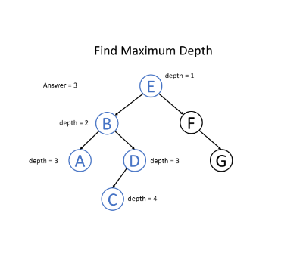 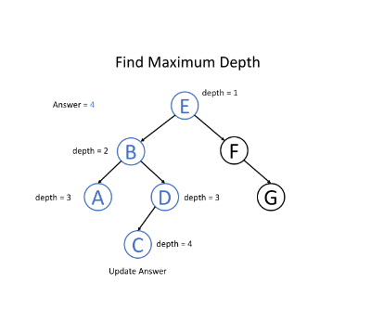

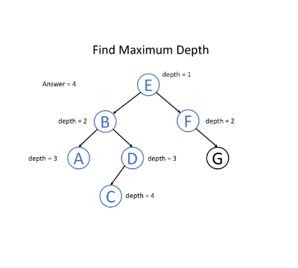 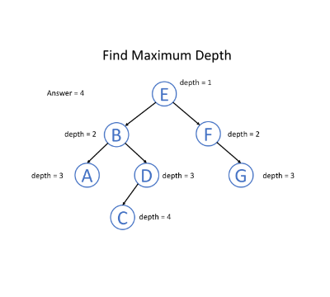

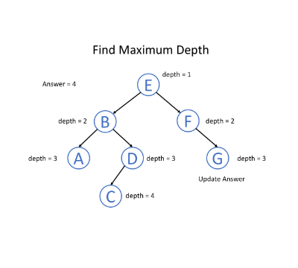 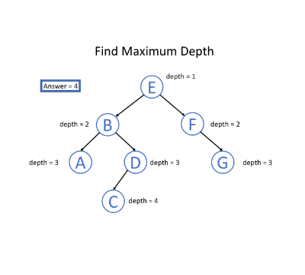

|  |
| --- |
| private int answer; // don't forget to initialize answer before call maximum_depth  private void maximum_depth(TreeNode root, int depth) {  if (root == null) {  return;  }  if (root.left == null && root.right == null) {  answer = Math.max(answer, depth);  }  maximum_depth(root.left, depth + 1);  maximum_depth(root.right, depth + 1);  } |

### **"Bottom-up" Solution**

"Bottom-up" is another recursive solution. In each recursive call, we will firstly call the function recursively for all the children nodes and then come up with the answer according to the returned values and the value of the current node itself. This process can be regarded as a kind of **postorder** traversal. Typically, a "bottom-up" recursive function bottom_up(root) will be something like this:

1. return specific value for null node

2. left_ans = bottom_up(root.left) // call function recursively for left child

3. right_ans = bottom_up(root.right) // call function recursively for right child

4. return answers // answer <-- left_ans, right_ans, root.val

Let's go on discussing the question about maximum depth but using a different way of thinking: for a single node of the tree, what will be the maximum depth x of the subtree rooted at itself?

If we know the maximum depth l of the subtree rooted at its **left** child and the maximum depth r of the subtree rooted at its **right** child, can we answer the previous question? Of course yes, we can choose the maximum between them and add 1 to get the maximum depth of the subtree rooted at the current node. That is x = max(l, r) + 1.

It means that for each node, we can get the answer after solving the problem for its children. Therefore, we can solve this problem using a "bottom-up" solution. Here is the pseudocode for the recursive function maximum_depth(root):

1. return 0 if root is null // return 0 for null node

2. left_depth = maximum_depth(root.left)

3. right_depth = maximum_depth(root.right)

4. return max(left_depth, right_depth) + 1 // return depth of the subtree rooted at root

Here is an example to help you understand how it works:

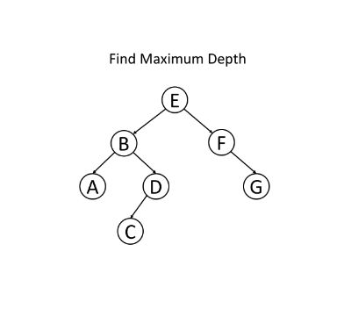 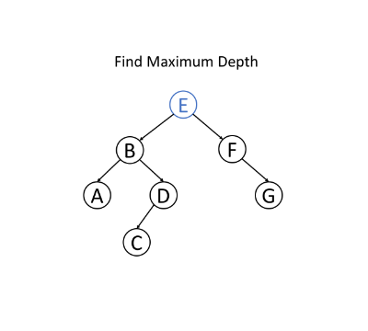

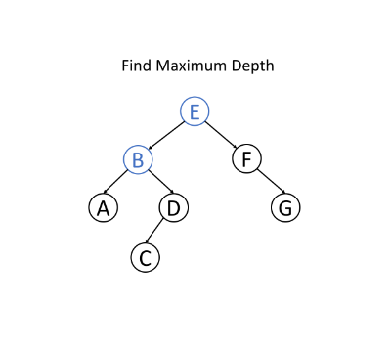 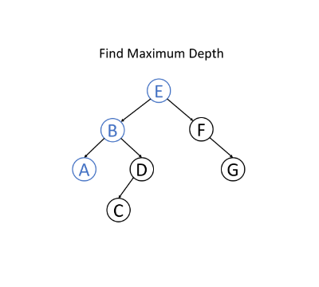

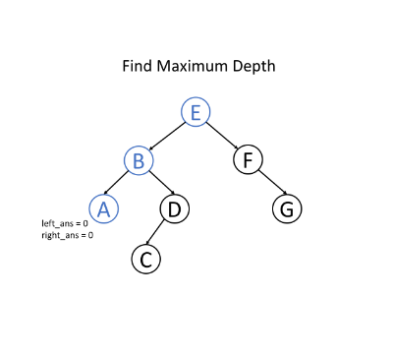 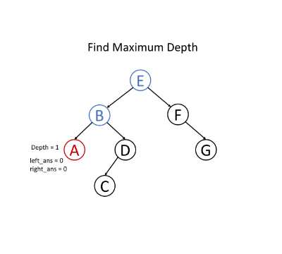

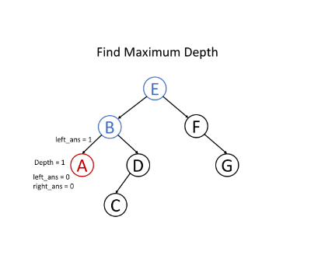 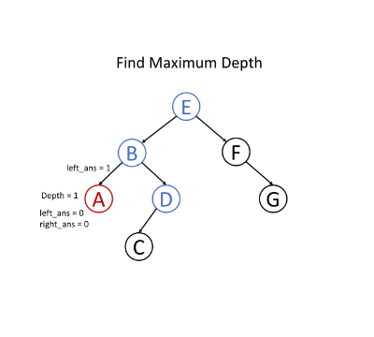

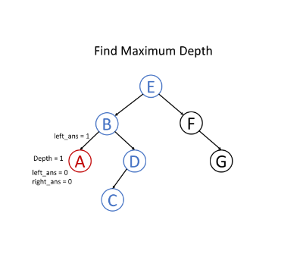 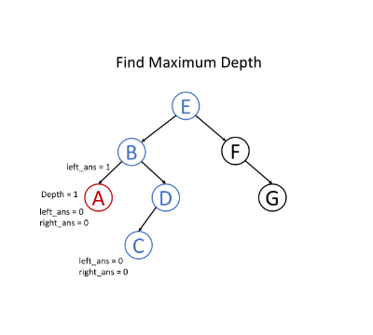

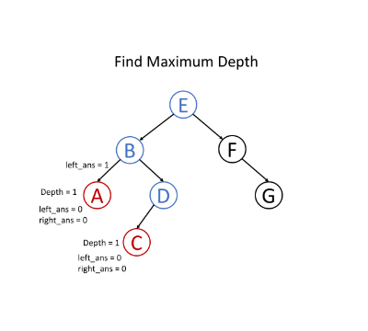 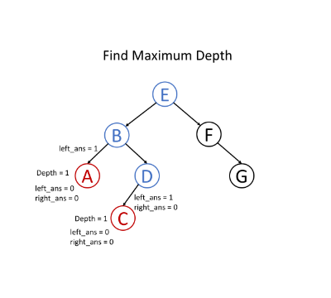

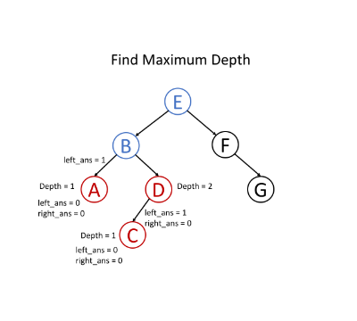 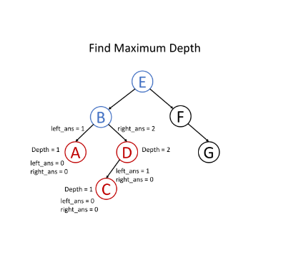

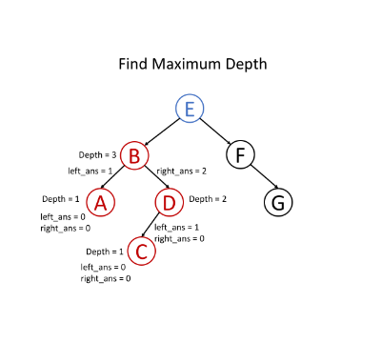 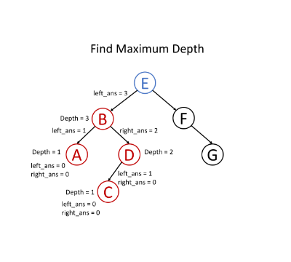

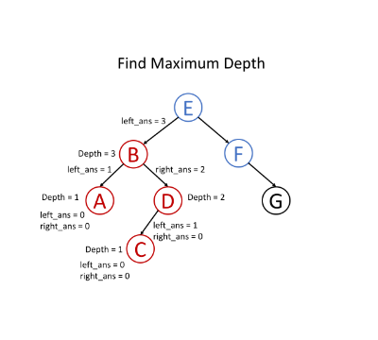 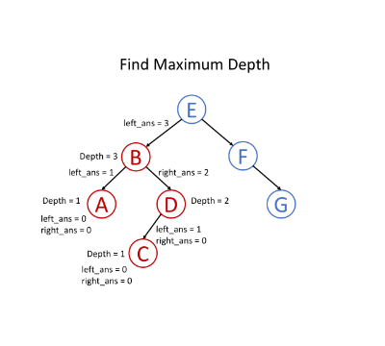

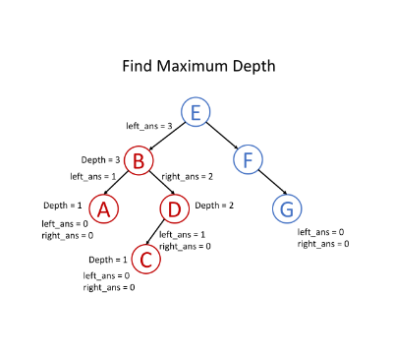 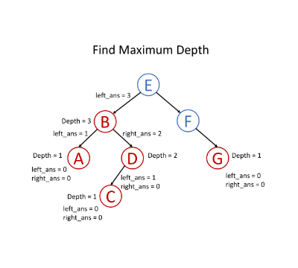

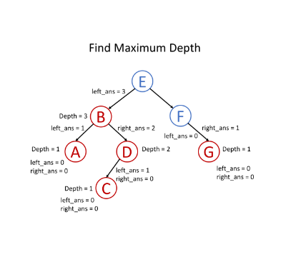 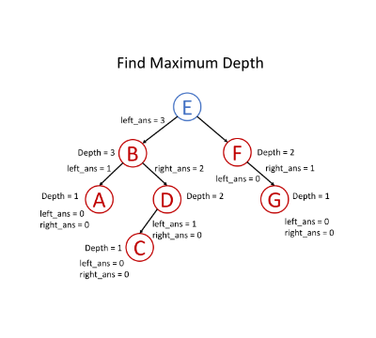

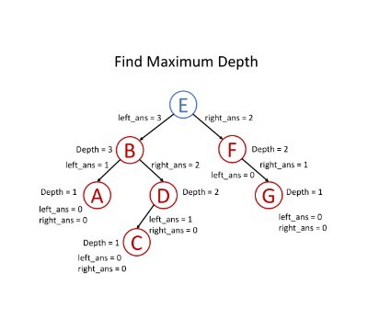 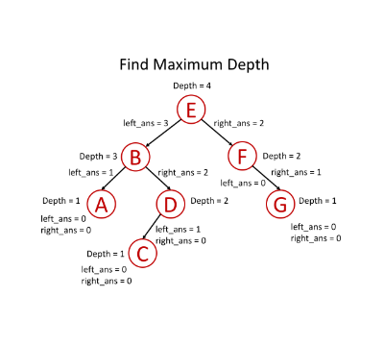

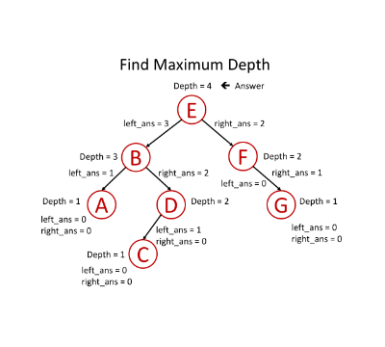

|  |
| --- |
| public int maximum_depth(TreeNode root) {  if (root == null) {  return 0; // return 0 for null node  }  int left_depth = maximum_depth(root.left);  int right_depth = maximum_depth(root.right);  return Math.max(left_depth, right_depth) + 1; // return depth of the subtree rooted at root  } |

### **Conclusion**

It is not easy to understand recursion and find out a recursive solution for the problem. It needs practice.

When you meet a tree problem, ask yourself two questions: Can you determine some parameters to help the node know its answer? Can you use these parameters and the value of the node itself to determine what should be the parameters passed to its children? If the answers are both yes, try to solve this problem using a "top-down" recursive solution.

Or, you can think of the problem in this way: for a node in a tree, if you know the answer of its children, can you calculate the answer of that node? If the answer is yes, solving the problem recursively using a bottom up approach might be a good idea.

In the following sections, we provide several classic problems for you to help you understand tree structure and recursion better.

**Maximum Depth of Binary Tree**

Given the root of a binary tree, return *its maximum depth*.

A binary tree's **maximum depth** is the number of nodes along the longest path from the root node down to the farthest leaf node.

**Example 1:**

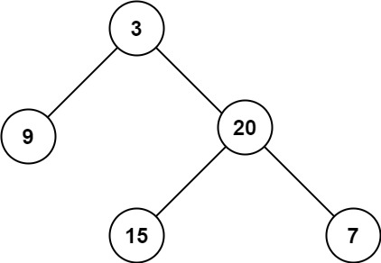

**Input:** root = [3,9,20,null,null,15,7]

**Output:** 3

**Example 2:**

**Input:** root = [1,null,2]

**Output:** 2

**Example 3:**

**Input:** root = []

**Output:** 0

**Example 4:**

**Input:** root = [0]

**Output:** 1

**Constraints:**

* The number of nodes in the tree is in the range [0, 104].
* -100 <= Node.val <= 100

## Solution

**Tree definition**

First of all, here is the definition of the TreeNode which we would use.

|  |
| --- |
| /* Definition for a binary tree node. */  public class TreeNode {  int val;  TreeNode left;  TreeNode right;  TreeNode(int x) {  val = x;  }  } |

#### **Approach 1: Recursion**

**Intuition** By definition, the maximum depth of a binary tree is the maximum number of steps to reach a leaf node from the root node.

From the definition, an intuitive idea would be to traverse the tree and record the maximum depth during the traversal.

**Algorithm**

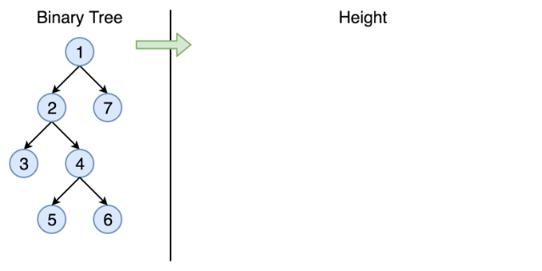

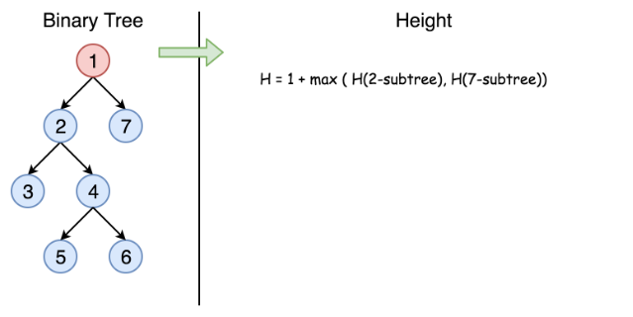

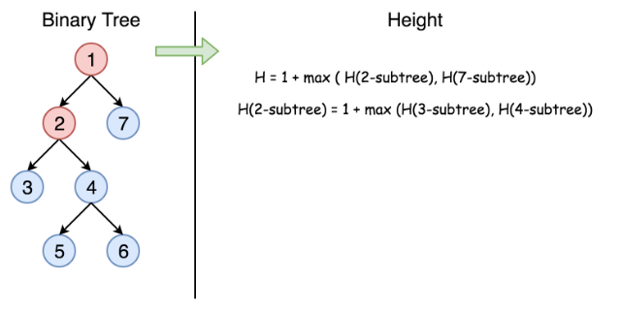

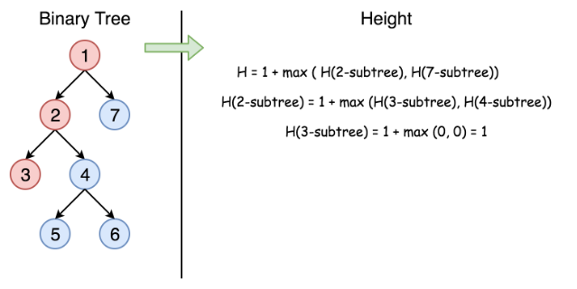

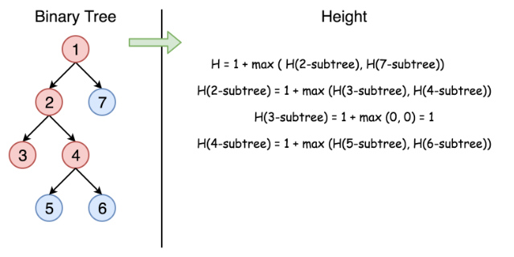

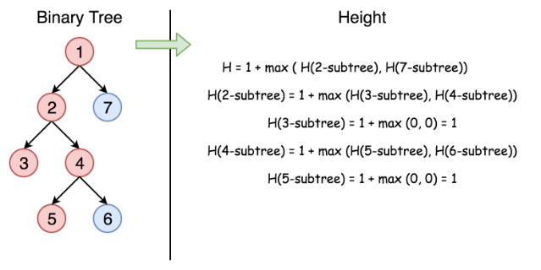

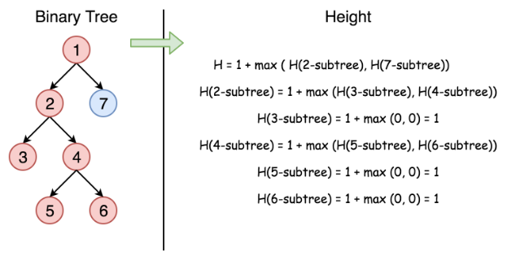

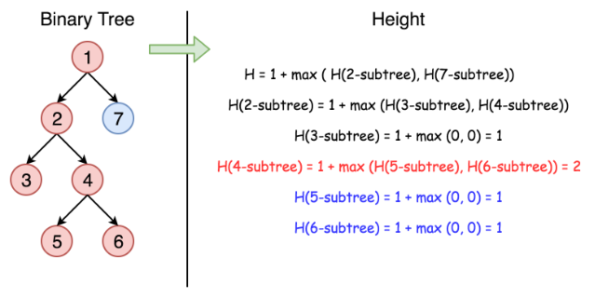

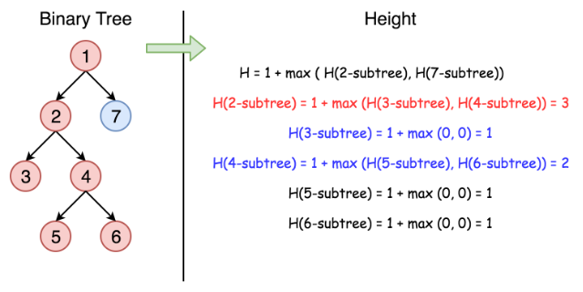

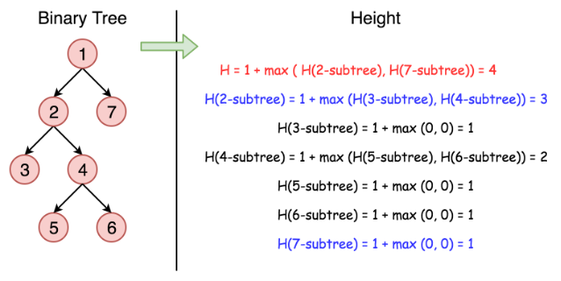

One could traverse the tree either by Depth-First Search (DFS) strategy or Breadth-First Search (BFS) strategy. For this problem, either way would do. Here we demonstrate a solution that is implemented with the **DFS** strategy and **recursion**.

|  |
| --- |
| class Solution {  public int maxDepth(TreeNode root) {  if (root == null) {  return 0;  } else {  int left_height = maxDepth(root.left);  int right_height = maxDepth(root.right);  return java.lang.Math.max(left_height, right_height) + 1;  }  }  } |

**Complexity analysis**

* Time complexity : we visit each node exactly once, thus the time complexity is O(*N*), where *N* is the number of nodes.
* Space complexity : in the worst case, the tree is completely unbalanced, *e.g.* each node has only left child node, the recursion call would occur *N* times (the height of the tree), therefore the storage to keep the call stack would be O(*N*). But in the best case (the tree is completely balanced), the height of the tree would be \log(N)log(*N*). Therefore, the space complexity in this case would be O(log(*N*)).

#### **Approach 2: Tail Recursion + BFS**

One might have noticed that the above recursion solution is probably not the most optimal one in terms of the space complexity, and in the extreme case the overhead of call stack might even lead to stack overflow.

To address the issue, one can tweak the solution a bit to make it **tail recursion**, which is a specific form of recursion where the recursive call is the last action in the function.

The benefit of having tail recursion, is that for certain programming languages (e.g. C++) the compiler could optimize the memory allocation of call stack by reusing the same space for every recursive call, rather than creating the space for each one. As a result, one could obtain the constant space complexity O(1) for the overhead of the recursive calls.

Here is a sample solution. Note that the optimization of tail recursion is not supported by Python or Java.

|  |
| --- |
| class Solution {  private:  // The queue that contains the next nodes to visit,  // along with the level/depth that each node is located.  queue<pair<TreeNode*, int>> next_items;  int max_depth = 0;    /**  * A tail recursion function to calculate the max depth  * of the binary tree.  */  int next_maxDepth() {    if (next_items.size() == 0) {  return max_depth;  }    auto next_item = next_items.front();  next_items.pop();  auto next_node = next_item.first;  auto next_level = next_item.second + 1;    max_depth = max(max_depth, next_level);  // Add the nodes to visit in the following recursive calls.  if (next_node->left != NULL) {  next_items.push(make_pair(next_node->left, next_level));  }  if (next_node->right != NULL) {  next_items.push(make_pair(next_node->right, next_level));  }    // The last action should be the ONLY recursive call  // in the tail-recursion function.  return next_maxDepth();  }    public:  int maxDepth(TreeNode* root) {  if (root == NULL) return 0;    // clear the previous queue.  std::queue<pair<TreeNode*, int>> empty;  std::swap(next_items, empty);  max_depth = 0;    // push the root node into the queue to kick off the next visit.  next_items.push(make_pair(root, 0));    return next_maxDepth();  }  }; |

**Complexity analysis**

* Time complexity : O(*N*), still we visit each node once and only once.
* Space complexity : , *i.e.* the maximum number of nodes at the same level (the number of leaf nodes in a full binary tree), since we traverse the tree in the **BFS** manner.

As one can see, this probably is not the best example to apply the *tail recursion* technique. Because though we did gain the constant space complexity for the recursive calls, we pay the price of O(*N*) complexity to maintain the state information for recursive calls. This defeats the purpose of applying tail recursion.

However, we would like to stress on the point that tail recursion is a useful form of recursion that could eliminate the space overhead incurred by the recursive function calls.

*Note: a function cannot be tail recursion if there are multiple occurrences of recursive calls in the function, even if the last action is the recursive call.* Because the system has to maintain the function call stack for the sub-function calls that occur within the same function.

#### **Approach 3: Iteration**

**Intuition**

We could also convert the above recursion into iteration, with the help of the stack data structure. Similar with the behaviors of the function call stack, the stack data structure follows the pattern of FILO (First-In-Last-Out), i.e. the last element that is added to a stack would come out first.

With the help of the stack data structure, one could mimic the behaviors of function call stack that is involved in the recursion, to convert a recursive function to a function with iteration.

**Algorithm**

The idea is to keep the next nodes to visit in a stack. Due to the FILO behavior of stack, one would get the order of visit same as the one in recursion.

We start from a stack which contains the root node and the corresponding depth which is 1. Then we proceed to the iterations: pop the current node out of the stack and push the child nodes. The depth is updated at each step.

|  |
| --- |
| class Solution {  public int maxDepth(TreeNode root) {  LinkedList<TreeNode> stack = new LinkedList<>();  LinkedList<Integer> depths = new LinkedList<>();  if (root == null) return 0;  stack.add(root);  depths.add(1);  int depth = 0, current_depth = 0;  while(!stack.isEmpty()) {  root = stack.pollLast();  current_depth = depths.pollLast();  if (root != null) {  depth = Math.max(depth, current_depth);  stack.add(root.left);  stack.add(root.right);  depths.add(current_depth + 1);  depths.add(current_depth + 1);  }  }  return depth;  }  }; |

**Complexity analysis**

* Time complexity : O(*N*).
* Space complexity : in the worst case, the tree is completely unbalanced, *e.g.* each node has only left child node, the recursion call would occur *N* times (the height of the tree), therefore the storage to keep the call stack would be O(*N*). But in the average case (the tree is balanced), the height of the tree would be log(*N*). Therefore, the space complexity in this case would be O(log(*N*)).

**Symmetric Tree**

Given a binary tree, check whether it is a mirror of itself (ie, symmetric around its center).

For example, this binary tree [1,2,2,3,4,4,3] is symmetric:

1

/ \

2 2

/ \ / \

3 4 4 3

But the following [1,2,2,null,3,null,3] is not:

1

/ \

2 2

\ \

3 3

**Follow up:** Solve it both recursively and iteratively.

## Solution

#### **Approach 1: Recursive**

A tree is symmetric if the left subtree is a mirror reflection of the right subtree.

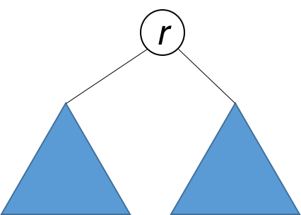

Therefore, the question is: when are two trees a mirror reflection of each other?

Two trees are a mirror reflection of each other if:

1. Their two roots have the same value.
2. The right subtree of each tree is a mirror reflection of the left subtree of the other tree.

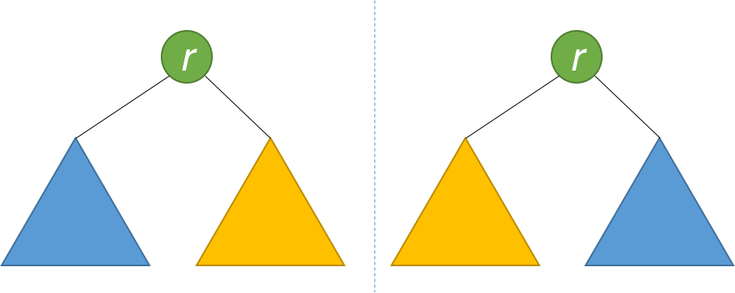

This is like a person looking at a mirror. The reflection in the mirror has the same head, but the reflection's right arm corresponds to the actual person's left arm, and vice versa.

The explanation above translates naturally to a recursive function as follows.

|  |
| --- |
| public boolean isSymmetric(TreeNode root) {  return isMirror(root, root);  }  public boolean isMirror(TreeNode t1, TreeNode t2) {  if (t1 == null && t2 == null) return true;  if (t1 == null || t2 == null) return false;  return (t1.val == t2.val)  && isMirror(t1.right, t2.left)  && isMirror(t1.left, t2.right);  } |

**Complexity Analysis**

* Time complexity : *O*(*n*). Because we traverse the entire input tree once, the total run time is *O*(*n*), where *n* is the total number of nodes in the tree.
* Space complexity : The number of recursive calls is bound by the height of the tree. In the worst case, the tree is linear and the height is in *O*(*n*). Therefore, space complexity due to recursive calls on the stack is *O*(*n*) in the worst case.

#### **Approach 2: Iterative**

Instead of recursion, we can also use iteration with the aid of a queue. Each two consecutive nodes in the queue should be equal, and their subtrees a mirror of each other. Initially, the queue contains root and root. Then the algorithm works similarly to BFS, with some key differences. Each time, two nodes are extracted and their values compared. Then, the right and left children of the two nodes are inserted in the queue in opposite order. The algorithm is done when either the queue is empty, or we detect that the tree is not symmetric (i.e. we pull out two consecutive nodes from the queue that are unequal).

|  |
| --- |
| public boolean isSymmetric(TreeNode root) {  Queue<TreeNode> q = new LinkedList<>();  q.add(root);  q.add(root);  while (!q.isEmpty()) {  TreeNode t1 = q.poll();  TreeNode t2 = q.poll();  if (t1 == null && t2 == null) continue;  if (t1 == null || t2 == null) return false;  if (t1.val != t2.val) return false;  q.add(t1.left);  q.add(t2.right);  q.add(t1.right);  q.add(t2.left);  }  return true;  } |

**Complexity Analysis**

* Time complexity : *O*(*n*). Because we traverse the entire input tree once, the total run time is *O*(*n*), where *n* is the total number of nodes in the tree.
* Space complexity : There is additional space required for the search queue. In the worst case, we have to insert *O*(*n*) nodes in the queue. Therefore, space complexity is *O*(*n*).

**Path Sum**

Given the root of a binary tree and an integer targetSum, return true if the tree has a **root-to-leaf** path such that adding up all the values along the path equals targetSum.

A **leaf** is a node with no children.

**Example 1:**

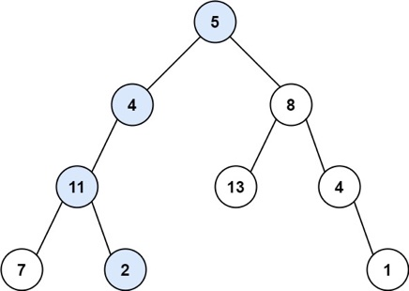

**Input:** root = [5,4,8,11,null,13,4,7,2,null,null,null,1], targetSum = 22

**Output:** true

**Example 2:**

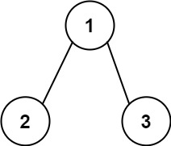

**Input:** root = [1,2,3], targetSum = 5

**Output:** false

**Example 3:**

**Input:** root = [1,2], targetSum = 0

**Output:** false

**Constraints:**

* The number of nodes in the tree is in the range [0, 5000].
* -1000 <= Node.val <= 1000
* -1000 <= targetSum <= 1000

## Solution

#### **Binary tree definition**

First of all, here is the definition of the TreeNode which we would use in the following implementation.

|  |
| --- |
| /* Definition for a binary tree node. */  public class TreeNode {  int val;  TreeNode left;  TreeNode right;  TreeNode(int x) {  val = x;  }  } |

#### **Approach 1: Recursion**

The most intuitive way is to use a recursion here. One is going through the tree by considering at each step the node itself and its children. If node is not a leaf, one calls recursively hasPathSum method for its children with a sum decreased by the current node value. If node is a leaf, one checks if the current sum is zero, i.e if the initial sum was discovered.

|  |
| --- |
| class Solution {  public boolean hasPathSum(TreeNode root, int sum) {  if (root == null)  return false;  sum -= root.val;  if ((root.left == null) && (root.right == null))  return (sum == 0);  return hasPathSum(root.left, sum) || hasPathSum(root.right, sum);  }  } |

**Complexity Analysis**

* Time complexity : we visit each node exactly once, thus the time complexity is O(*N*), where *N* is the number of nodes.
* Space complexity : in the worst case, the tree is completely unbalanced, *e.g.* each node has only one child node, the recursion call would occur *N* times (the height of the tree), therefore the storage to keep the call stack would be O(*N*). But in the best case (the tree is completely balanced), the height of the tree would be log(*N*). Therefore, the space complexity in this case would be O(log(*N*)).

#### **Approach 2: Iterations**

**Algorithm**

We could also convert the above recursion into iteration, with the help of stack. DFS would be better than BFS here since it works faster except the worst case. In the worst case the path root->leaf with the given sum is the last considered one and in this case DFS results in the same productivity as BFS.

The idea is to visit each node with the DFS strategy, while updating the remaining sum to cumulate at each visit.

So we start from a stack which contains the root node and the corresponding remaining sum which is sum - root.val. Then we proceed to the iterations: pop the current node out of the stack and return True if the remaining sum is 0 and we're on the leaf node. If the remaining sum is not zero or we're not on the leaf yet then we push the child nodes and corresponding remaining sums into stack.

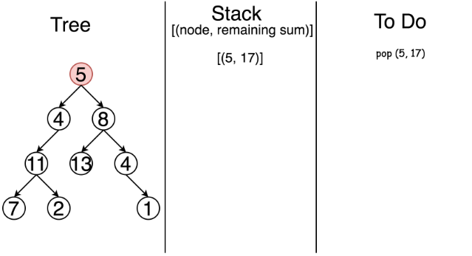

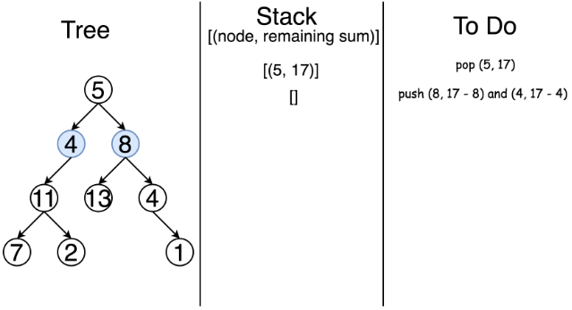

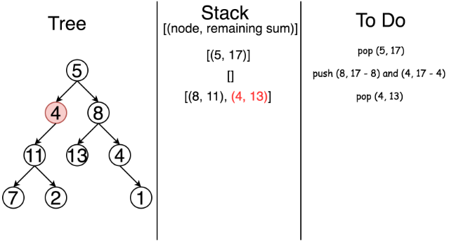

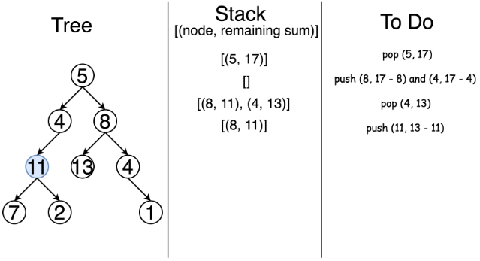

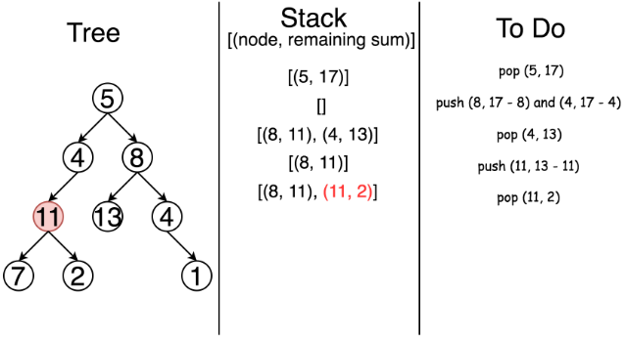

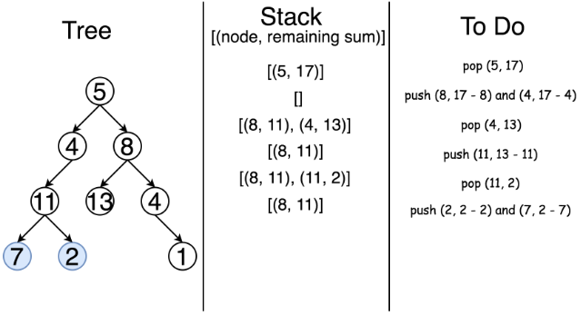

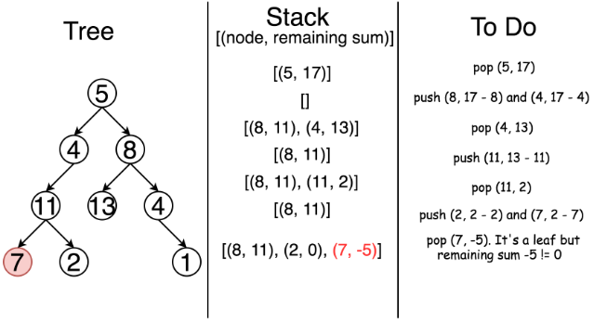

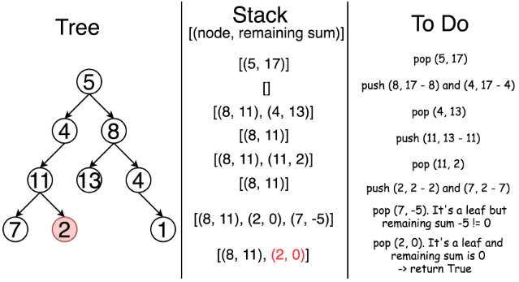

|  |
| --- |
| class Solution {  public boolean hasPathSum(TreeNode root, int sum) {  if (root == null)  return false;  LinkedList<TreeNode> node_stack = new LinkedList();  LinkedList<Integer> sum_stack = new LinkedList();  node_stack.add(root);  sum_stack.add(sum - root.val);  TreeNode node;  int curr_sum;  while ( !node_stack.isEmpty() ) {  node = node_stack.pollLast();  curr_sum = sum_stack.pollLast();  if ((node.right == null) && (node.left == null) && (curr_sum == 0))  return true;  if (node.right != null) {  node_stack.add(node.right);  sum_stack.add(curr_sum - node.right.val);  }  if (node.left != null) {  node_stack.add(node.left);  sum_stack.add(curr_sum - node.left.val);  }  }  return false;  }  } |

**Complexity Analysis**

* Time complexity : the same as the recursion approach O(*N*).
* Space complexity : O(*N*) since in the worst case, when the tree is completely unbalanced, *e.g.* each node has only one child node, we would keep all *N* nodes in the stack. But in the best case (the tree is balanced), the height of the tree would be log(*N*). Therefore, the space complexity in this case would be O(log(*N*)).

**Count Univalue Subtrees**

Given the root of a binary tree, return the number of **uni-value** subtrees.

A **uni-value subtree** means all nodes of the subtree have the same value.

**Example 1:**

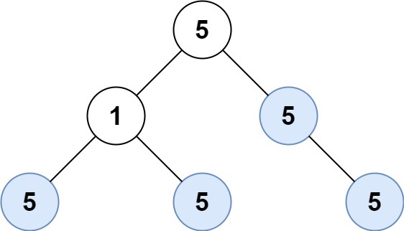

**Input:** root = [5,1,5,5,5,null,5]

**Output:** 4

**Example 2:**

**Input:** root = []

**Output:** 0

**Example 3:**

**Input:** root = [5,5,5,5,5,null,5]

**Output:** 6

**Constraints:**

* The numbrt of the node in the tree will be in the range [0, 1000].
* -1000 <= Node.val <= 1000

## Solution

#### **Approach 1: Depth First Search**

**Intuition**

Given a node in our tree, we know that it is a univalue subtree if it meets one of the following criteria:

1. The node has no children (base case)
2. All of the node's children are univalue subtrees, and the node and its children all have the same value

With this in mind we can perform a depth-first-search on our tree, and test if each subtree is uni-value in a bottom-up manner.

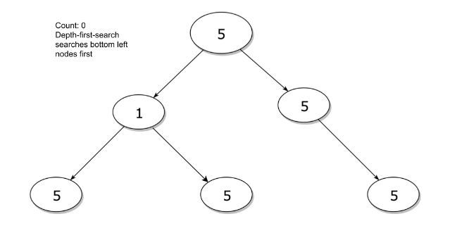

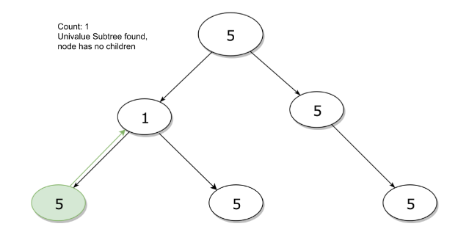

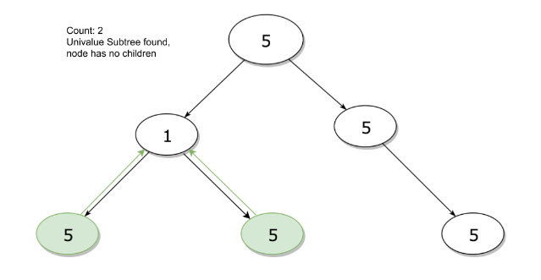

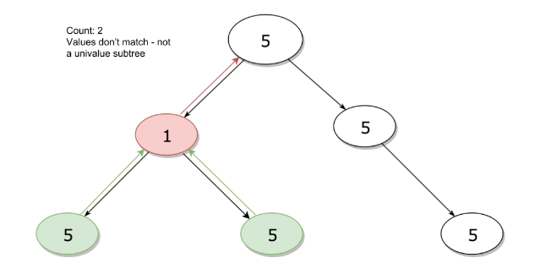

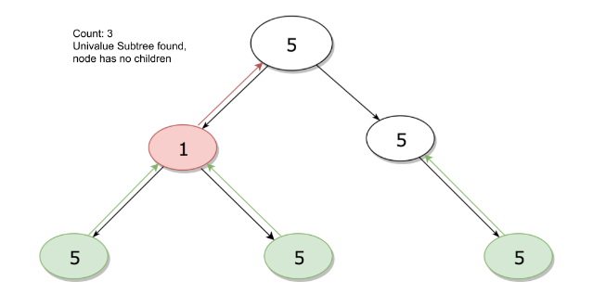

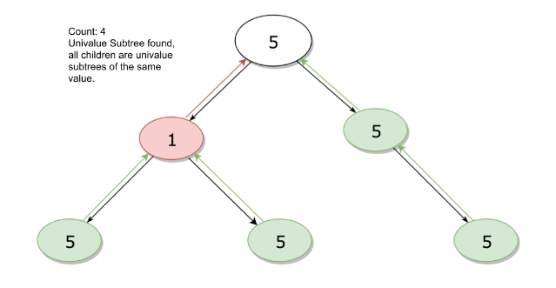

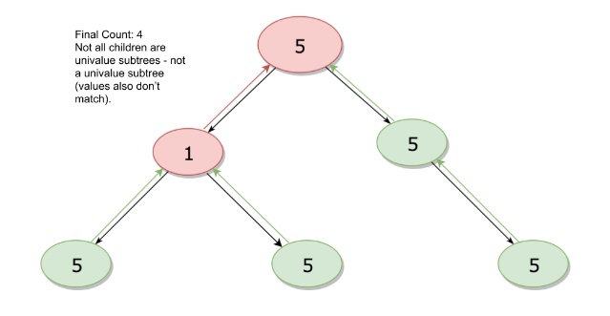

|  |
| --- |
| public class Solution {  int count = 0;  boolean is_uni(TreeNode node) {  //base case - if the node has no children this is a univalue subtree  if (node.left == null && node.right == null) {  // found a univalue subtree - increment  count++;  return true;  }  boolean is_unival = true;  // check if all of the node's children are univalue subtrees and if they have the same value  // also recursively call is_uni for children  if (node.left != null) {  is_unival = is_uni(node.left) && is_unival && node.left.val == node.val;  }  if (node.right != null) {  is_unival = is_uni(node.right) && is_unival && node.right.val == node.val;  }  // return if a univalue tree exists here and increment if it does  if (!is_unival) return false;  count++;  return true;  }  public int countUnivalSubtrees(TreeNode root) {  if (root == null) return 0;  is_uni(root);  return count;  }  } |

**Complexity Analysis**

* Time complexity : *O*(*n*).

Due to the algorithm's depth-first nature, the is_uni status of each node is computed from bottom up. When given the is_uni status of its children, computing the is_uni status of a node occurs in *O*(1)

This gives us *O*(1) time for each node in the tree with *O*(*N*) total nodes for a time complexity of *O*(*N*)

* Space complexity : *O*(*H*), with H being the height of the tree. Each recursive call of is_uni requires stack space. Since we fully process is_uni(node.left) before calling is_uni(node.right), the recursive stack is bound by the longest path from the root to a leaf - in other words the height of the tree.

#### **Approach 2: Depth First Search - Pass Parent Values**

**Algorithm**

We can use the intuition from approach one to further simplify our algorithm. Instead of checking if a node has no children, we treat null values as univalue subtrees that we don't add to the count.

In this manner, if a node has a null child, that child is automatically considered to a valid subtree, which results in the algorithm only checking if other children are invalid.

Finally, the helper function checks if the current node is a valid subtree but returns a boolean indicating if it is a valid component for its parent. This is done by passing in the value of the parent node.

|  |
| --- |
| public class Solution {  int count = 0;  boolean is_valid_part(TreeNode node, int val) {  // considered a valid subtree  if (node == null) return true;  // check if node.left and node.right are univalue subtrees of value node.val  // note that || short circuits but | does not - both sides of the or get evaluated with | so we explore all possible routes  if (!is_valid_part(node.left, node.val) | !is_valid_part(node.right, node.val)) return false;  // if it passed the last step then this a valid subtree - increment  count++;  // at this point we know that this node is a univalue subtree of value node.val  // pass a boolean indicating if this is a valid subtree for the parent node  return node.val == val;  }  public int countUnivalSubtrees(TreeNode root) {  is_valid_part(root, 0);  return count;  }  } |

The above code is a commented version of the code [here](https://leetcode.com/problems/count-univalue-subtrees/discuss/67602/Java-11-lines-added), originally written by [Stefan Pochmann](https://leetcode.com/stefanpochmann/).

**Complexity Analysis**

* Time complexity : *O*(*N*). Same as the previous approach.
* Space complexity : *O*(*H*), with H being the height of the tree. Same as the previous approach.

## Conclusion

After finishing the previous chapters, you should be familiar with binary trees be able to solve basic problems related to them.

In this chapter, we are going to provide you more exercise to help you be more confident with this topic.

**Construct Binary Tree from Inorder and Postorder Traversal**

Given inorder and postorder traversal of a tree, construct the binary tree.

**Note:**  
You may assume that duplicates do not exist in the tree.

For example, given

inorder = [9,3,15,20,7]

postorder = [9,15,7,20,3]

Return the following binary tree:

3

/ \

9 20

/ \

15 7

## Solution

#### **How to traverse the tree**

There are two general strategies to traverse a tree:

* Depth First Search (DFS)

In this strategy, we adopt the depth as the priority, so that one would start from a root and reach all the way down to certain leaf, and then back to root to reach another branch.

The DFS strategy can further be distinguished as preorder, inorder, and postorder depending on the relative order among the root node, left node and right node.

* Breadth First Search (BFS)

We scan through the tree level by level, following the order of height, from top to bottom. The nodes on higher level would be visited before the ones with lower levels.

On the following figure the nodes are enumerated in the order you visit them, please follow 1-2-3-4-5 to compare different strategies.

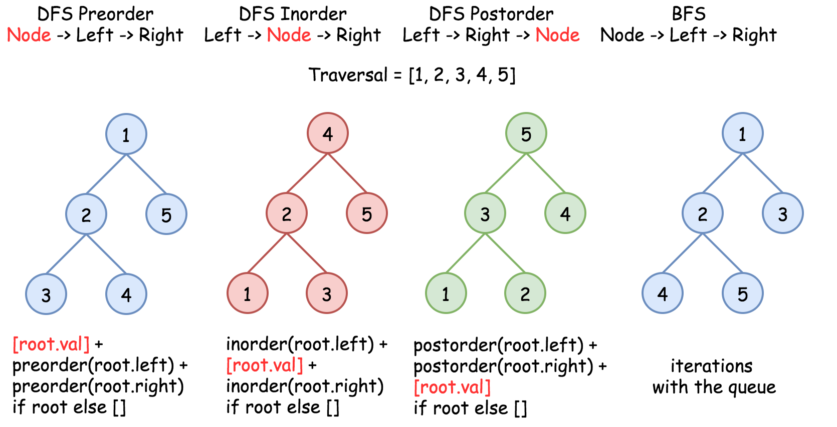

In this problem one deals with inorder and postorder traversals.

#### **Approach 1: Recursion**

**How to construct the tree from two traversals: inorder and preorder/postorder/etc**

Problems like this one are often at Facebook interviews, and could be solved in O(*N*) time:

* Start from not inorder traversal, usually it's preorder or postorder one, and use the traversal picture above to define the strategy to pick the nodes. For example, for preorder traversal the first value is a root, then its left child, then its right child, etc. For postorder traversal the last value is a root, then its right child, then its left child, etc.
* The value picked from preorder/postorder traversal splits the inorder traversal into left and right subtrees. The only information one needs from inorder - if the current subtree is empty (= return None) or not (= continue to construct the subtree).

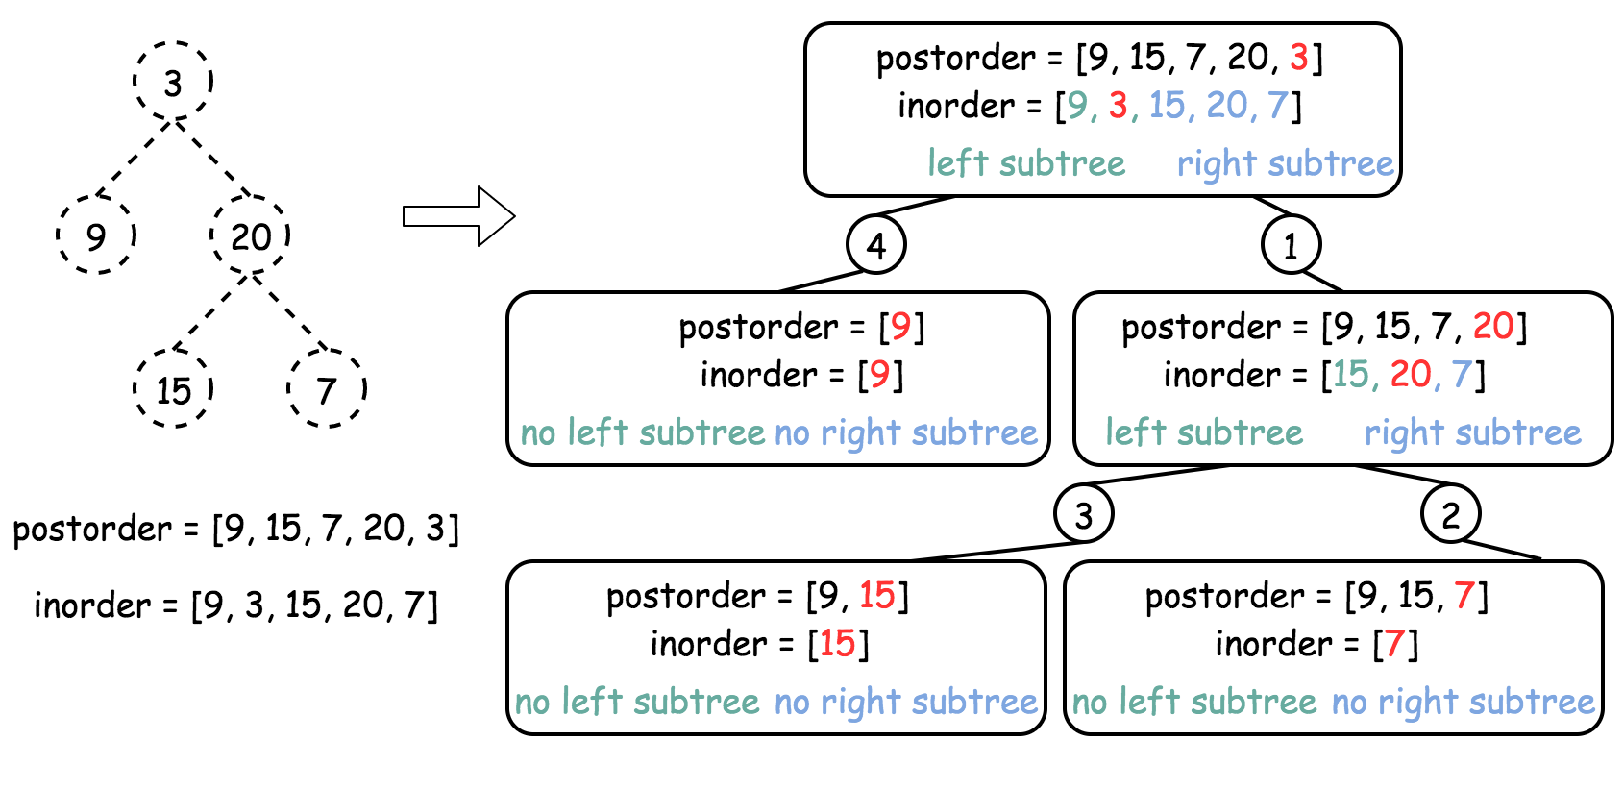

**Algorithm**

* Build hashmap value -> its index for inorder traversal.
* Return helper function which takes as the arguments the left and right boundaries for the current subtree in the inorder traversal. These boundaries are used only to check if the subtree is empty or not. Here is how it works helper(in_left = 0, in_right = n - 1):
  + If in_left > in_right, the subtree is empty, return None.
  + Pick the last element in postorder traversal as a root.
  + Root value has index index in the inorder traversal, elements from in_left to index - 1 belong to the left subtree, and elements from index + 1 to in_right belong to the right subtree.
  + Following the postorder logic, proceed recursively first to construct the right subtree helper(index + 1, in_right) and then to construct the left subtree helper(in_left, index - 1).
  + Return root.

**Implementation**

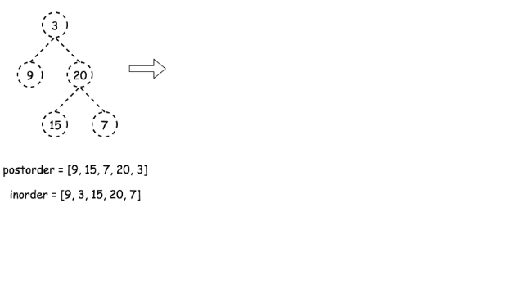 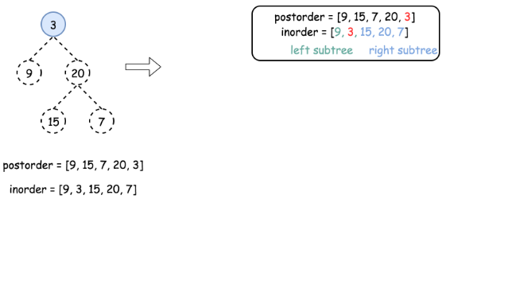

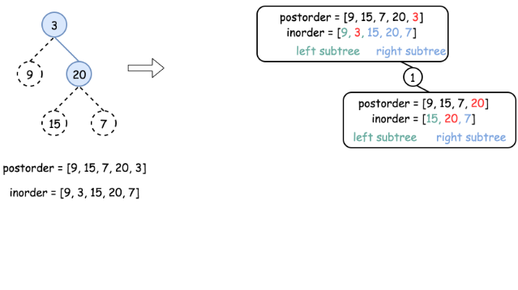

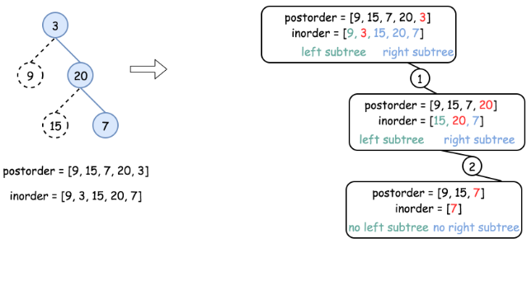

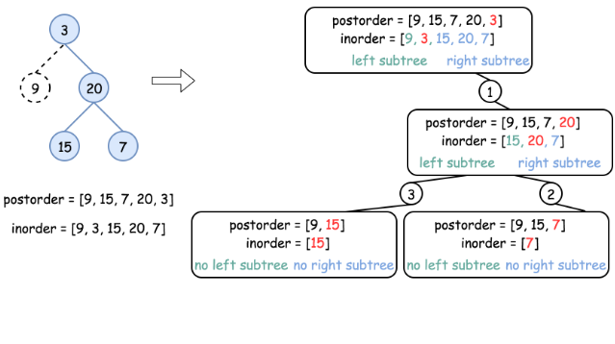

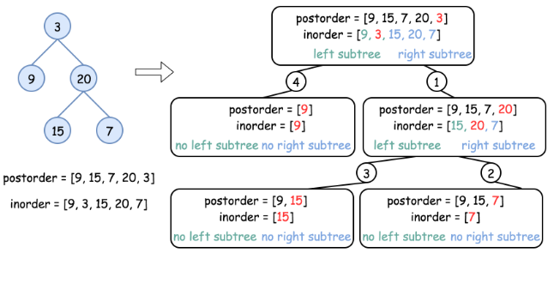

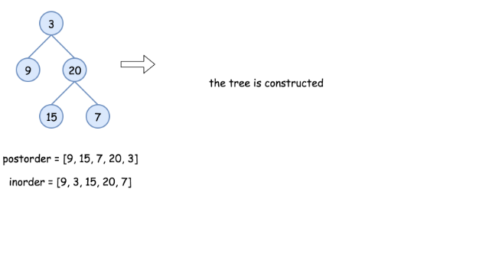

|  |
| --- |
| class Solution {  int post_idx;  int[] postorder;  int[] inorder;  HashMap<Integer, Integer> idx_map = new HashMap<Integer, Integer>();  public TreeNode helper(int in_left, int in_right) {  // if there is no elements to construct subtrees  if (in_left > in_right)  return null;  // pick up post_idx element as a root  int root_val = postorder[post_idx];  TreeNode root = new TreeNode(root_val);  // root splits inorder list  // into left and right subtrees  int index = idx_map.get(root_val);  // recursion  post_idx--;  // build right subtree  root.right = helper(index + 1, in_right);  // build left subtree  root.left = helper(in_left, index - 1);  return root;  }  public TreeNode buildTree(int[] inorder, int[] postorder) {  this.postorder = postorder;  this.inorder = inorder;  // start from the last postorder element  post_idx = postorder.length - 1;  // build a hashmap value -> its index  int idx = 0;  for (Integer val : inorder)  idx_map.put(val, idx++);  return helper(0, inorder.length - 1);  }  } |

**Complexity Analysis**

* Time complexity : O(*N*). Let's compute the solution with the help of [master theorem](https://en.wikipedia.org/wiki/Master_theorem_(analysis_of_algorithms)) 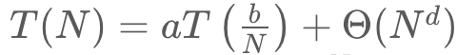. The equation represents dividing the problem up into *a* subproblems of size 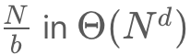time. Here one divides the problem in two subproblemes a = 2, the size of each subproblem (to compute left and right subtree) is a half of initial problem b = 2, and all this happens in a constant time d = 0. That means that 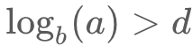  and hence we're dealing with [case 1](https://en.wikipedia.org/wiki/Master_theorem_(analysis_of_algorithms)#Case_1_example) that means 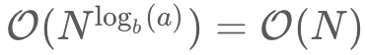 time complexity.
* Space complexity : O(*N*), since we store the entire tree.

**Construct Binary Tree from Preorder and Inorder Traversal**

Given preorder and inorder traversal of a tree, construct the binary tree.

**Note:**  
You may assume that duplicates do not exist in the tree.

For example, given

preorder = [3,9,20,15,7]

inorder = [9,3,15,20,7]

Return the following binary tree:

3

/ \

9 20

/ \

15 7

## Solution

#### **How to traverse the tree**

There are two general strategies to traverse a tree:

* Breadth First Search (BFS)

We scan through the tree level by level, following the order of height, from top to bottom. The nodes on higher level would be visited before the ones with lower levels.

* Depth First Search (DFS)

In this strategy, we adopt the depth as the priority, so that one would start from a root and reach all the way down to certain leaf, and then back to root to reach another branch.

The DFS strategy can further be distinguished as preorder, inorder, and postorder depending on the relative order among the root node, left node and right node.

On the following figure the nodes are numerated in the order you visit them, please follow 1-2-3-4-5 to compare different strategies.



Here the problem is to construct a binary tree from its preorder and inorder traversal.

#### **Approach 1: Recursion**

**Tree definition**

First of all, here is the definition of the TreeNode which we would use.

|  |
| --- |
| // Definition for a binary tree node.  public class TreeNode {  int val;  TreeNode left;  TreeNode right;  TreeNode(int x) {  val = x;  }  } |

**Algorithm**

As discussed above the preorder traversal follows Root -> Left -> Right order, that makes it very convenient to construct the tree from its root.

Let's do it. The first element in the *preorder* list is a root. This root splits *inorder* list into left and right subtrees. Now one have to pop up the root from preorder list since it's already used as a tree node and then repeat the step above for the left and right subtrees.

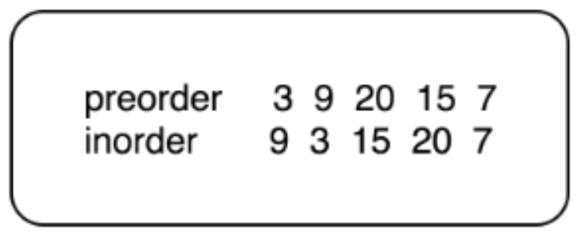

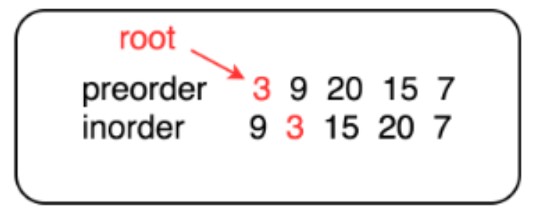

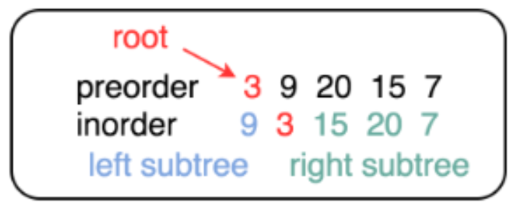

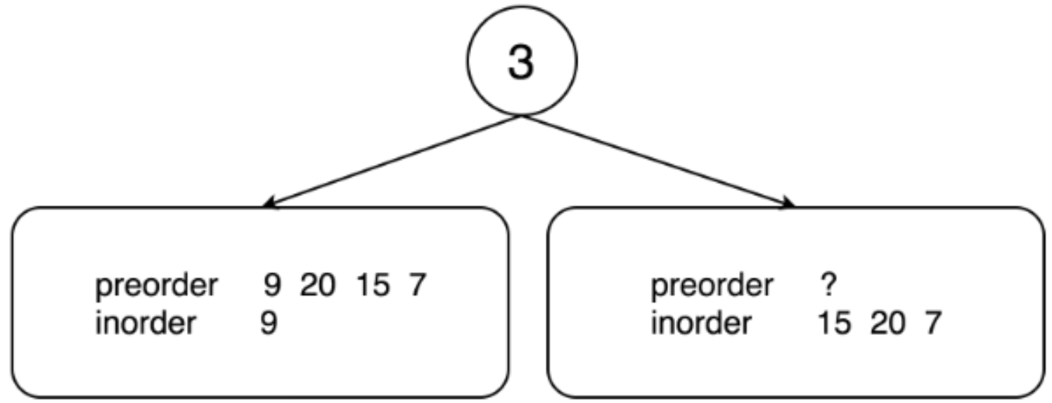

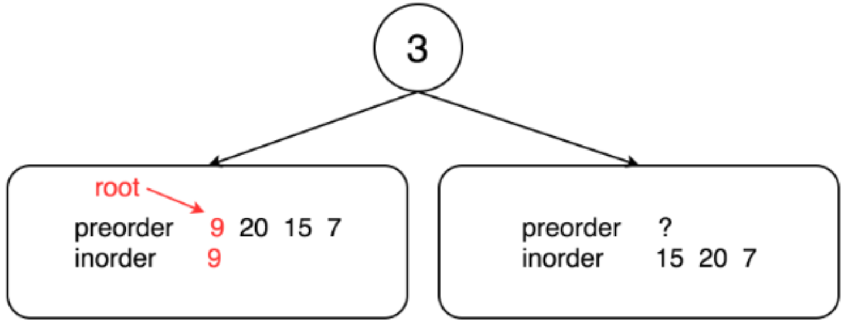 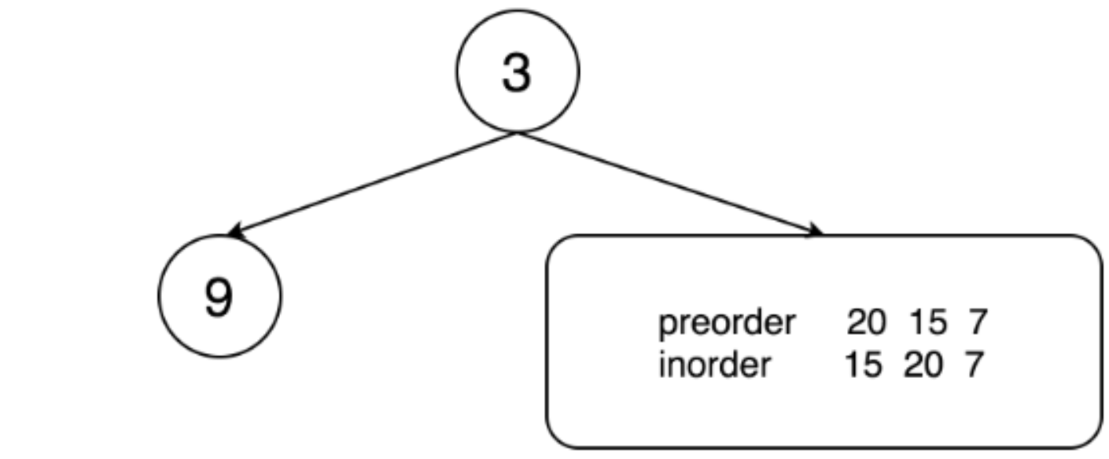 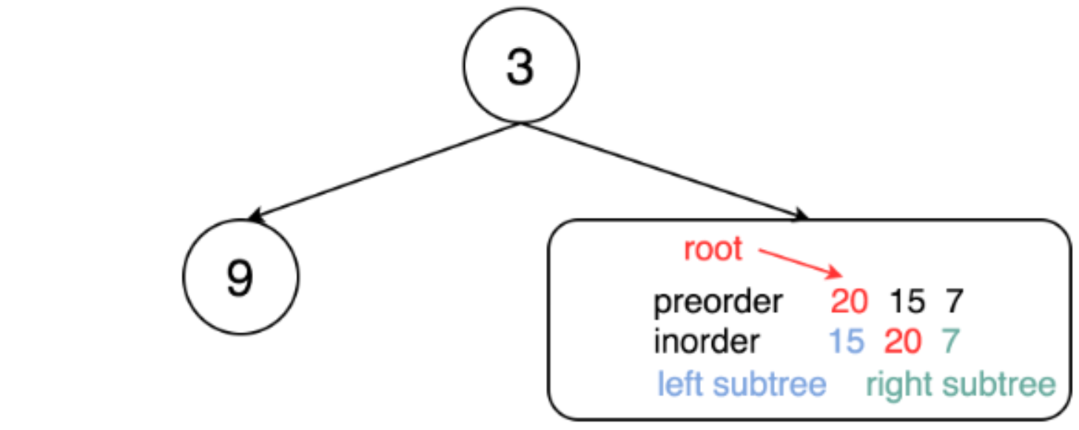 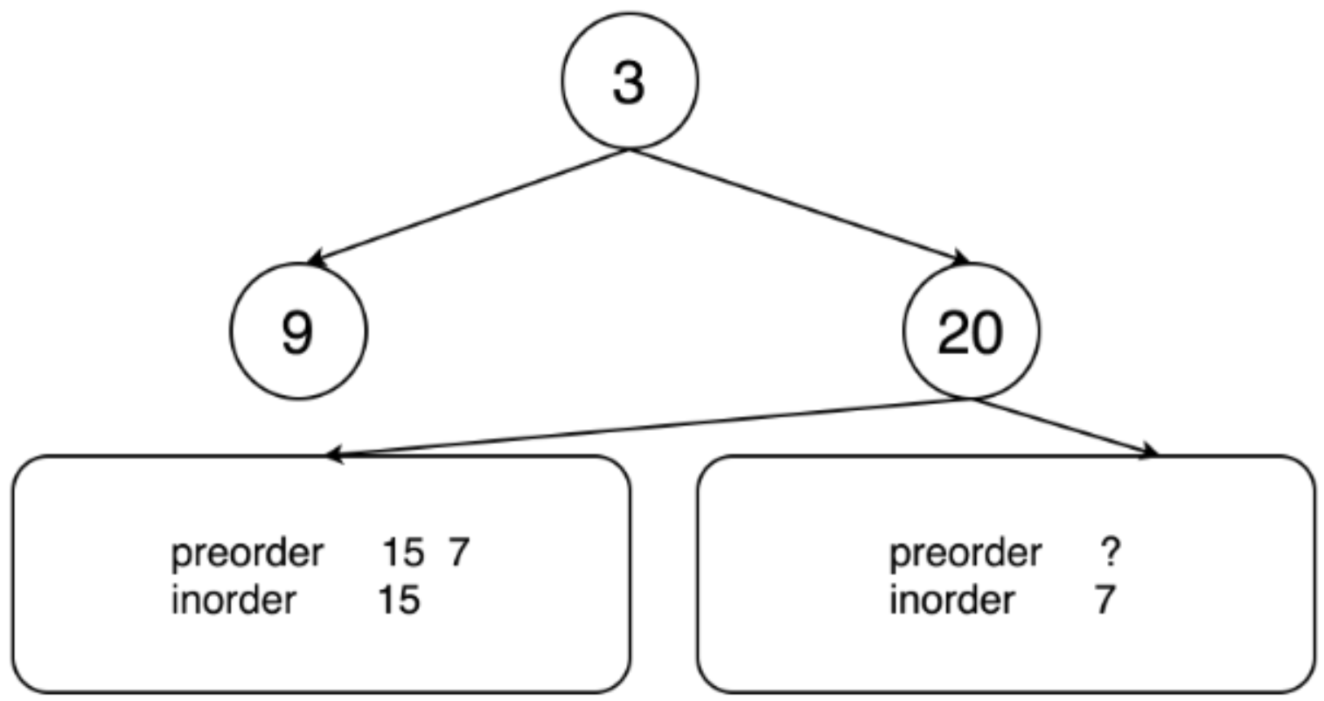 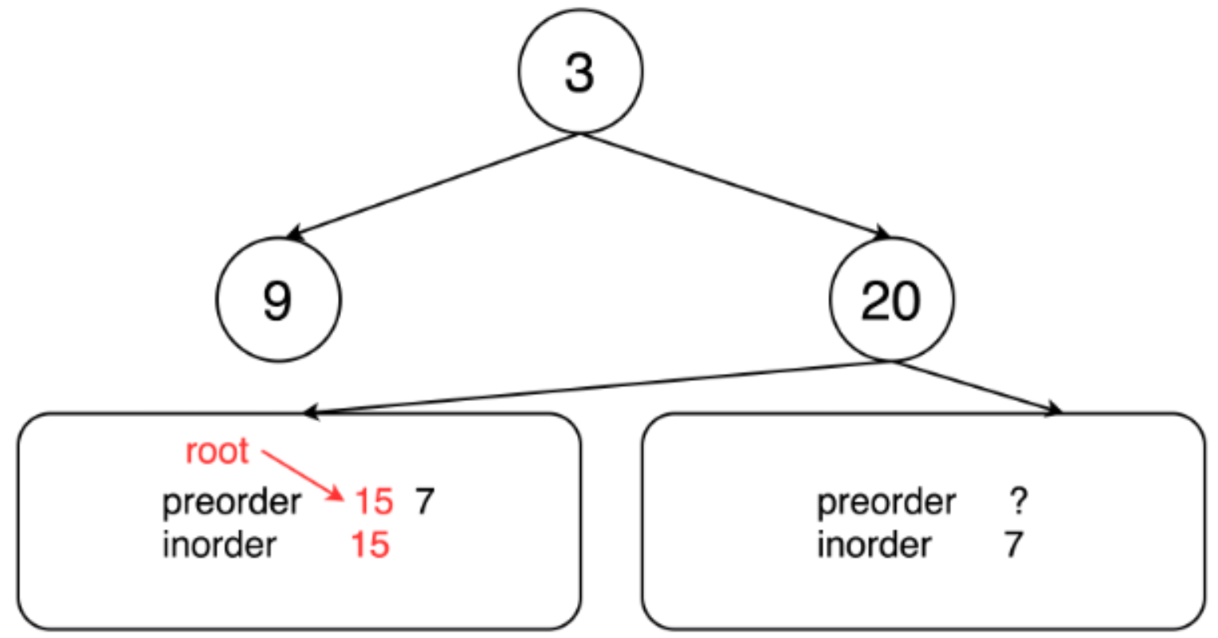 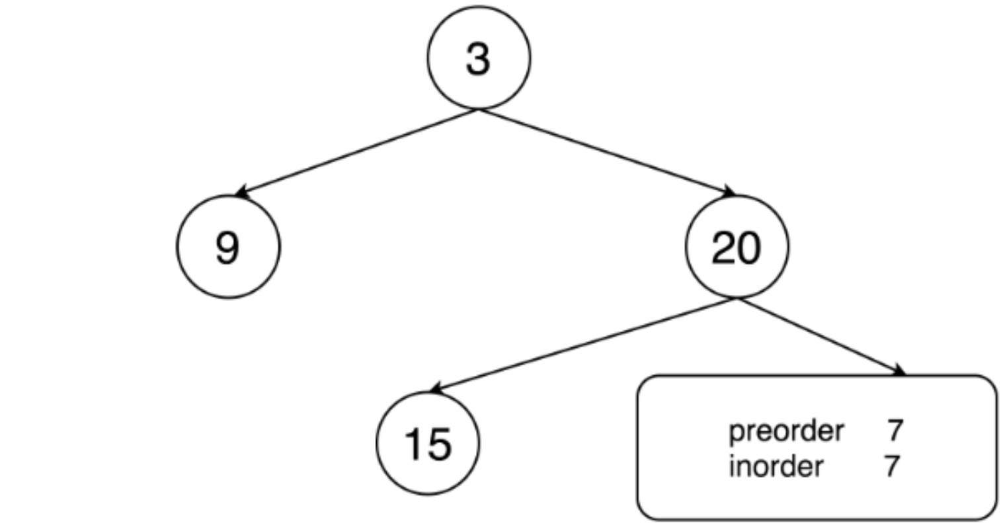 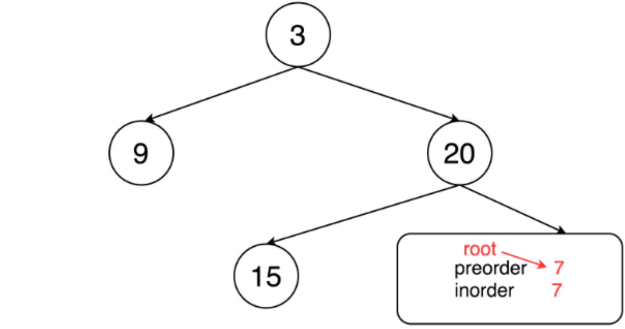 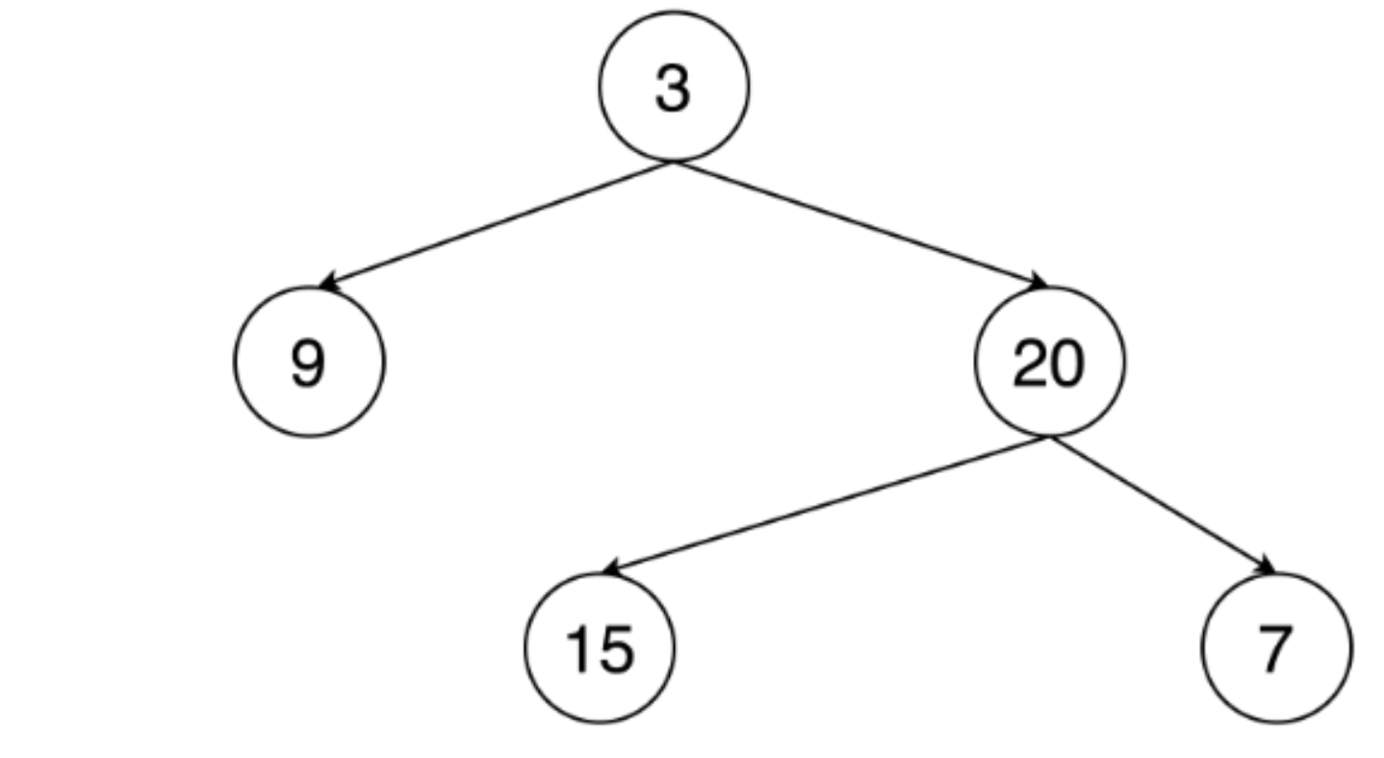

|  |
| --- |
| class Solution {  // start from first preorder element  int pre_idx = 0;  int[] preorder;  int[] inorder;  HashMap<Integer, Integer> idx_map = new HashMap<Integer, Integer>();  public TreeNode helper(int in_left, int in_right) {  // if there is no elements to construct subtrees  if (in_left == in_right)  return null;  // pick up pre_idx element as a root  int root_val = preorder[pre_idx];  TreeNode root = new TreeNode(root_val);  // root splits inorder list  // into left and right subtrees  int index = idx_map.get(root_val);  // recursion  pre_idx++;  // build left subtree  root.left = helper(in_left, index);  // build right subtree  root.right = helper(index + 1, in_right);  return root;  }  public TreeNode buildTree(int[] preorder, int[] inorder) {  this.preorder = preorder;  this.inorder = inorder;  // build a hashmap value -> its index  int idx = 0;  for (Integer val : inorder)  idx_map.put(val, idx++);  return helper(0, inorder.length);  }  } |

**Complexity analysis**

* Time complexity : O(*N*). Let's compute the solution with the help of [master theorem](https://en.wikipedia.org/wiki/Master_theorem_(analysis_of_algorithms)) , The equation represents dividing the problem up into a*a* subproblems of size   time. Here one divides the problem in two subproblemes a = 2, the size of each subproblem (to compute left and right subtree) is a half of initial problem b = 2, and all this happens in a constant time d = 0. That means that *d* and hence we're dealing with [case 1](https://en.wikipedia.org/wiki/Master_theorem_(analysis_of_algorithms)#Case_1_example) that means time complexity.
* Space complexity : O(*N*), since we store the entire tree.

**Populating Next Right Pointers in Each Node**

You are given a **perfect binary tree** where all leaves are on the same level, and every parent has two children. The binary tree has the following definition:

struct Node {

int val;

Node *left;

Node *right;

Node *next;

}

Populate each next pointer to point to its next right node. If there is no next right node, the next pointer should be set to NULL.

Initially, all next pointers are set to NULL.

**Follow up:**

* You may only use constant extra space.
* Recursive approach is fine, you may assume implicit stack space does not count as extra space for this problem.

**Example 1:**

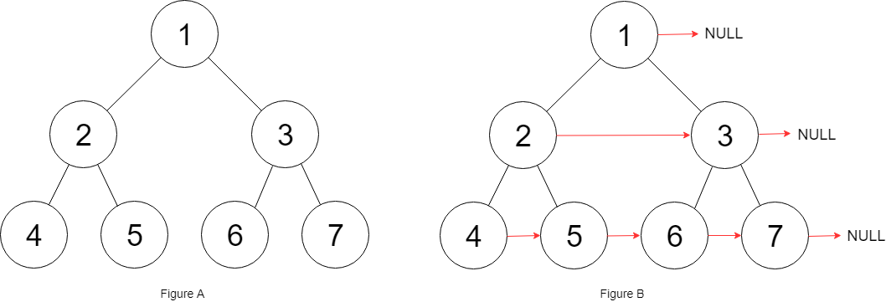

**Input:** root = [1,2,3,4,5,6,7]

**Output:** [1,#,2,3,#,4,5,6,7,#]

**Explanation:** Given the above perfect binary tree (Figure A), your function should populate each next pointer to point to its next right node, just like in Figure B. The serialized output is in level order as connected by the next pointers, with '#' signifying the end of each level.

**Constraints:**

* The number of nodes in the given tree is less than 4096.
* -1000 <= node.val <= 1000

## Solution

#### **Approach 1: Level Order Traversal**

**Intuition**

There are two basic kinds of traversals on a tree or a graph. One is where we explore the tree in a depth first manner i.e. one branch at a time. The other one is where we traverse the tree breadth-wise i.e. we explore one level of the tree before moving on to the next one. For trees, we have further classifications of the depth first traversal approach called preorder, inorder, and the postorder traversals. Breadth first approach to exploring a tree is based on the concept of the level of a node. The level of a node is its depth or distance from the root node. We process all the nodes on one level before moving on to the next one.

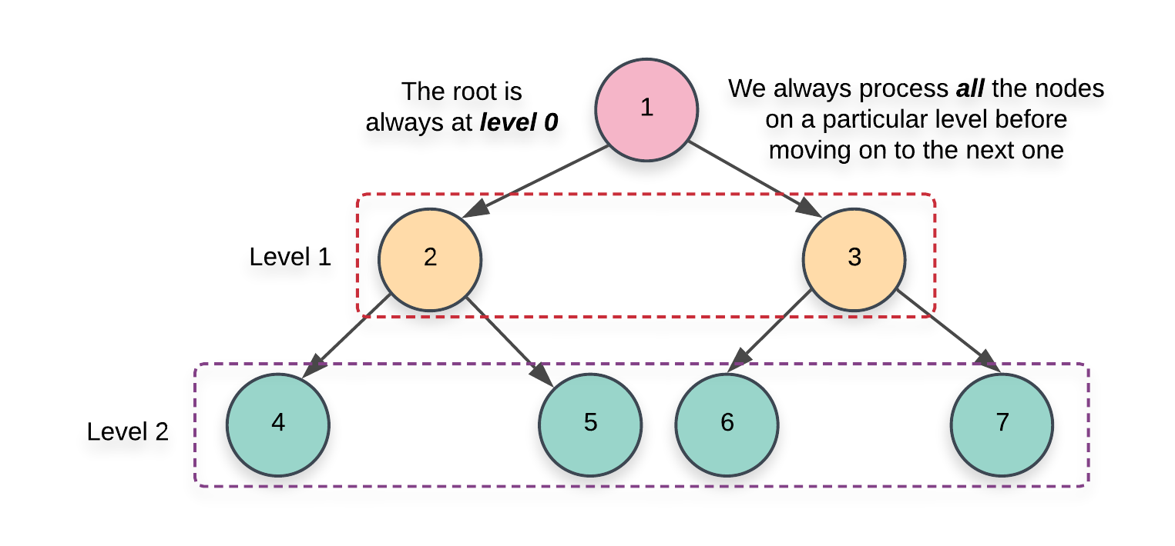

Now that we have the basics out of the way, it's pretty evident that the problem statement strongly hints at a breadth first kind of a solution. We need to link all the nodes together which lie on the same level and the level order or the breadth first traversal gives us access to all such nodes.

**Algorithm**

1. Initialize a queue, Q which we will be making use of during our traversal. There are multiple ways to implement the level order traversal especially when it comes to identifying the level of a particular node.
   1. We can add a pair of (*node*,*level*) to the queue and whenever we add the children of a node, we add *node*.*left*,*parent*_*level*+1) and *node*.*right*,*parent*_*level*+1). This approach wouldn't be very efficient for our algorithm since we need all the nodes on the same level and we would need another data structure just for that.

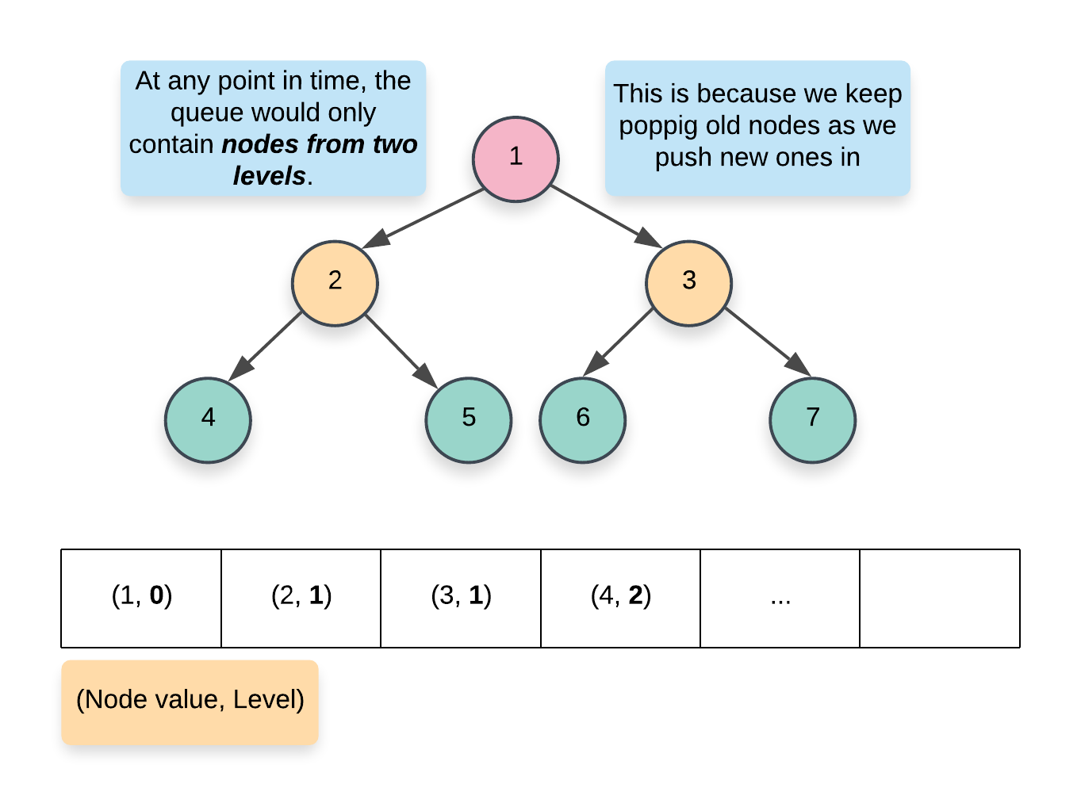

* 1. A more memory efficient way of segregating the same level nodes is to use some demarcation between the levels. Usually, we insert a NULL entry in the queue which marks the end of the previous level and the start of the next level. This is a great approach but again, it would still consume some memory proportional to the number of levels in the tree.

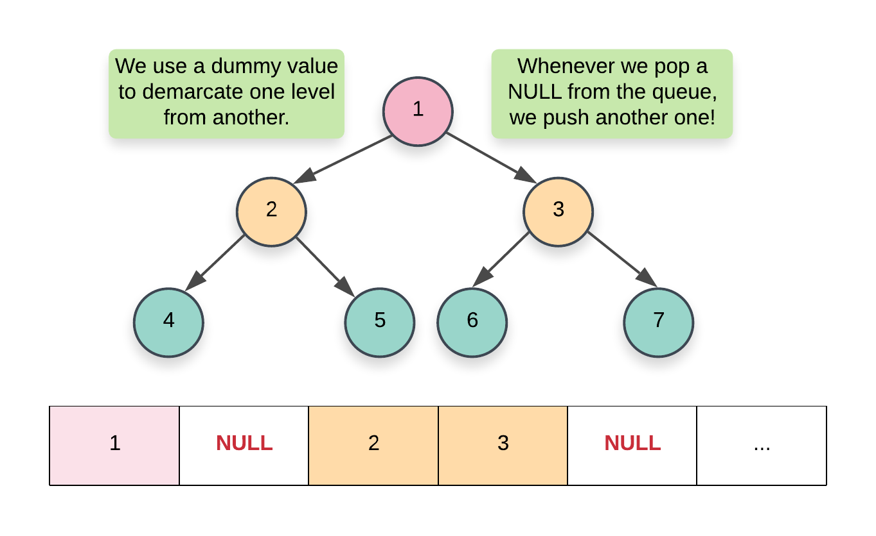

* 1. The approach we will be using here would have a nested loop structure to get around the requirement of a NULL pointer. Essentially, at each step, we record the size of the queue and that always corresponds to ***all*** the nodes on a particular level. Once we have this size, we only process these many elements and no more. By the time we are done processing size number of elements, the queue would contain ***all*** the nodes on the next level. Here's a pseudocode for the same:

while (!Q.empty())

{

size = Q.size()

for i in range 0..size

{

node = Q.pop()

Q.push(node.left)  
 Q.push(node.right)

}

}

1. We start off by adding the root of the tree in the queue. Since there is just one node on the level 0, we don't need to establish any connections and can move onto the while loop.

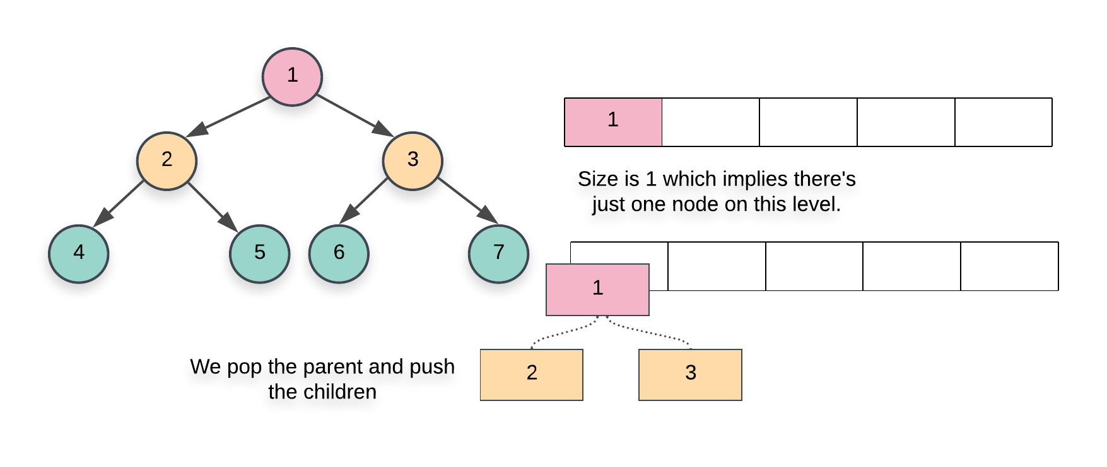

1. The first while loop from the pseudocode above essentially iterates over each level one by one and the inner for loop iterates over all the nodes on the particular level. Since we have access to all the nodes on the same level, we can establish the next pointers easily.
2. When we pop a node inside the for loop from the pseudocode above, we add its children at the back of the queue. Also, the element at the head of the queue is the next element in order, on the current level. So, we can easily establish the new pointers.

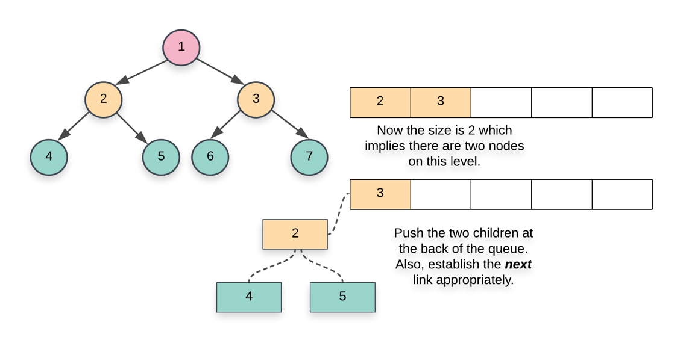

|  |
| --- |
| class Solution {  public Node connect(Node root) {    if (root == null) {  return root;  }    // Initialize a queue data structure which contains  // just the root of the tree  Queue<Node> Q = new LinkedList<Node>();  Q.add(root);    // Outer while loop which iterates over  // each level  while (Q.size() > 0) {    // Note the size of the queue  int size = Q.size();    // Iterate over all the nodes on the current level  for(int i = 0; i < size; i++) {    // Pop a node from the front of the queue  Node node = Q.poll();    // This check is important. We don't want to  // establish any wrong connections. The queue will  // contain nodes from 2 levels at most at any  // point in time. This check ensures we only  // don't establish next pointers beyond the end  // of a level  if (i < size - 1) {  node.next = Q.peek();  }    // Add the children, if any, to the back of  // the queue  if (node.left != null) {  Q.add(node.left);  }  if (node.right != null) {  Q.add(node.right);  }  }  }    // Since the tree has now been modified, return the root node  return root;  }  } |

**Complexity Analysis**

* Time Complexity: *O*(*N*) since we process each node exactly once. Note that processing a node in this context means popping the node from the queue and then establishing the next pointers.
* Space Complexity: *O*(*N*). This is a perfect binary tree which means the last level contains *N*/2 nodes. The space complexity for breadth first traversal is the space occupied by the queue which is dependent upon the maximum number of nodes in particular level. So, in this case, the space complexity would be *O*(*N*).

#### **Approach 2: Using previously established next pointers**

**Intuition**

Let's look at the two types of next pointer connections we need to establish for a given tree.

1. This first case is the one where we establish the next pointers between the two children of a given node. This is the easier of the two cases since both the children are accessible via the same node. We can simply do the following to establish this connection.

node.left.next = node.right

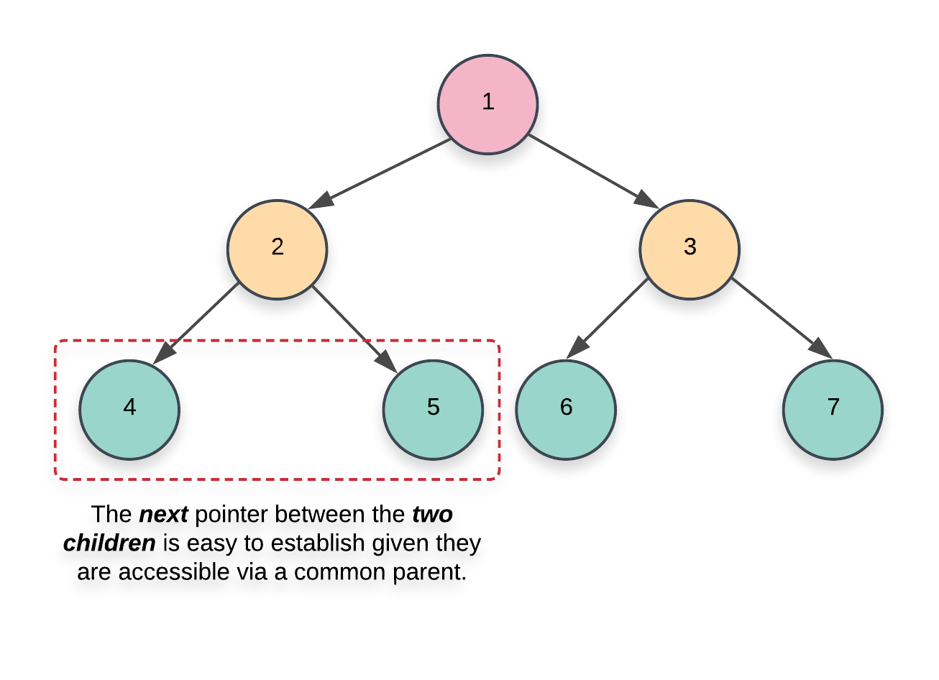

1. This next case is not too straightforward to handle. In addition to establishing the next pointers between the nodes having a common parent, we also need to set-up the correct pointers between nodes which have a different parent.

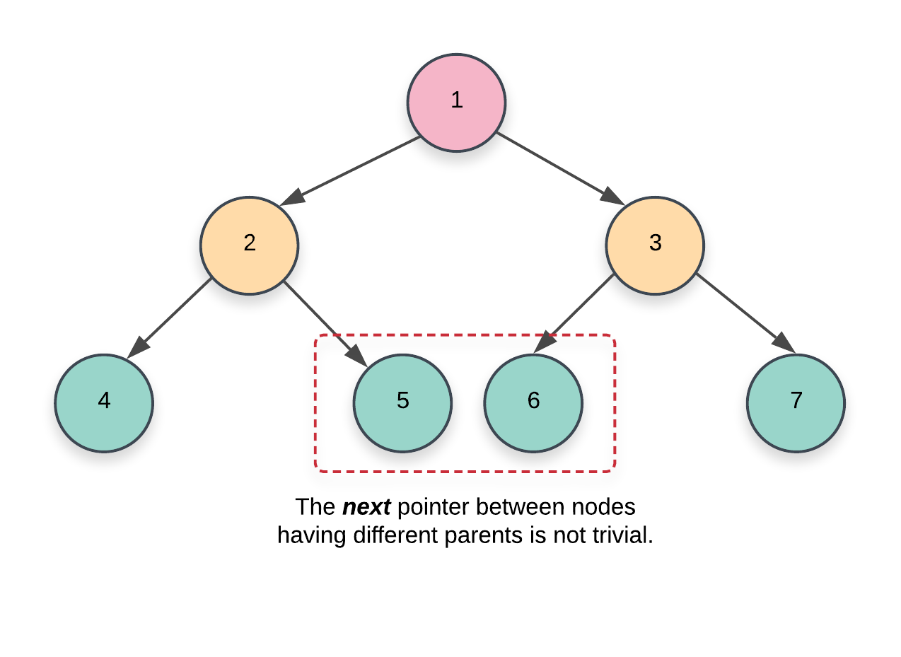

If we simply had the parent pointers available with each node, this problem would have been trivial to solve. However, we don't have any such pointers available. The basic idea for this approach is based on the fact that:

We only move on to the level N+1 when we are done establishing the next pointers for the level N. Since we have access to all the nodes on a particular level via the next pointers, we can use these next pointers to establish the connections for the next level or the level containing their children.

**Algorithm**

1. We start at the root node. Since there are no more nodes to process on the first level or level 0, we can establish the next pointers on the next level i.e. level 1. An important thing to remember in this algorithm is that we establish the next pointers for a level *N* while we are still on level *N*−1 and once we are done establishing these new connections, we move on to N*N* and do the same thing for *N*+1.
2. As we just said, when we go over the nodes of a particular level, their next pointers are already established. This is what helps get rid of the queue data structure from the previous approach and helps save space. To start on a particular level, we just need the leftmost node. From there on out, it’s just a linked list traversal.
3. Based on these ideas, our algorithm will have the following pseudocode:

leftmost = root

while (leftmost.left != null)

{

head = leftmost

while (head.next != null)

{

1) Establish Connection 1

2) Establish Connection 2 using next pointers

head = head.next

}

leftmost = leftmost.left

}

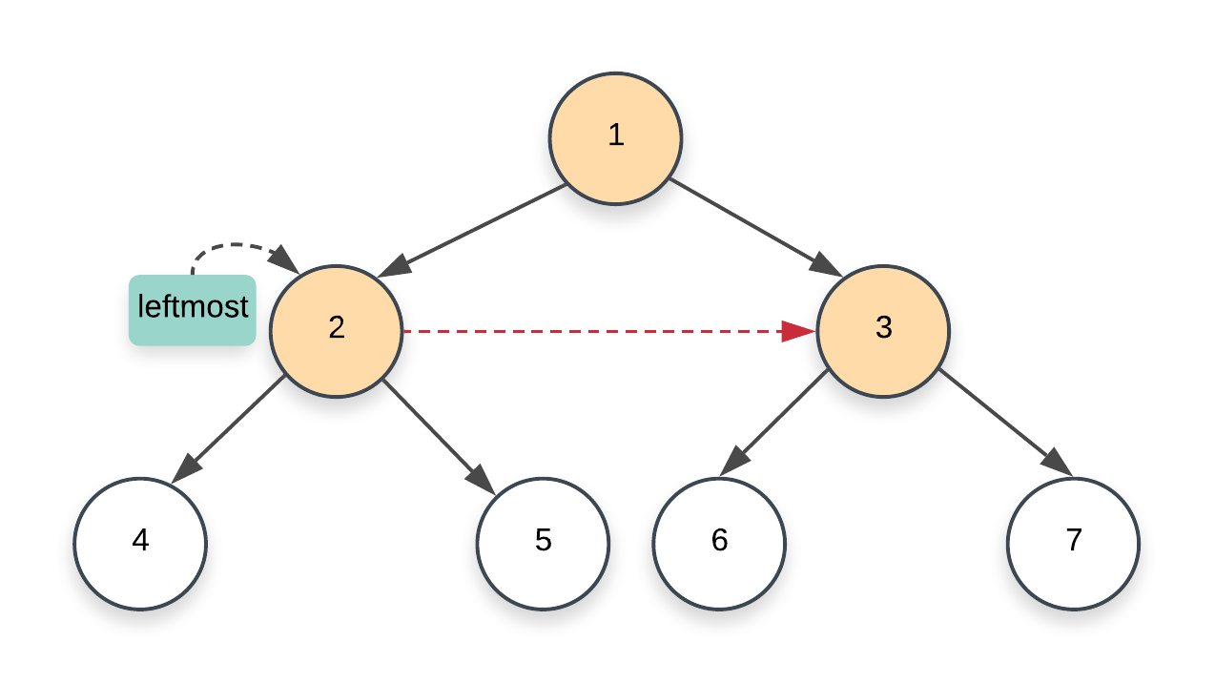

1. The Connection 1 and Connection 2 mentioned above correspond to the two kinds of connections we looked at earlier on in the intuition section of this approach.
   1. The first one is fairly simple to establish given that it's between the two nodes having a common parent. So, we could simply do something like this to link the two children:

node.left.next = node.right

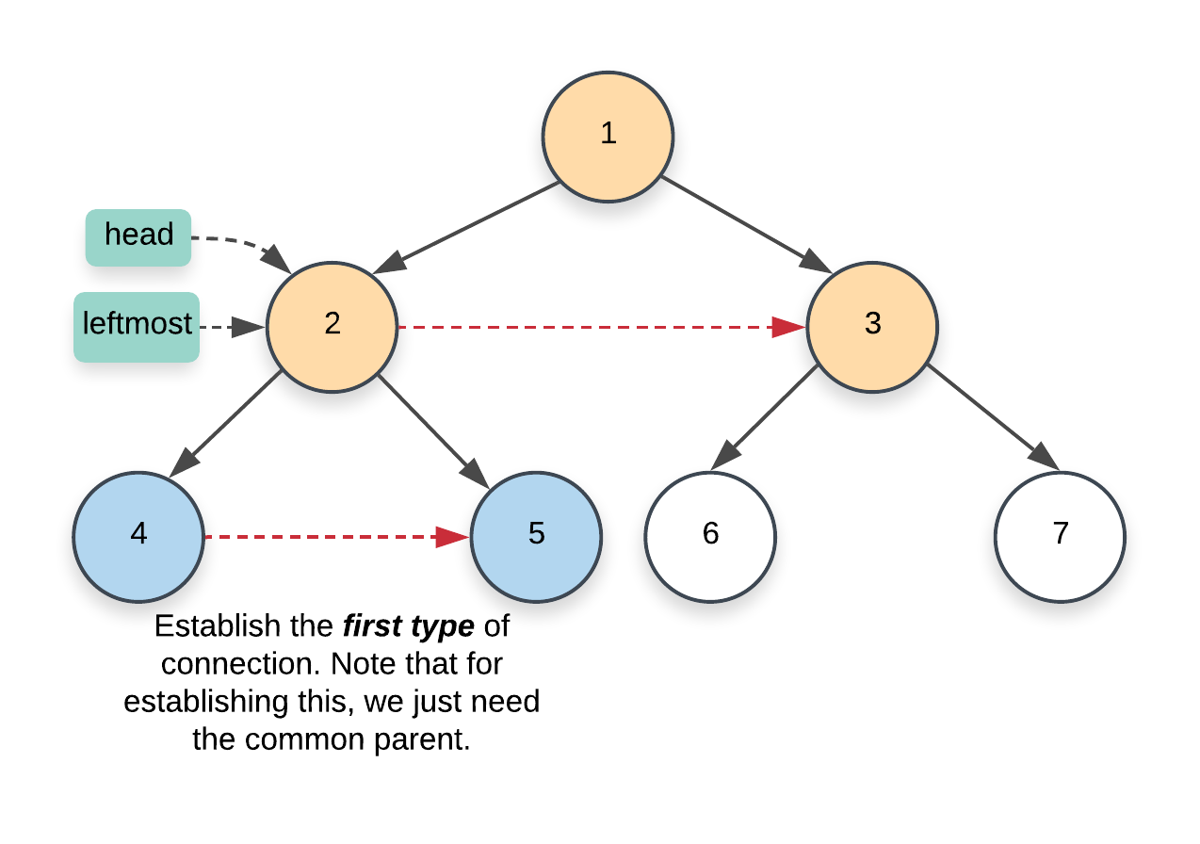

* 1. For the second type of connection, we have to make use of the next pointers on the current level. Remember that this second type of connection is between nodes that have different parents. More specifically, it's the link between the right child of a node and the left child of the next node. Since we already have the next pointers set up on the current level, we use this to set up the correct pointers on the next level.

node.right.next = node.next.left

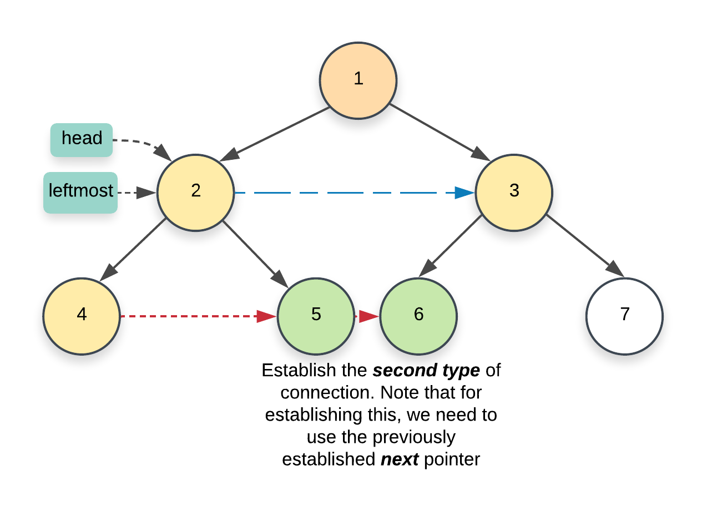

1. Once we are done with the current level, we move on to the next one. One last thing that's left here is to update the leftmost node. We need that node to start traversal on a particular level. Think of it as the head of the linked list. Since this is a perfect binary tree, the leftmost node will always be the left child of the current leftmost node. The only nodes which don't have any children are the ones on the final level and these would be the leaves of the tree.

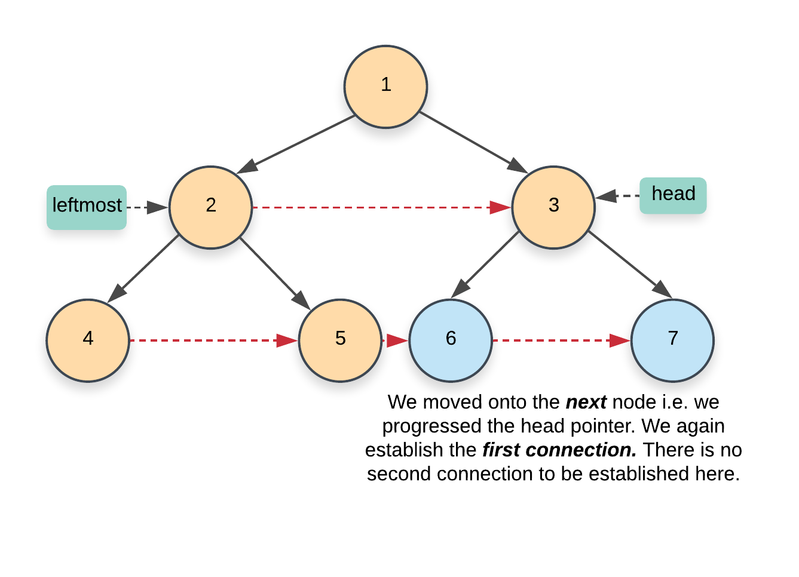

|  |
| --- |
| class Solution {  public Node connect(Node root) {    if (root == null) {  return root;  }    // Start with the root node. There are no next pointers  // that need to be set up on the first level  Node leftmost = root;    // Once we reach the final level, we are done  while (leftmost.left != null) {    // Iterate the "linked list" starting from the head  // node and using the next pointers, establish the  // corresponding links for the next level  Node head = leftmost;    while (head != null) {    // CONNECTION 1  head.left.next = head.right;    // CONNECTION 2  if (head.next != null) {  head.right.next = head.next.left;  }    // Progress along the list (nodes on the current level)  head = head.next;  }    // Move onto the next level  leftmost = leftmost.left;  }    return root;  }  } |

**Complexity Analysis**

* Time Complexity: *O*(*N*) since we process each node exactly once.
* Space Complexity: *O*(1) since we don't make use of any additional data structure for traversing nodes on a particular level like the previous approach does.

**Populating Next Right Pointers in Each Node II**

Given a binary tree

struct Node {

int val;

Node *left;

Node *right;

Node *next;

}

Populate each next pointer to point to its next right node. If there is no next right node, the next pointer should be set to NULL.

Initially, all next pointers are set to NULL.

**Follow up:**

* You may only use constant extra space.
* Recursive approach is fine, you may assume implicit stack space does not count as extra space for this problem.

**Example 1:**

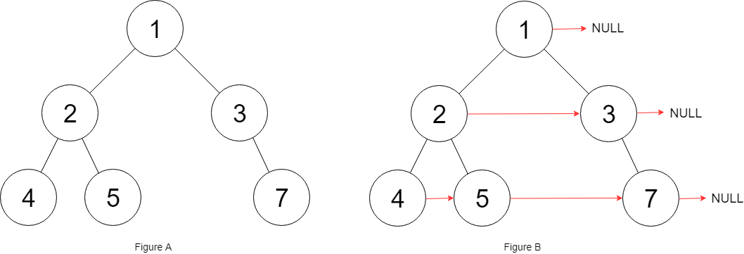

**Input:** root = [1,2,3,4,5,null,7]

**Output:** [1,#,2,3,#,4,5,7,#]

**Explanation:** Given the above binary tree (Figure A), your function should populate each next pointer to point to its next right node, just like in Figure B. The serialized output is in level order as connected by the next pointers, with '#' signifying the end of each level.

**Constraints:**

* The number of nodes in the given tree is less than 6000.
* -100 <= node.val <= 100

## Solution

#### **Approach 1: Level Order Traversal**

**Intuition**

There are two basic kinds of traversals on a tree or a graph. One is where we explore the tree in a depth first manner i.e. one branch at a time. The other one is where we traverse the tree breadth-wise i.e. we explore one level of the tree before moving on to the next one. For trees, we have further classifications of the depth first traversal approach called preorder, inorder, and the postorder traversals. Breadth first approach to exploring a tree is based on the concept of the level of a node. The level of a node is its depth or distance from the root node. We process all the nodes on one level before moving on to the next one.



Now that we have the basics out of the way, it's pretty evident that the problem statement strongly hints at a breadth first kind of a solution. We need to link all the nodes together which lie on the same level and the level order or the breadth first traversal gives us access to all such nodes which lie on the same level.

**Algorithm**

1. Initialize a queue, Q which we will be making use of during our traversal. There are multiple ways to implement the level order traversal especially when it comes to identifying the level of a particular node.
   1. We can add a pair of (*node*,*level*) to the queue and whenever we add the children of a node, we add *node*.*left*,*parent*_*level*+1) and *node*.*right*,*parent*_*level*+1). This approach wouldn't be very efficient for our algorithm since we need all the nodes on the same level and we would need another data structure just for that.



* 1. A more memory efficient way of segregating the same level nodes is to use some demarcation between the levels. Usually, we insert a NULL entry in the queue which marks the end of the previous level and the start of the next level. This is a great approach but again, it would still consume some memory proportional to the number of levels in the tree.



* 1. The approach we will be using here would have a nested loop structure to get around the requirement of a NULL pointer. Essentially, at each step, we record the size of the queue and that always corresponds to ***all*** the nodes on a particular level. Once we have this size, we only process these many elements and no more. By the time we are done processing size number of elements, the queue would contain ***all*** the nodes on the next level. Here's a pseudocode for the same:

while (!Q.empty())

{

size = Q.size()

for i in range 0..size

{

node = Q.pop()

Q.push(node.left)

Q.push(node.right)

}

}

1. We start off by adding the root of the tree in the queue. Since there is just one node on the level 0, we don't need to establish any connections and can move onto the while loop.



1. The first while loop from the pseudocode above essentially iterates over each level one by one and the inner for loop iterates over all the nodes on the particular level. Since we have access to all the nodes on the same level, we can establish the next pointers easily.
2. When we pop a node inside the for loop from the pseudocode above, we add its children at the back of the queue. Also, the element at the head of the queue is the next element in order, on the current level. So, we can easily establish the new pointers.

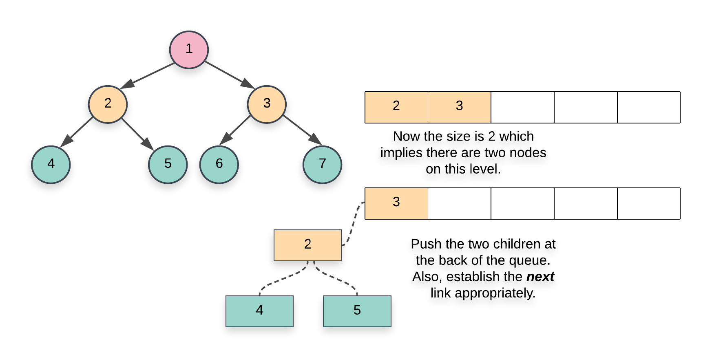

|  |
| --- |
| class Solution {  public Node connect(Node root) {    if (root == null) {  return root;  }    // Initialize a queue data structure which contains  // just the root of the tree  Queue<Node> Q = new LinkedList<Node>();  Q.add(root);    // Outer while loop which iterates over  // each level  while (Q.size() > 0) {    // Note the size of the queue  int size = Q.size();    // Iterate over all the nodes on the current level  for(int i = 0; i < size; i++) {    // Pop a node from the front of the queue  Node node = Q.poll();    // This check is important. We don't want to  // establish any wrong connections. The queue will  // contain nodes from 2 levels at most at any  // point in time. This check ensures we only  // don't establish next pointers beyond the end  // of a level  if (i < size - 1) {  node.next = Q.peek();  }    // Add the children, if any, to the back of  // the queue  if (node.left != null) {  Q.add(node.left);  }  if (node.right != null) {  Q.add(node.right);  }  }  }    // Since the tree has now been modified, return the root node  return root;  }  } |

**Complexity Analysis**

* Time Complexity: *O*(*N*) since we process each node exactly once. Note that processing a node in this context means popping the node from the queue and then establishing the next pointers.
* Space Complexity: *O*(*N*). This is a perfect binary tree which means the last level contains *N*/2 nodes. The space complexity for breadth first traversal is the maximum space occupied and the space occupied by the queue is dependent upon the maximum number of nodes in particular level. So, in this case, the space complexity would be *O*(*N*).

## Solution

#### **Approach 1: Level Order Traversal**

**Intuition**

There are two basic kinds of traversals on a tree or a graph. One is where we explore the tree in a depth first manner i.e. one branch at a time. The other one is where we traverse the tree breadth-wise i.e. we explore one level of the tree before moving on to the next one. For trees, we have further classifications of the depth first traversal approach called preorder, inorder, and the postorder traversals. Breadth first approach to exploring a tree is based on the concept of the level of a node. The level of a node is its depth or distance from the root node. We process all the nodes on one level before moving on to the next one.



Now that we have the basics out of the way, it's pretty evident that the problem statement strongly hints at a breadth first kind of a solution. We need to link all the nodes together which lie on the same level and the level order or the breadth first traversal gives us access to all such nodes which lie on the same level.

**Algorithm**

1. Initialize a queue, Q which we will be making use of during our traversal. There are multiple ways to implement the level order traversal especially when it comes to identifying the level of a particular node.
   1. We can add a pair of (*node*,*level*) to the queue and whenever we add the children of a node, we add *node*.*left*,*parent*_*level*+1) and  (*node*.*right*,*parent*_*level*+1). This approach wouldn't be very efficient for our algorithm since we need all the nodes on the same level and we would need another data structure just for that.



* 1. A more memory efficient way of segregating the same level nodes is to use some demarcation between the levels. Usually, we insert a NULL entry in the queue which marks the end of the previous level and the start of the next level. This is a great approach but again, it would still consume some memory proportional to the number of levels in the tree.



* 1. The approach we will be using here would have a nested loop structure to get around the requirement of a NULL pointer. Essentially, at each step, we record the size of the queue and that always corresponds to ***all*** the nodes on a particular level. Once we have this size, we only process these many elements and no more. By the time we are done processing size number of elements, the queue would contain ***all*** the nodes on the next level. Here's a pseudocode for the same:

while (!Q.empty())

{

size = Q.size()

for i in range 0..size

{

node = Q.pop()

Q.push(node.left)

Q.push(node.right)

}

}

1. We start off by adding the root of the tree in the queue. Since there is just one node on the level 0, we don't need to establish any connections and can move onto the while loop.



1. The first while loop from the pseudocode above essentially iterates over each level one by one and the inner for loop iterates over all the nodes on the particular level. Since we have access to all the nodes on the same level, we can establish the next pointers easily.
2. When we pop a node inside the for loop from the pseudocode above, we add its children at the back of the queue. Also, the element at the head of the queue is the next element in order, on the current level. So, we can easily establish the new pointers.



|  |
| --- |
| class Solution {  public Node connect(Node root) {    if (root == null) {  return root;  }    // Initialize a queue data structure which contains  // just the root of the tree  Queue<Node> Q = new LinkedList<Node>();  Q.add(root);    // Outer while loop which iterates over  // each level  while (Q.size() > 0) {    // Note the size of the queue  int size = Q.size();    // Iterate over all the nodes on the current level  for(int i = 0; i < size; i++) {    // Pop a node from the front of the queue  Node node = Q.poll();    // This check is important. We don't want to  // establish any wrong connections. The queue will  // contain nodes from 2 levels at most at any  // point in time. This check ensures we only  // don't establish next pointers beyond the end  // of a level  if (i < size - 1) {  node.next = Q.peek();  }    // Add the children, if any, to the back of  // the queue  if (node.left != null) {  Q.add(node.left);  }  if (node.right != null) {  Q.add(node.right);  }  }  }    // Since the tree has now been modified, return the root node  return root;  }  } |

**Complexity Analysis**

* Time Complexity: *O*(*N*) since we process each node exactly once. Note that processing a node in this context means popping the node from the queue and then establishing the next pointers.
* Space Complexity: *O*(*N*). This is a perfect binary tree which means the last level contains *N*/2 nodes. The space complexity for breadth first traversal is the maximum space occupied and the space occupied by the queue is dependent upon the maximum number of nodes in particular level. So, in this case, the space complexity would be *O*(*N*).

#### **Approach 2: Using previously established next pointers**

**Intuition**

We have to process all the nodes of the tree. So we can't reduce the time complexity any further. However, we can try and reduce the space complexity. The reason we need a queue here is because we don't have any idea about the structure of the tree and the kind of branches it has and we need to access all the nodes on a common level, together, and establish connections between them.

Once we are done establishing the next pointers between the nodes, don't they kind of represent a linked list? After the next connections are established, all the nodes on a particular level actually form a linked list via these next pointers. Based on this idea, we have the following intuition for our space efficient algorithm:

We only move on to the level N+1 when we are done establishing the next pointers for the level N. So, since we have access to all the nodes on a particular level via the next pointers, we can use these next pointers to establish the connections for the next level or the level containing their children.

**Algorithm**

1. We start at the root node. Since there are no more nodes to process on the first level or level 0, we can establish the next pointers on the next level i.e. level 1. An important thing to remember in this algorithm is that we establish the next pointers for a level *N* while we are still on level *N*−1 and once we are done establishing these new connections, we move on to *N* and do the same thing for *N*+1.
2. As we just said, when we go over the nodes of a particular level, their next pointers are already established. This is what helps get rid of the queue data structure from the previous approach and helps save space. To start on a particular level, we just need the leftmost node. From there on its just a linked list traversal.
3. Based on these ideas, our algorithm will have the following pseudocode:

leftmost = root

while (leftmost != null)

{

curr = leftmost

prev = NULL

while (curr != null)

{

→ process left child

→ process right child

→ set leftmost for the next level

curr = curr.next

}

}

1. Before we proceed with the steps in our algorithm, we need to understand some of the variables we have used above in the pseudocode since they will be important in understanding the implementation.
   1. **leftmost:** represents the corresponding variable on each level. This node is important to discover on each level since this would act as our head of the linked list and we will start our traversal of all the nodes on a level from this node onwards. Since the structure of the tree can be anything, we don't really know what the leftmost node on a level would be. Let's look at a few tree structures and the corresponding leftmost nodes on each level.

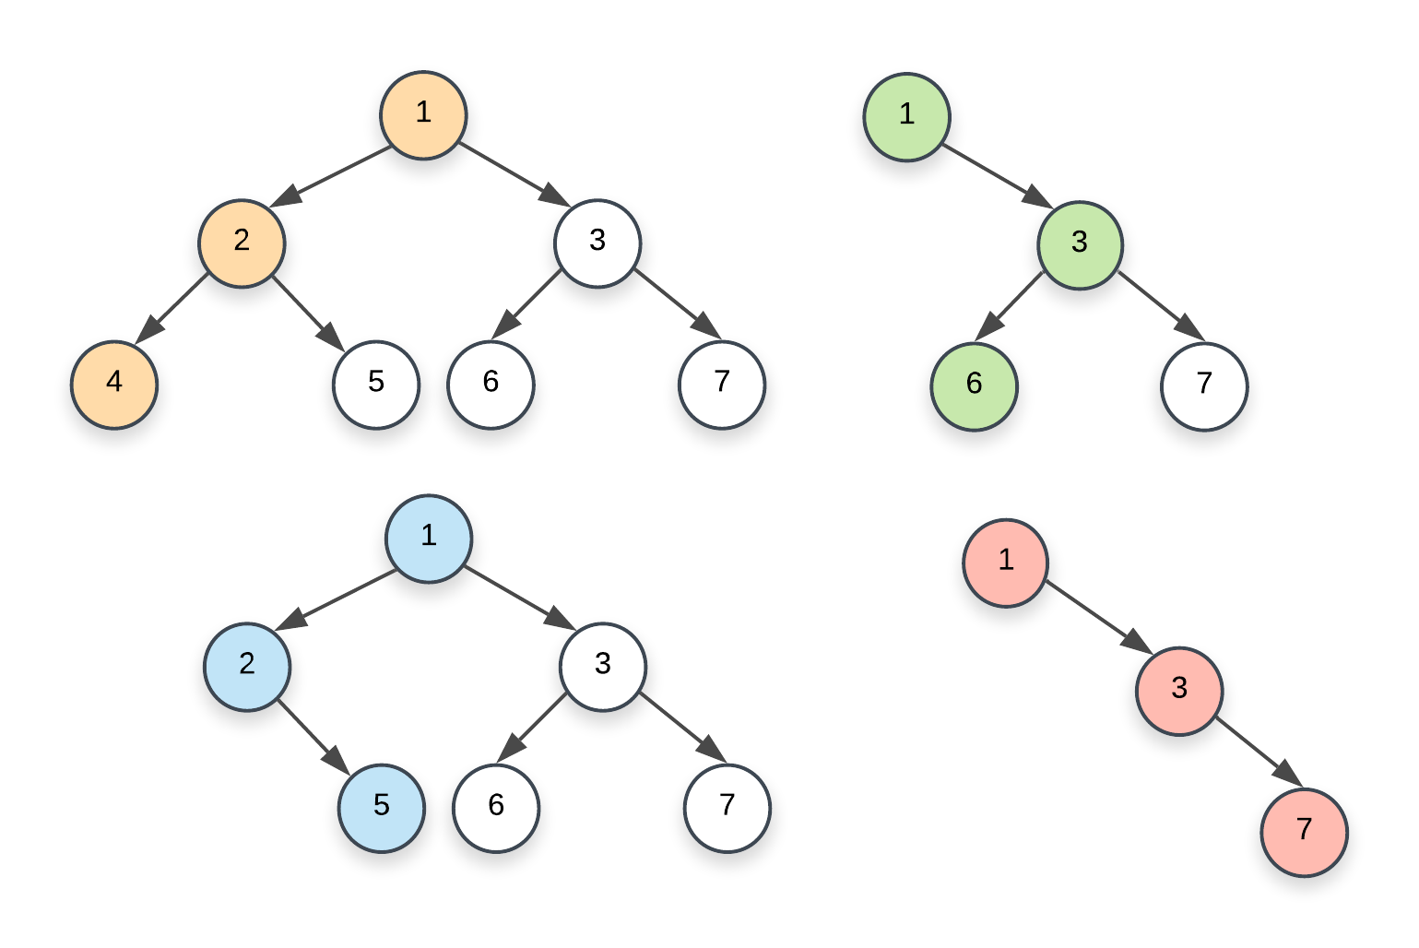

Oh, in case you are interested in a fun problem that find out all such nodes (rightmost instead of leftmost), check out [this problem](https://leetcode.com/problems/binary-tree-right-side-view/description/).

* 1. **curr:** As we can see in the pseudocode, this is just the variable we use to traverse all the nodes on the current level. It starts off with leftmost and then follows the next pointers all the way to the very end.
  2. **prev:** This is the pointer to the leading node on the next level. We need this pointer because whenever we update the node curr, we assign prev.next to the left child of curr if one exists, otherwise the right child. When we do so, we also update the prev pointer. Let's consider an example that highlights how the prev pointer is updated. Namely, the following example will highlight the 4 possible scenarios for pointer updates:
     + The first case is when the prev pointer is assigned a non-null value for the very first time i.e. when it is initialized. We start with a null value and when we find the first node on the next level i.e whenever we find the very first node on the current level that has at least one child, we assign the leftmost child to prev.

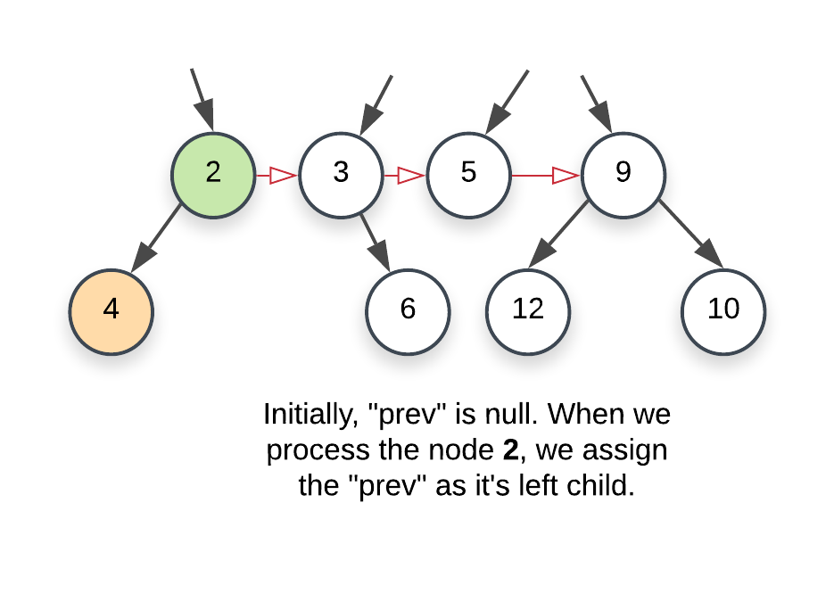

* + - Next is when the node on the current level doesn't have a left child. We then point prev to the right child of the current node. An important thing to remember in this illustration is that the level 2, 3, 5, 9 already has their next pointers properly established.

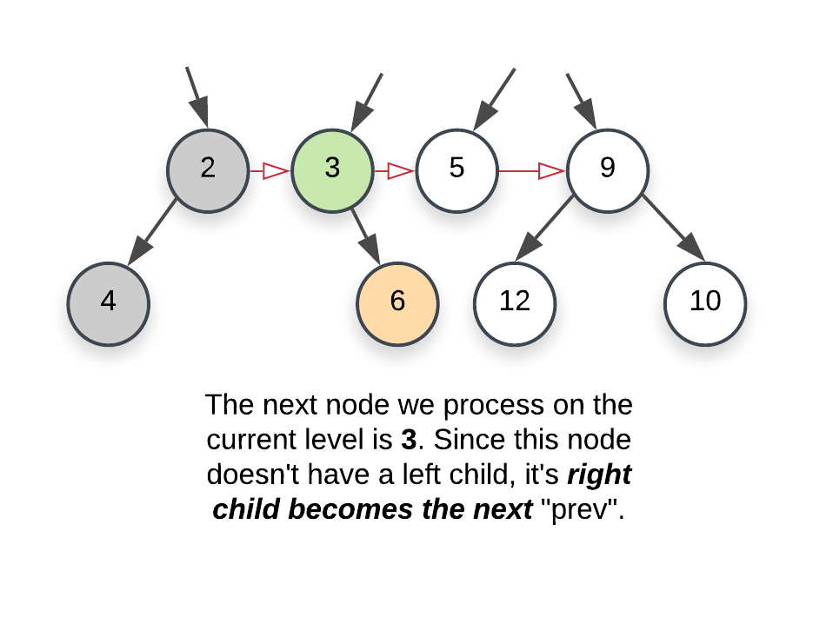

* + - Moving on, we have a node with no children. Here, we don't update the prev pointer.

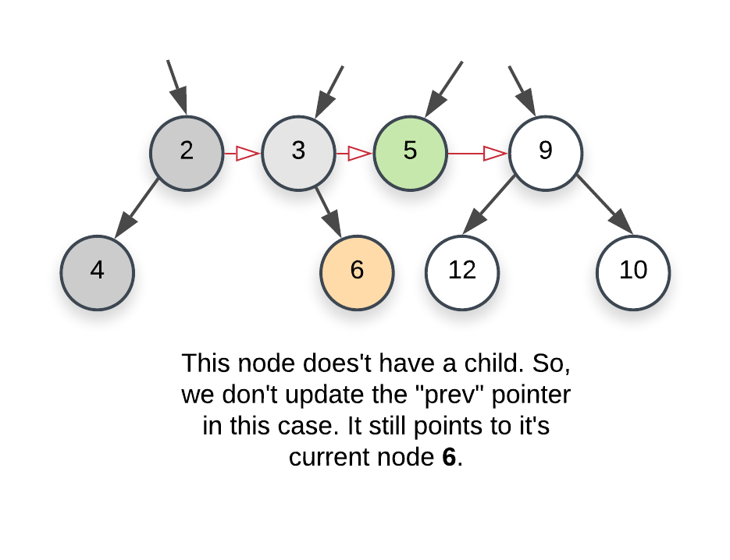

* + - And finally, we come across a node with 2 children. We first update prev to the left child and once the necessary processing is done, we update it to the right child.

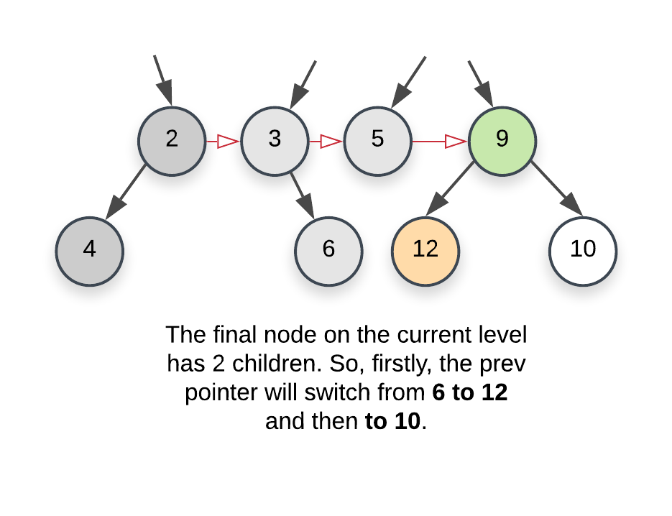

1. Once we are done with the current level, we move on to the next one. One last thing that's left here to update the leftmost node. We need that node to start traversal on a particular level. Think of it as the head of the linked list. This is easy to do by using the prev pointer. Whenever we set the value for prev pointer for the first time corresponding to a level i.e. whenever we set it to it's first node, we also set the head or the leftmost to that node. So, in the following image, leftmost originally was 2 and now it would change to 4.



|  |
| --- |
| class Solution {    Node prev, leftmost;    public void processChild(Node childNode) {    if (childNode != null) {    // If the "prev" pointer is alread set i.e. if we  // already found atleast one node on the next level,  // setup its next pointer  if (this.prev != null) {  this.prev.next = childNode;    } else {    // Else it means this child node is the first node  // we have encountered on the next level, so, we  // set the leftmost pointer  this.leftmost = childNode;  }    this.prev = childNode;  }  }    public Node connect(Node root) {    if (root == null) {  return root;  }    // The root node is the only node on the first level  // and hence its the leftmost node for that level  this.leftmost = root;    // Variable to keep track of leading node on the "current" level  Node curr = leftmost;    // We have no idea about the structure of the tree,  // so, we keep going until we do find the last level.  // the nodes on the last level won't have any children  while (this.leftmost != null) {    // "prev" tracks the latest node on the "next" level  // while "curr" tracks the latest node on the current  // level.  this.prev = null;  curr = this.leftmost;    // We reset this so that we can re-assign it to the leftmost  // node of the next level. Also, if there isn't one, this  // would help break us out of the outermost loop.  this.leftmost = null;    // Iterate on the nodes in the current level using  // the next pointers already established.  while (curr != null) {    // Process both the children and update the prev  // and leftmost pointers as necessary.  this.processChild(curr.left);  this.processChild(curr.right);    // Move onto the next node.  curr = curr.next;  }  }    return root ;  }  } |

**Complexity Analysis**

* Time Complexity: *O*(*N*) since we process each node exactly once.
* Space Complexity: *O*(1) since we don't make use of any additional data structure for traversing nodes on a particular level like the previous approach does.

**Lowest Common Ancestor of a Binary Tree**

Given a binary tree, find the lowest common ancestor (LCA) of two given nodes in the tree.

According to the [definition of LCA on Wikipedia](https://en.wikipedia.org/wiki/Lowest_common_ancestor): “The lowest common ancestor is defined between two nodes p and q as the lowest node in T that has both p and q as descendants (where we allow **a node to be a descendant of itself**).”

**Example 1:**

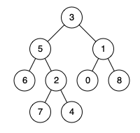

**Input:** root = [3,5,1,6,2,0,8,null,null,7,4], p = 5, q = 1

**Output:** 3

**Explanation:** The LCA of nodes 5 and 1 is 3.

**Example 2:**



**Input:** root = [3,5,1,6,2,0,8,null,null,7,4], p = 5, q = 4

**Output:** 5

**Explanation:** The LCA of nodes 5 and 4 is 5, since a node can be a descendant of itself according to the LCA definition.

**Example 3:**

**Input:** root = [1,2], p = 1, q = 2

**Output:** 1

**Constraints:**

* The number of nodes in the tree is in the range [2, 105].
* -109 <= Node.val <= 109
* All Node.val are **unique**.
* p != q
* p and q will exist in the tree.

## Solution

First the given nodes p and q are to be searched in a binary tree and then their lowest common ancestor is to be found. We can resort to a normal tree traversal to search for the two nodes. Once we reach the desired nodes p and q, we can backtrack and find the lowest common ancestor.

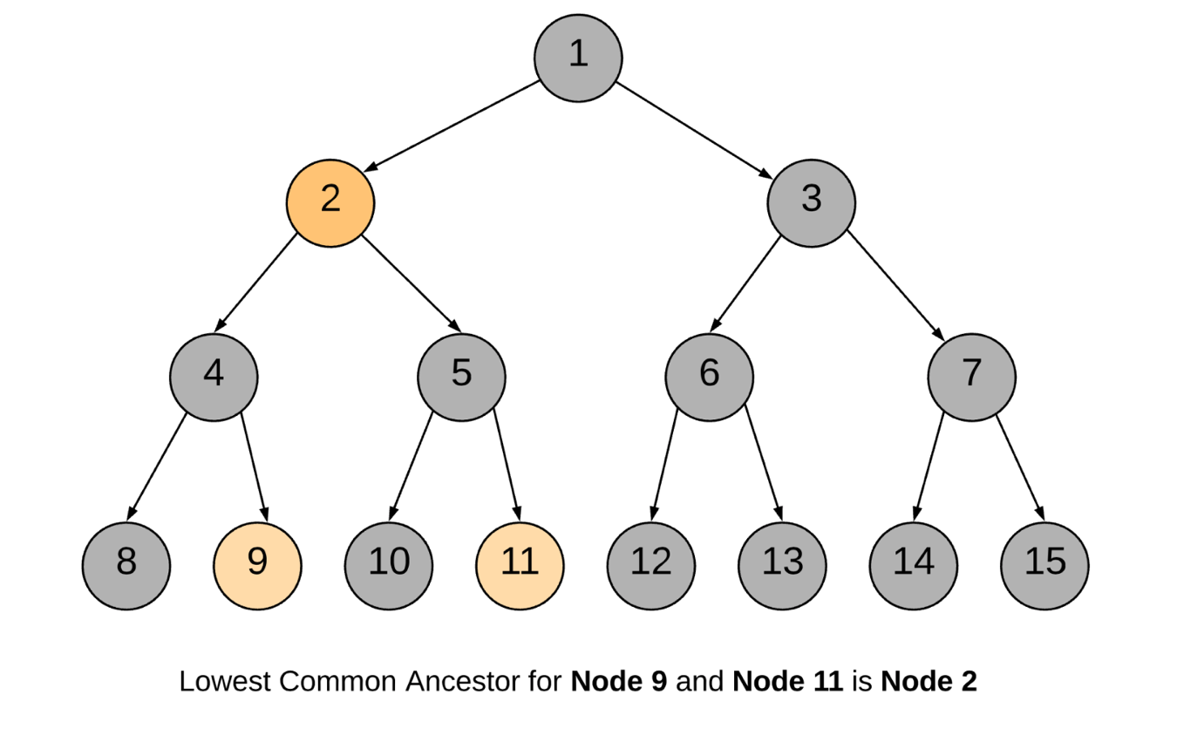

#### **Approach 1: Recursive Approach**

**Intuition**

The approach is pretty intuitive. Traverse the tree in a depth first manner. The moment you encounter either of the nodes p or q, return some boolean flag. The flag helps to determine if we found the required nodes in any of the paths. The least common ancestor would then be the node for which both the subtree recursions return a True flag. It can also be the node which itself is one of p or q and for which one of the subtree recursions returns a True flag.

Let us look at the formal algorithm based on this idea.

**Algorithm**

1. Start traversing the tree from the root node.
2. If the current node itself is one of p or q, we would mark a variable mid as True and continue the search for the other node in the left and right branches.
3. If either of the left or the right branch returns True, this means one of the two nodes was found below.
4. If at any point in the traversal, any two of the three flags left, right or mid become True, this means we have found the lowest common ancestor for the nodes p and q.

Let us look at a sample tree and we search for the lowest common ancestor of two nodes 9 and 11 in the tree.

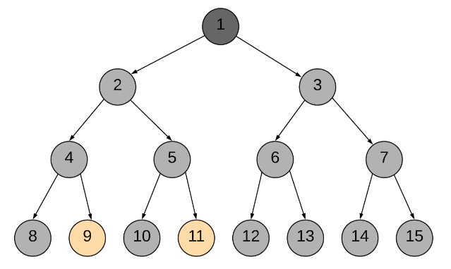

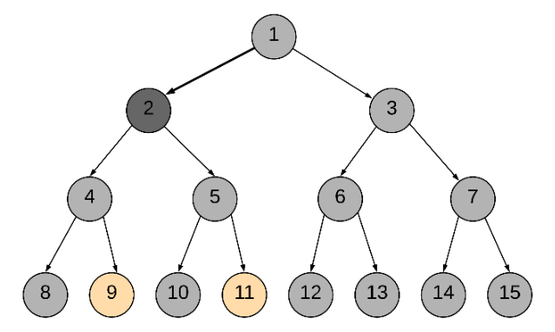

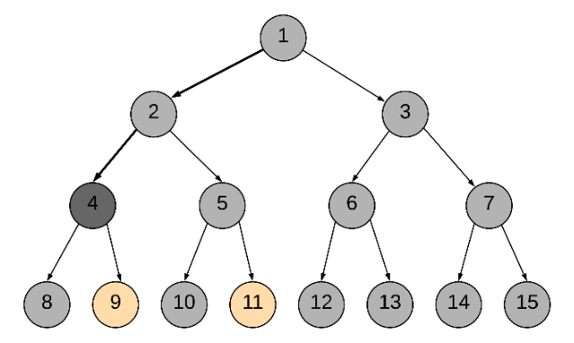

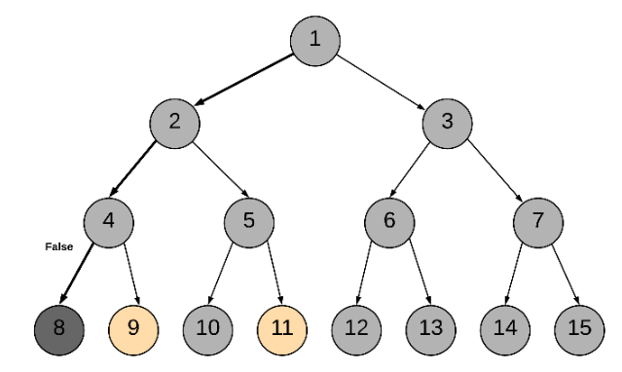

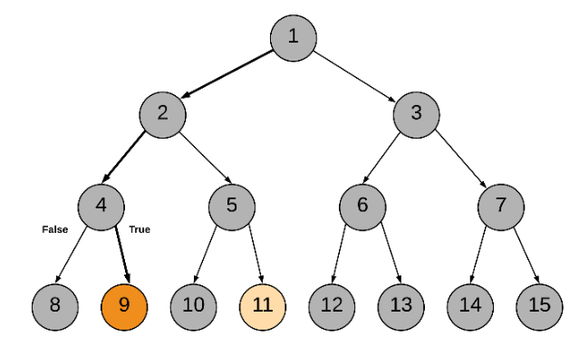

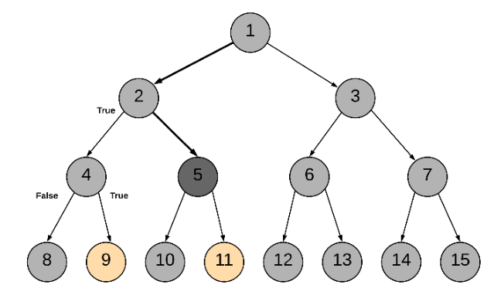

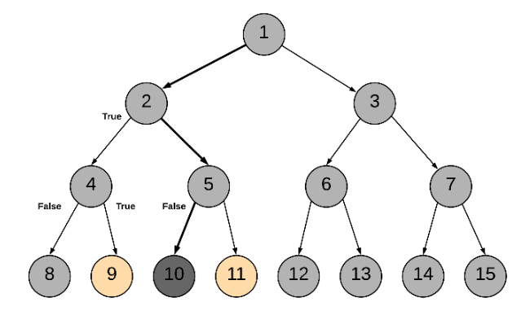

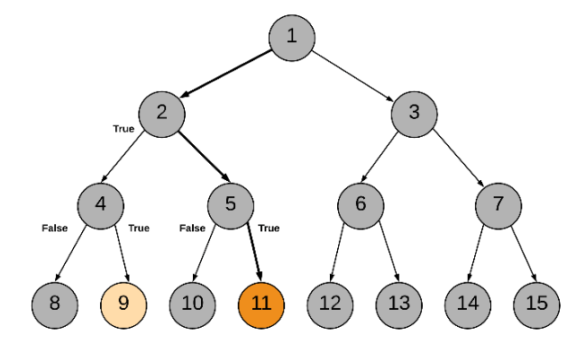

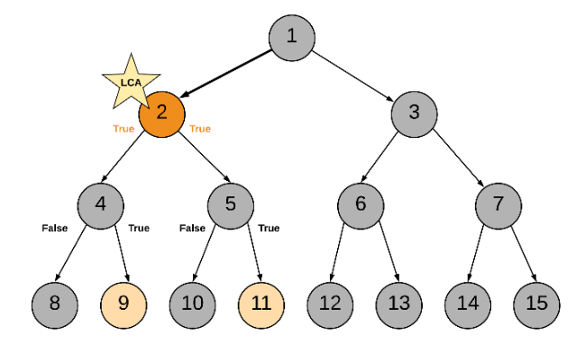

Following is the sequence of nodes that are followed in the recursion:

1 --> 2 --> 4 --> 8

BACKTRACK 8 --> 4

4 --> 9 (ONE NODE FOUND, return True)

BACKTRACK 9 --> 4 --> 2

2 --> 5 --> 10

BACKTRACK 10 --> 5

5 --> 11 (ANOTHER NODE FOUND, return True)

BACKTRACK 11 --> 5 --> 2

2 is the node where we have left = True and right = True and hence it is the lowest common ancestor.

|  |
| --- |
| class Solution {  private TreeNode ans;  public Solution() {  // Variable to store LCA node.  this.ans = null;  }  private boolean recurseTree(TreeNode currentNode, TreeNode p, TreeNode q) {  // If reached the end of a branch, return false.  if (currentNode == null) {  return false;  }  // Left Recursion. If left recursion returns true, set left = 1 else 0  int left = this.recurseTree(currentNode.left, p, q) ? 1 : 0;  // Right Recursion  int right = this.recurseTree(currentNode.right, p, q) ? 1 : 0;  // If the current node is one of p or q  int mid = (currentNode == p || currentNode == q) ? 1 : 0;  // If any two of the flags left, right or mid become True  if (mid + left + right >= 2) {  this.ans = currentNode;  }  // Return true if any one of the three bool values is True.  return (mid + left + right > 0);  }  public TreeNode lowestCommonAncestor(TreeNode root, TreeNode p, TreeNode q) {  // Traverse the tree  this.recurseTree(root, p, q);  return this.ans;  }  } |

**Complexity Analysis**

* Time Complexity: *O*(*N*), where *N* is the number of nodes in the binary tree. In the worst case we might be visiting all the nodes of the binary tree.
* Space Complexity: *O*(*N*). This is because the maximum amount of space utilized by the recursion stack would be *N* since the height of a skewed binary tree could be *N*.

#### **Approach 2: Iterative using parent pointers**

**Intuition**

If we have parent pointers for each node we can traverse back from p and q to get their ancestors. The first common node we get during this traversal would be the LCA node. We can save the parent pointers in a dictionary as we traverse the tree.

**Algorithm**

1. Start from the root node and traverse the tree.
2. Until we find p and q both, keep storing the parent pointers in a dictionary.
3. Once we have found both p and q, we get all the ancestors for p using the parent dictionary and add to a set called ancestors.
4. Similarly, we traverse through ancestors for node q. If the ancestor is present in the ancestors set for p, this means this is the first ancestor common between p and q (while traversing upwards) and hence this is the LCA node.

|  |
| --- |
| class Solution {  public TreeNode lowestCommonAncestor(TreeNode root, TreeNode p, TreeNode q) {  // Stack for tree traversal  Deque<TreeNode> stack = new ArrayDeque<>();  // HashMap for parent pointers  Map<TreeNode, TreeNode> parent = new HashMap<>();  parent.put(root, null);  stack.push(root);  // Iterate until we find both the nodes p and q  while (!parent.containsKey(p) || !parent.containsKey(q)) {  TreeNode node = stack.pop();  // While traversing the tree, keep saving the parent pointers.  if (node.left != null) {  parent.put(node.left, node);  stack.push(node.left);  }  if (node.right != null) {  parent.put(node.right, node);  stack.push(node.right);  }  }  // Ancestors set() for node p.  Set<TreeNode> ancestors = new HashSet<>();  // Process all ancestors for node p using parent pointers.  while (p != null) {  ancestors.add(p);  p = parent.get(p);  }  // The first ancestor of q which appears in  // p's ancestor set() is their lowest common ancestor.  while (!ancestors.contains(q))  q = parent.get(q);  return q;  }  } |

**Complexity Analysis**

* Time Complexity : *O*(*N*), where *N* is the number of nodes in the binary tree. In the worst case we might be visiting all the nodes of the binary tree.
* Space Complexity : *O*(*N*). In the worst case space utilized by the stack, the parent pointer dictionary and the ancestor set, would be *N* each, since the height of a skewed binary tree could be *N*.

#### **Approach 3: Iterative without parent pointers**

**Intuition**

In the previous approach, we come across the LCA during the backtracking process. We can get rid of the backtracking process itself. In this approach we always have a pointer to the probable LCA and the moment we find both the nodes we return the pointer as the answer.

**Algorithm**

1. Start with root node.
2. Put the (root, root_state) on to the stack. root_state defines whether one of the children or both children of root are left for traversal.
3. While the stack is not empty, peek into the top element of the stack represented as (parent_node, parent_state).
4. Before traversing any of the child nodes of parent_node we check if the parent_node itself is one of p or q.
5. First time we find either of p or q, set a boolean flag called one_node_found to True. Also start keeping track of the lowest common ancestors by keeping a note of the top index of the stack in the variable LCA_index. Since all the current elements of the stack are ancestors of the node we just found.
6. The second time parent_node == p or parent_node == q it means we have found both the nodes and we can return the LCA node.
7. Whenever we visit a child of a parent_node we push the (parent_node, updated_parent_state) onto the stack. We update the state of the parent since a child/branch has been visited/processed and accordingly the state changes.
8. A node finally gets popped off from the stack when the state becomes BOTH_DONE implying both left and right subtrees have been pushed onto the stack and processed. If one_node_found is True then we need to check if the top node being popped could be one of the ancestors of the found node. In that case we need to reduce LCA_index by one. Since one of the ancestors was popped off.

Whenever both p and q are found, LCA_index would be pointing to an index in the stack which would contain all the common ancestors between p and q. And the LCA_index element has the lowest ancestor common between p and q.

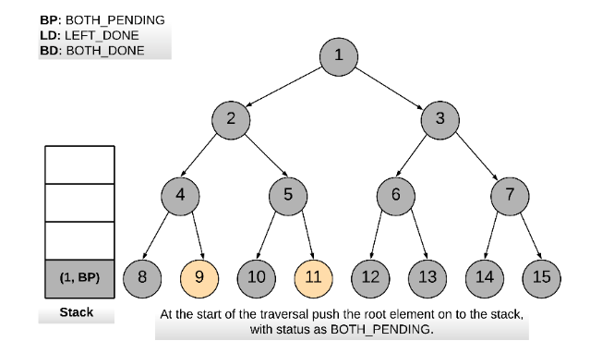 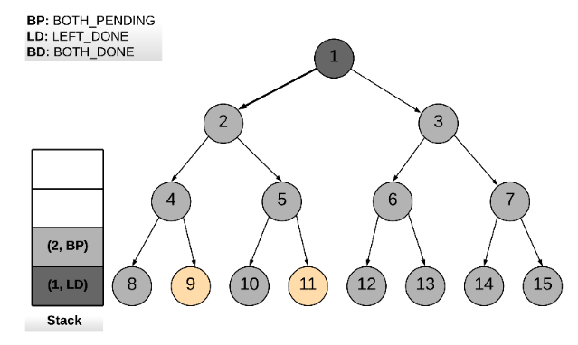

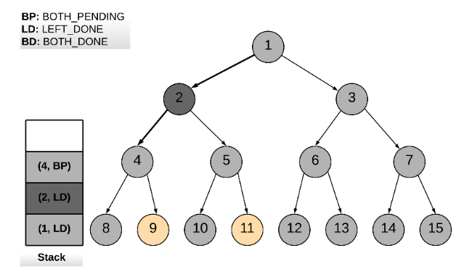

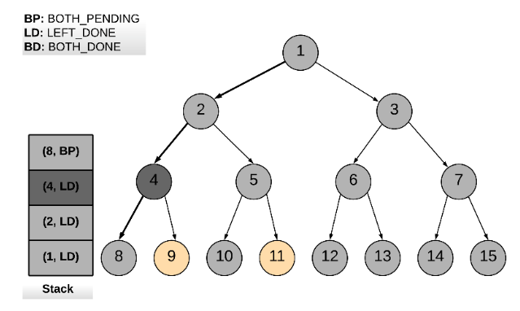

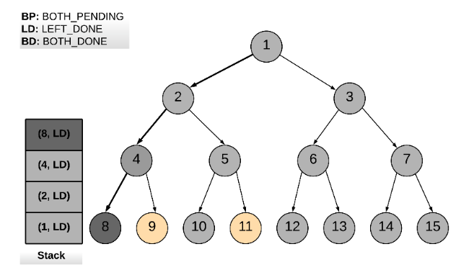

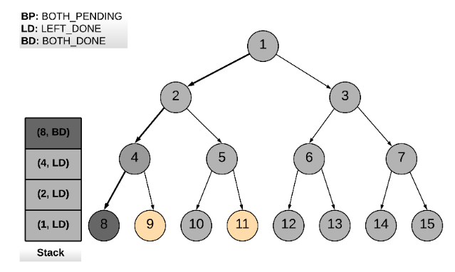

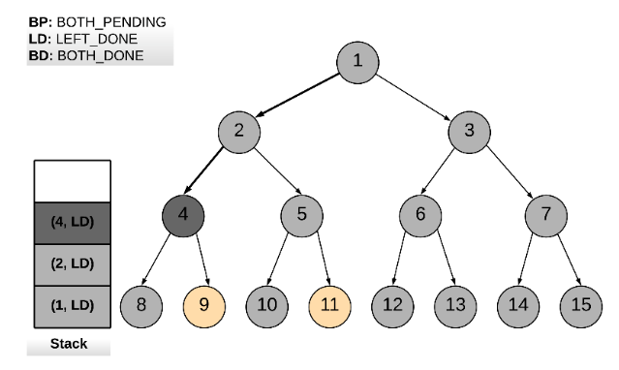

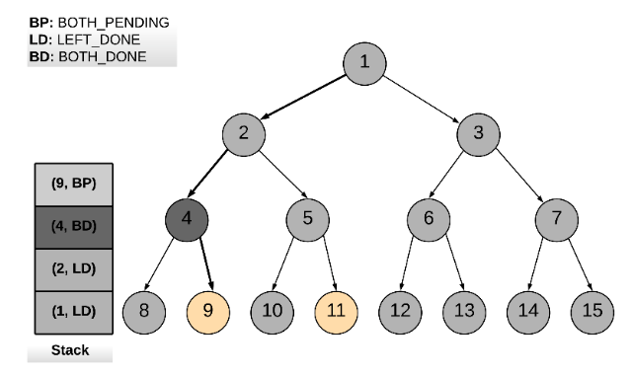

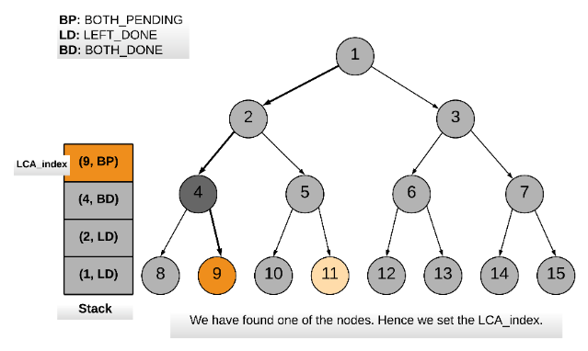

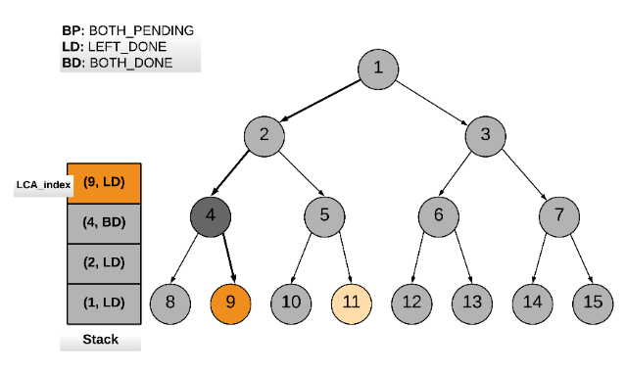

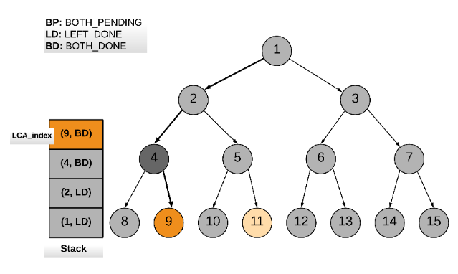 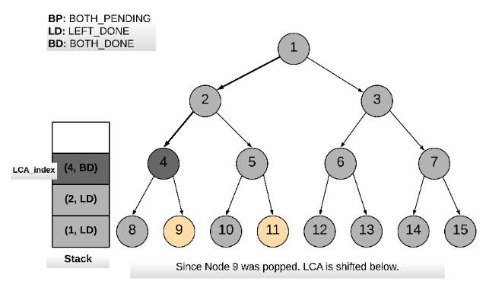

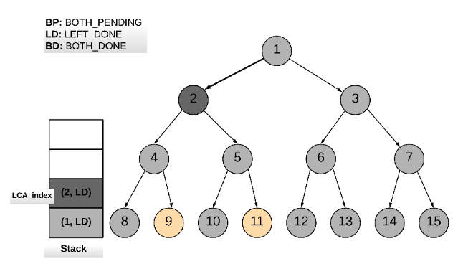

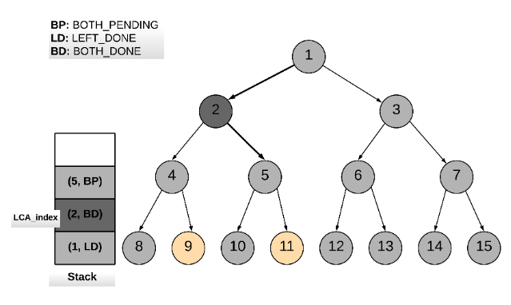

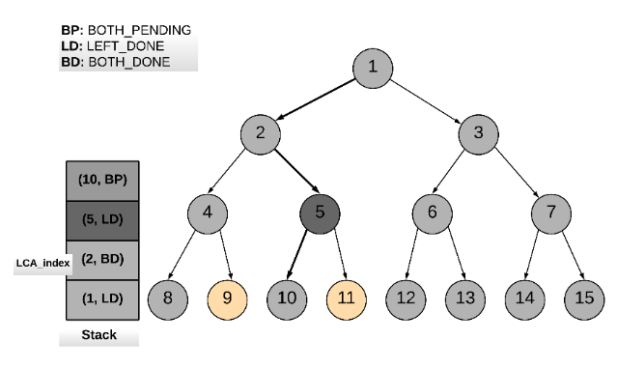

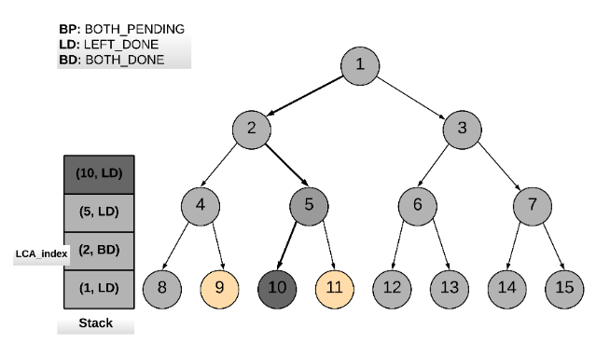

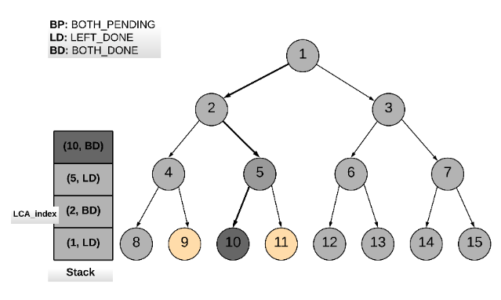

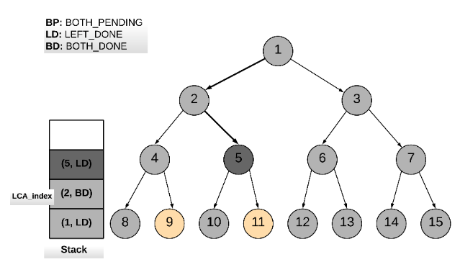

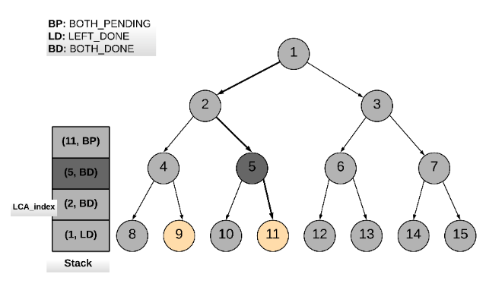

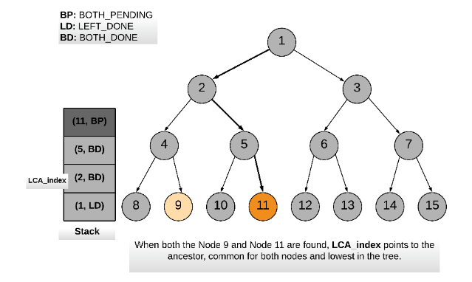

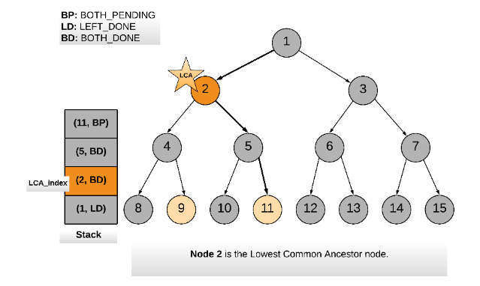

The animation above shows how a stack is used to traverse the binary tree and keep track of the common ancestors between nodes p and q.

|  |
| --- |
| class Solution {  // Three static flags to keep track of post-order traversal.  // Both left and right traversal pending for a node.  // Indicates the nodes children are yet to be traversed.  private static int BOTH_PENDING = 2;  // Left traversal done.  private static int LEFT_DONE = 1;  // Both left and right traversal done for a node.  // Indicates the node can be popped off the stack.  private static int BOTH_DONE = 0;  public TreeNode lowestCommonAncestor(TreeNode root, TreeNode p, TreeNode q) {  Stack<Pair<TreeNode, Integer>> stack = new Stack<Pair<TreeNode, Integer>>();  // Initialize the stack with the root node.  stack.push(new Pair<TreeNode, Integer>(root, Solution.BOTH_PENDING));  // This flag is set when either one of p or q is found.  boolean one_node_found = false;  // This is used to keep track of the LCA.  TreeNode LCA = null;  // Child node  TreeNode child_node = null;  // We do a post order traversal of the binary tree using stack  while (!stack.isEmpty()) {  Pair<TreeNode, Integer> top = stack.peek();  TreeNode parent_node = top.getKey();  int parent_state = top.getValue();  // If the parent_state is not equal to BOTH_DONE,  // this means the parent_node can't be popped off yet.  if (parent_state != Solution.BOTH_DONE) {  // If both child traversals are pending  if (parent_state == Solution.BOTH_PENDING) {  // Check if the current parent_node is either p or q.  if (parent_node == p || parent_node == q) {  // If one_node_found was set already, this means we have found  // both the nodes.  if (one_node_found) {  return LCA;  } else {  // Otherwise, set one_node_found to True,  // to mark one of p and q is found.  one_node_found = true;  // Save the current top element of stack as the LCA.  LCA = stack.peek().getKey();  }  }  // If both pending, traverse the left child first  child_node = parent_node.left;  } else {  // traverse right child  child_node = parent_node.right;  }  // Update the node state at the top of the stack  // Since we have visited one more child.  stack.pop();  stack.push(new Pair<TreeNode, Integer>(parent_node, parent_state - 1));  // Add the child node to the stack for traversal.  if (child_node != null) {  stack.push(new Pair<TreeNode, Integer>(child_node, Solution.BOTH_PENDING));  }  } else {  // If the parent_state of the node is both done,  // the top node could be popped off the stack.  // Update the LCA node to be the next top node.  if (LCA == stack.pop().getKey() && one_node_found) {  LCA = stack.peek().getKey();  }  }  }  return null;  }  } |

**Complexity Analysis**

* Time Complexity : *O*(*N*), where *N* is the number of nodes in the binary tree. In the worst case we might be visiting all the nodes of the binary tree. The advantage of this approach is that we can prune backtracking. We simply return once both the nodes are found.
* Space Complexity : *O*(*N*). In the worst case the space utilized by stack would be *N* since the height of a skewed binary tree could be *N*.

**Serialize and Deserialize Binary Tree**

Serialization is the process of converting a data structure or object into a sequence of bits so that it can be stored in a file or memory buffer, or transmitted across a network connection link to be reconstructed later in the same or another computer environment.

Design an algorithm to serialize and deserialize a binary tree. There is no restriction on how your serialization/deserialization algorithm should work. You just need to ensure that a binary tree can be serialized to a string and this string can be deserialized to the original tree structure.

**Clarification:** The input/output format is the same as [how LeetCode serializes a binary tree](https://leetcode.com/faq/#binary-tree). You do not necessarily need to follow this format, so please be creative and come up with different approaches yourself.

**Example 1:**

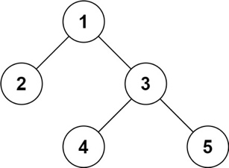

**Input:** root = [1,2,3,null,null,4,5]

**Output:** [1,2,3,null,null,4,5]

**Example 2:**

**Input:** root = []

**Output:** []

**Example 3:**

**Input:** root = [1]

**Output:** [1]

**Example 4:**

**Input:** root = [1,2]

**Output:** [1,2]

**Constraints:**

* The number of nodes in the tree is in the range [0, 104].
* -1000 <= Node.val <= 1000

## Solution

#### **Approach 1: Depth First Search (DFS)**

**Intuition**

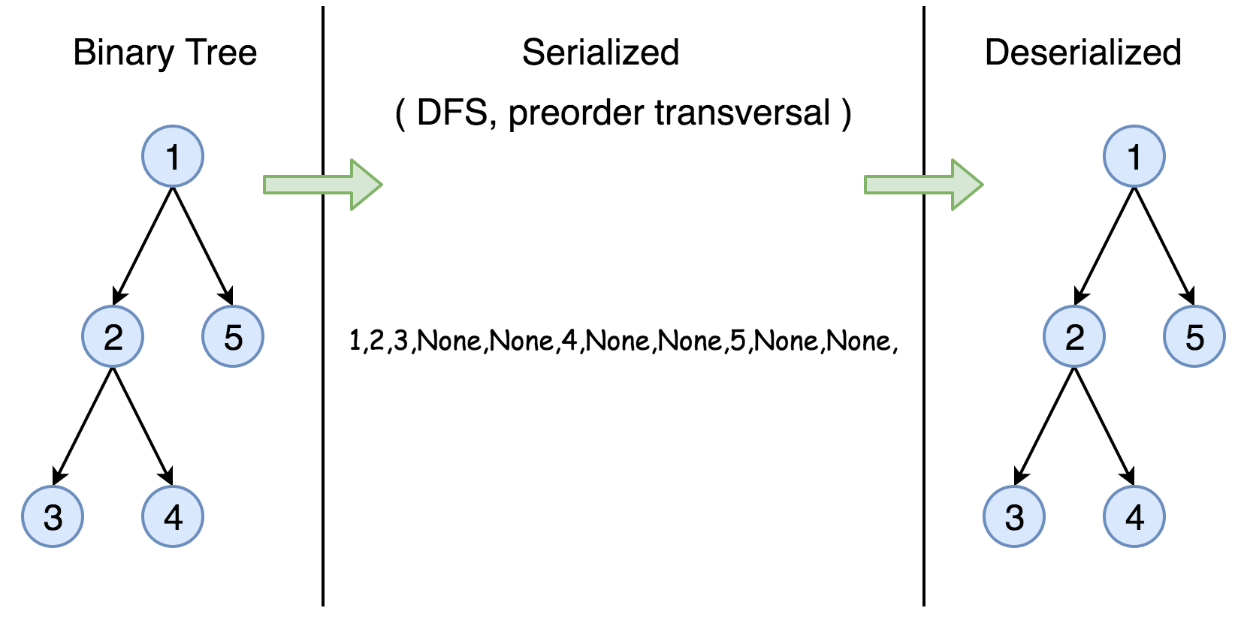

The **serialization** of a Binary Search Tree is essentially to encode its values and more importantly its structure. One can traverse the tree to accomplish the above task. And it is well know that we have two general strategies to do so:

* Breadth First Search (BFS)

We scan through the tree level by level, following the order of height, from top to bottom. The nodes on higher level would be visited before the ones with lower levels.

* Depth First Search (DFS)

In this strategy, we adopt the depth as the priority, so that one would start from a root and reach all the way down to certain leaf, and then back to root to reach another branch.

The DFS strategy can further be distinguished as preorder, inorder, and postorder depending on the relative order among the root node, left node and right node.

In this task, however, the DFS strategy is more adapted for our needs, since the linkage among the adjacent nodes is naturally encoded in the order, which is rather helpful for the later task of **deserialization**.

Therefore, in this solution, we demonstrate an example with the preorder DFS strategy. One can check out more tutorial about Binary Search Tree on the [LeetCode Explore](https://leetcode.com/explore/learn/card/introduction-to-data-structure-binary-search-tree/).

**Algorithm**

First of all, here is the definition of the TreeNode which we would use in the following implementation.

|  |
| --- |
| /* Definition for a binary tree node. */  public class TreeNode {  int val;  TreeNode left;  TreeNode right;  TreeNode(int x) {  val = x;  }  } |

The preorder DFS traverse follows recursively the order of  
root -> left subtree -> right subtree.

As an example, let's serialize the following tree. Note that serialization contains information about the node values as well as the information about the tree structure.

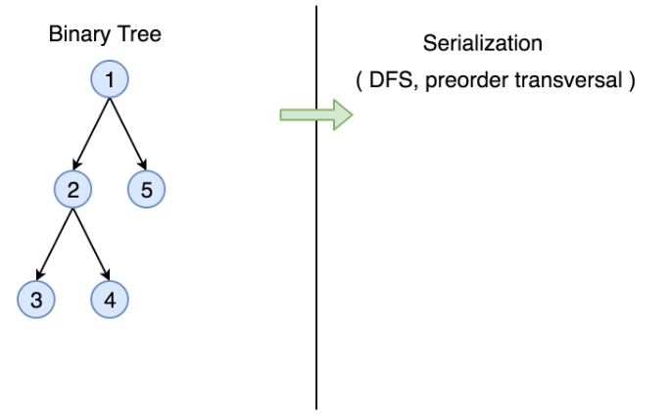

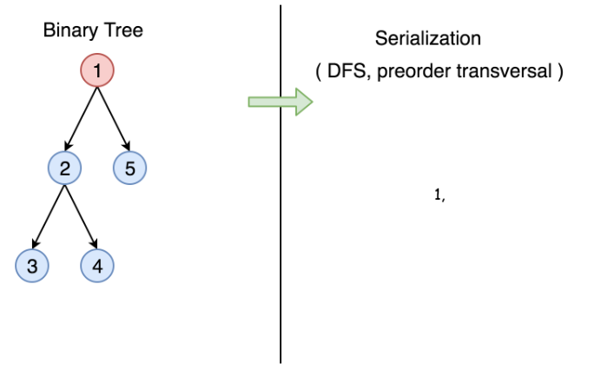

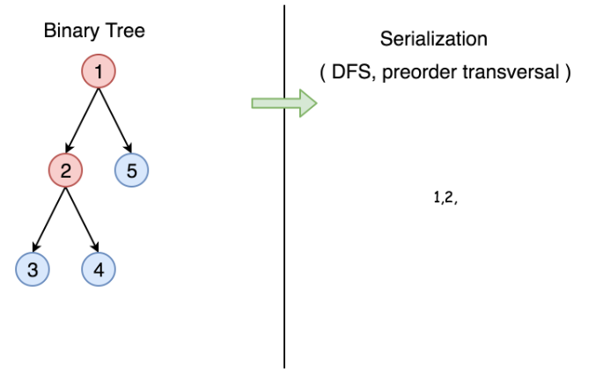 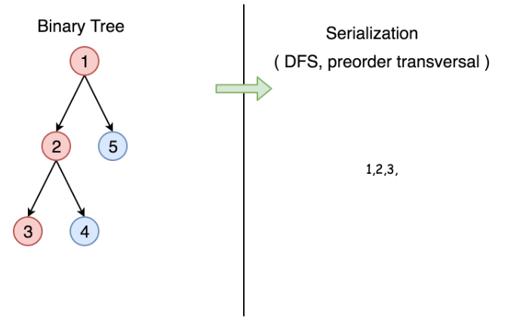

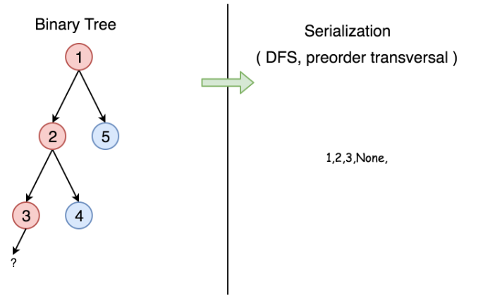

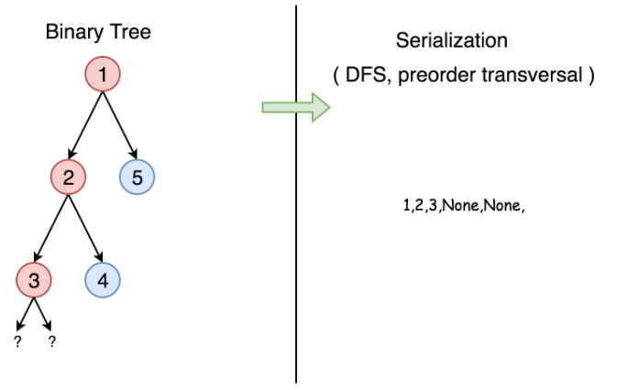

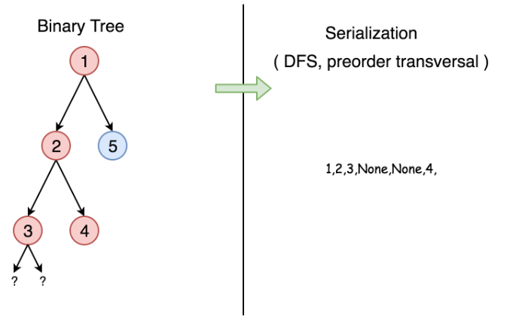

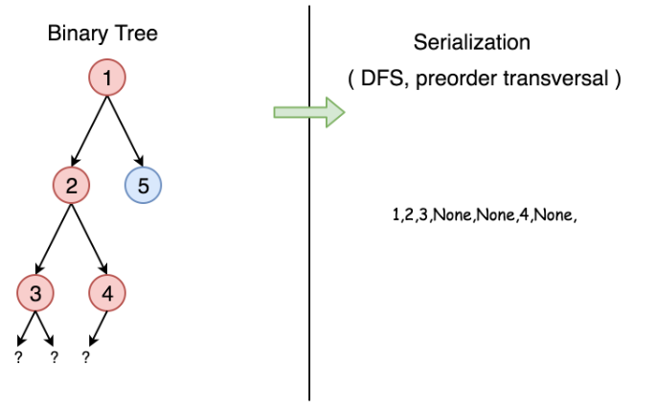

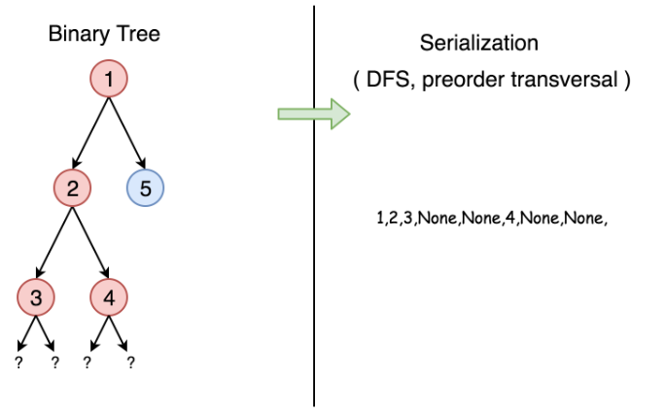

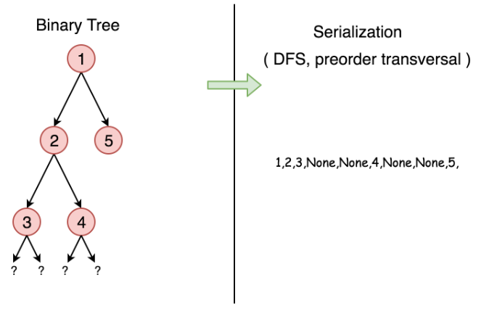

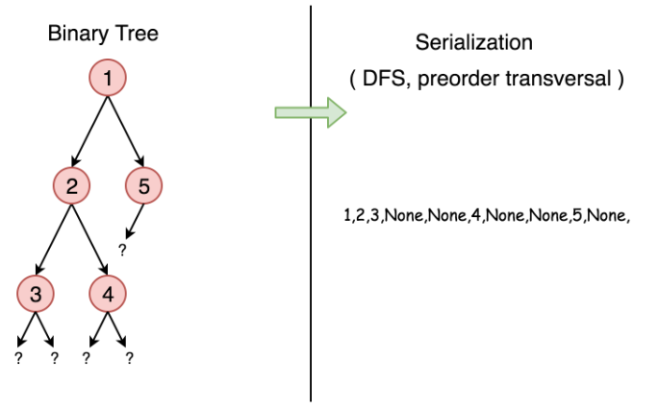

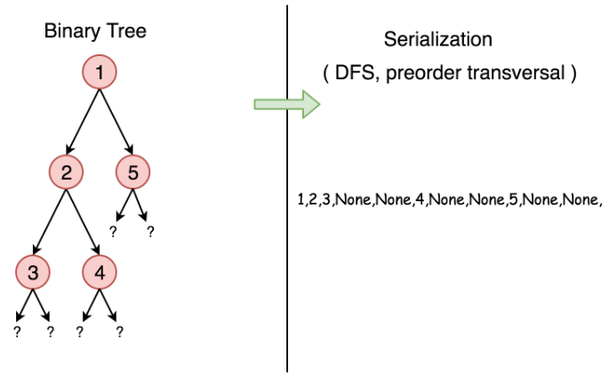

We start from the root, node 1, the serialization string is 1,. Then we jump to its left subtree with the root node 2, and the serialization string becomes 1,2,. Now starting from node 2, we visit its left node 3 (1,2,3,None,None,) and right node 4 (1,2,3,None,None,4,None,None) sequentially. Note that None,None, appears for each leaf to mark the absence of left and right child node, this is how we save the tree structure during the serialization. And finally, we get back to the root node 1 and visit its right subtree which happens to be a leaf node 5. Finally, the serialization string is done as 1,2,3,None,None,4,None,None,5,None,None,.

|  |
| --- |
| // Serialization  public class Codec {  public String rserialize(TreeNode root, String str) {  // Recursive serialization.  if (root == null) {  str += "null,";  } else {  str += str.valueOf(root.val) + ",";  str = rserialize(root.left, str);  str = rserialize(root.right, str);  }  return str;  }  // Encodes a tree to a single string.  public String serialize(TreeNode root) {  return rserialize(root, "");  }  }; |

Now let's deserialize the serialization string constructed above 1,2,3,None,None,4,None,None,5,None,None,. It goes along the string, initiate the node value and then calls itself to construct its left and right child nodes.

|  |
| --- |
| public class Codec {  public TreeNode rdeserialize(List<String> l) {  // Recursive deserialization.  if (l.get(0).equals("null")) {  l.remove(0);  return null;  }  TreeNode root = new TreeNode(Integer.valueOf(l.get(0)));  l.remove(0);  root.left = rdeserialize(l);  root.right = rdeserialize(l);  return root;  }  // Decodes your encoded data to tree.  public TreeNode deserialize(String data) {  String[] data_array = data.split(",");  List<String> data_list = new LinkedList<String>(Arrays.asList(data_array));  return rdeserialize(data_list);  }  }; |

**Complexity Analysis**

* Time complexity : in both serialization and deserialization functions, we visit each node exactly once, thus the time complexity is *O*(*N*), where *N* is the number of nodes, *i.e.* the size of tree.
* Space complexity : in both serialization and deserialization functions, we keep the entire tree, either at the beginning or at the end, therefore, the space complexity is *O*(*N*).

The solutions with BFS or other DFS strategies normally will have the same time and space complexity.

**Further Space Optimization**

In the above solution, we store the node value and the references to None child nodes, which means *N*⋅*V*+2*N* complexity, where V*V* is the size of value. That is called *natural serialization*, and has was implemented above.

The *N*⋅*V* component here is the encoding of values, can't be optimized further, but there is a way to reduce 2*N* part which is the encoding of the tree structure.

The number of unique binary tree structures that can be constructed using n nodes is C(n), where C(n) is the nth Catalan number. Please refer to [this article](https://leetcode.com/articles/unique-binary-search-trees/) for more information.

